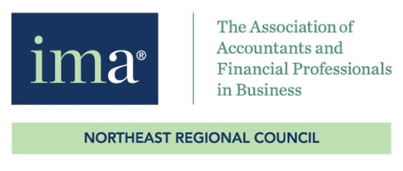
Fall 2021 Conference Evaluation Form

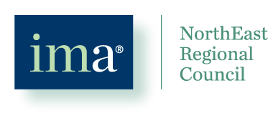
Please take a few minutes to complete this evaluation. Your responses are important and are used to continually improve the conference. Circle a rating for each item or circle all that apply based on the question and add any comments. We really do read them and make changes based on your feedback!
Name (Optional):_________________________________________

Your State or Chapter:________________________ Your Industry:_____________________________________
Is this your first IMA NERC Conference: Yes - No
Which days did you attend: Sunday - Monday - Networking Reception - Tuesday
How was the registration process: Poor - Fair - Good - Very Good - Great
How was the check-in process: Poor - Fair - Good - Very Good - Great
The variety of educational content was: Poor - Fair - Good - Very Good - Great
The quality of the educational information was: Poor - Fair - Good - Very Good - Great
Speakers were prepared and presented well: Poor - Fair - Good - Very Good – Great
I learned something new: Poor - Fair - Good - Very Good – Great
I learned something useful for my current role: Poor - Fair - Good - Very Good - Great
Length/time of sessions: Poor - Fair - Good - Very Good – Great
Length/time for breaks and lunch: Poor - Fair - Good - Very Good – Great
Time available for networking: Poor - Fair - Good - Very Good - Great
Networking Reception on Monday evening: Poor - Fair - Good - Very Good - Great or N/A
Conference Facilities overall: Poor - Fair - Good - Very Good – Great
Location/accessibility of the hotel: Poor - Fair - Good - Very Good – Great
Friendliness and turnaround time of hotel staff: Poor - Fair - Good - Very Good - Great
Cleanliness of room and conference facilities: Poor - Fair - Good - Very Good - Great
The cost of the conference for the value received was: Poor - Fair - Good - Very Good – Great
Comments about the above questions:

(over please)
Fall 2021 Conference Evaluation Form (continued)

What was the main reason you attended this conference:

____CPEs ____Topic Mix ____Speakers ____Price ____Networking ____Other (please describe) ______________________

How did you hear of this conference (circle all that apply)?

Brochure | IMA E-mail | Council E-Mail | Website | LinkedIn
Twitter | Facebook | Other Social Media | In person | IMA Webinar or Meeting

Other (please describe)

Did the general timing and format of the Conference work well for you? Yes - No

Were there any sessions and/or speakers that stood out for you? Please explain reason.

Were there any sessions and/or speakers you feel did not add value? Please explain reason.

What was the most enjoyable part of the conference?

What was the least enjoyable part of the conference?

Do you anticipate attending the 2022 14th Annual Conference at the Courtyard Marriott in Nashua New Hampshire, Sept 18-20? Yes - No

Any suggestions for 14th Annual Fall Conference in 2022 (e.g. format, topics, timing, food, promotion, networking activities, door prizes, finding volunteers, etc.) please e-mail northeastregionalima@gmail.com!

THANK YOU for attending the IMA NorthEast Regional Council 13th Annual Fall Conference!!!
We appreciate your valuable input and hope you enjoyed the conference. See you next year!

