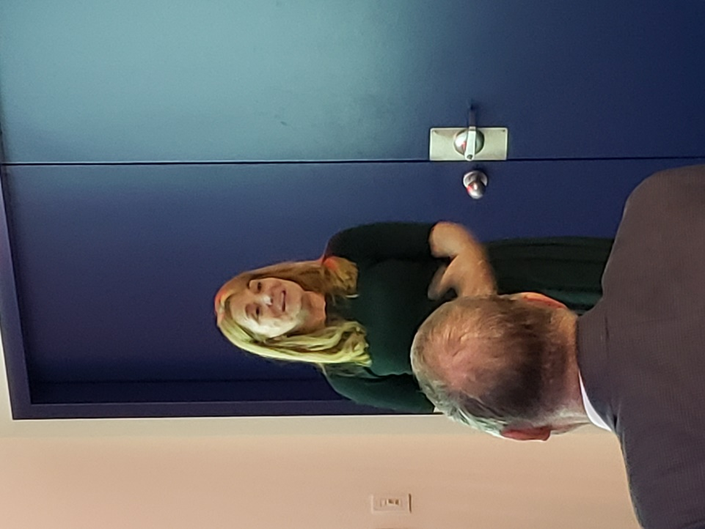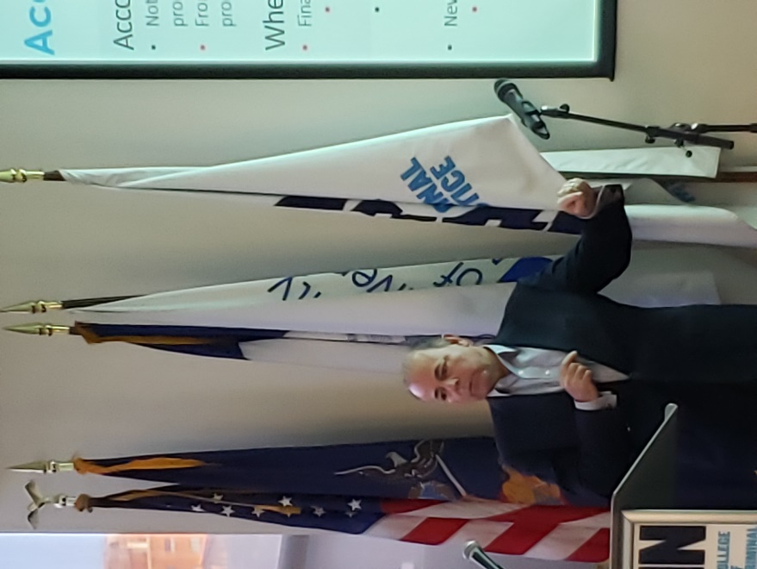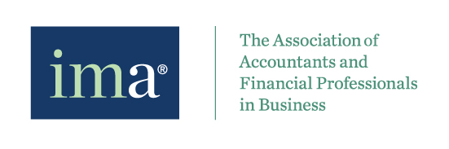

IMA NY Chapter would like to thank you everyone who joined us on April 3, 2019 at John Jay College for Finance in the Arts: Accounting and Finance for Broadway Show. Without you, we cannot possible to have such a wonderful evening.

We are honored and thankful to have Robert Fried and Karen Kowgios from Withum to be our guest speaker for this seminar.

For those who may interest in joining our organization, please visit <http://www.imanet.org> or contact our VP Membership, Mia Lam, at [ny@imachapter.org](mailto:ny@imachapter.org)

We will have more events coming soon. Looking forward to meet you all again!

April Post-Event Newsletter

This event is presented by Institute of Management Accountants – New York Chapter.