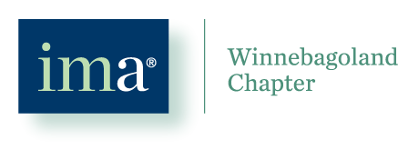
NON-MEMBER PRIVACY ACKNOWLEDGMENT FORM

Name
Email Address

By selecting one of the following options (A-C), you are giving your permission to be contacted by the Winnebagoland chapter and acknowledging your email will be part of a list maintained by the chapter. Selecting D will remove you from all future chapter communications.

- A) Contact me for upcoming events
- C) Contact me for new products/services
- B) I would like to hear from your sponsors
- D) Do not contact me/ Remove me from your mailing list

If you wish to continue receiving communications from the chapter, please complete this form and email it to winnwire@gmail.com. Selection of option D or non-response will result in removal from all future chapter communications.

