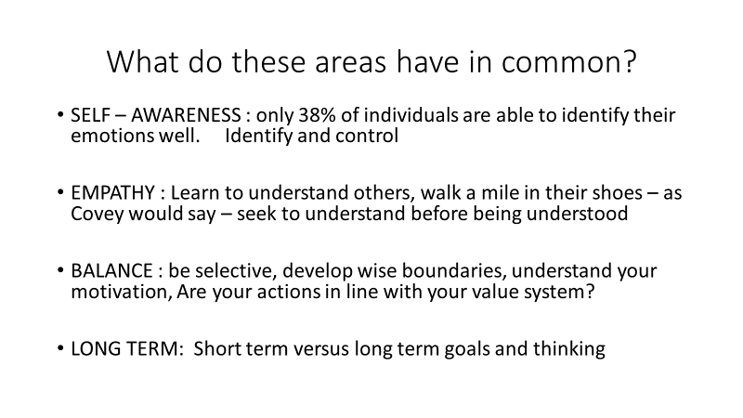

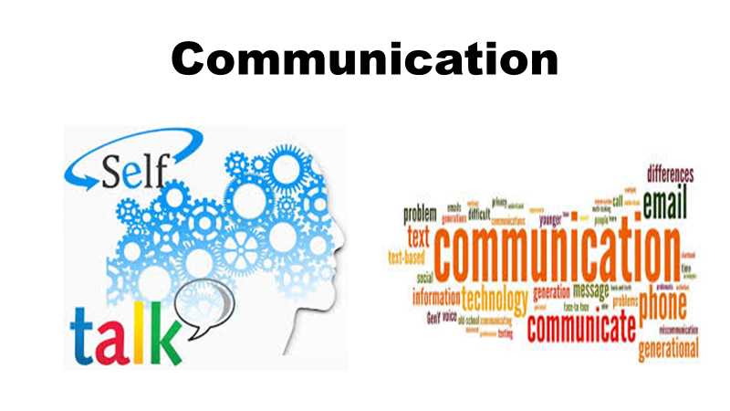
Some ways to increase in these areas: read, study, watch, ask, assess yourself, mentorship, etc
Soft skills can be learned and continue to be increased. This is an area that can be extremely important in both your professional and personal life.

Presentation by: Sheryl Huhn
Sheryl.huhn@gmail.com
920-427-3795

