Ethics Series:
Blinded by Pressure

Participant Workbook

OBJECTIVES

After this session, you will be able to:

- Recognize an ethical dilemma within an organization.
- Identify improper departures from U.S. Generally Accepted Accounting Principles (GAAP) reporting as a means to improve reported results.
- Recognize the appropriate ways to increase profits within GAAP and ethical guidelines.
- Identify an auditor’s role and responsibility when faced with an ethical dilemma.

REFLECTION

Think of a time when you were faced with an ethical dilemma (either personal or professional). How did you handle it?

What do you hope to get out of this workshop?

FACTORS OF AN ETHICAL DILEMMA

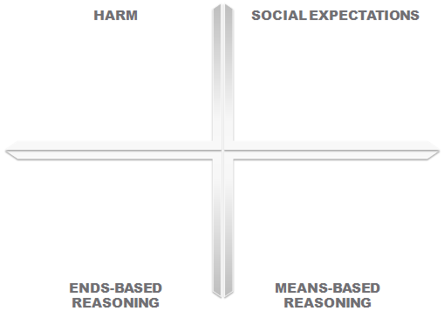

SCENARIO PRACTICE: EVALUATE FINANCIAL DATA
In this exercise, you will be asked to review key financial data for a fictional company named ABC Company and evaluate if any red flags should be raised.

Let’s assume you are acting as the cost accounting manager for ABC Company where upper management is finalizing their budget for next year (20X4).

We’ll begin by taking a look at pricing charged in the prior year by ABC Company’s approved vendors.

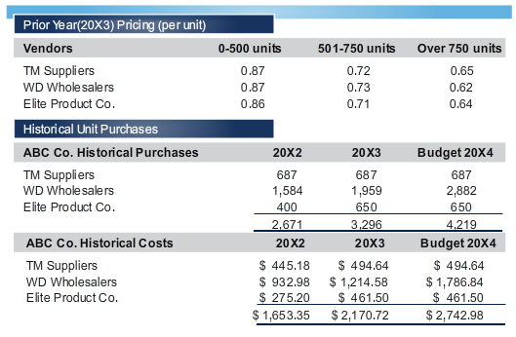

At first glance, we notice that pricing will depend on quantities purchased. Next, let’s take a look at our historical unit purchases and extended product costs by vendor.

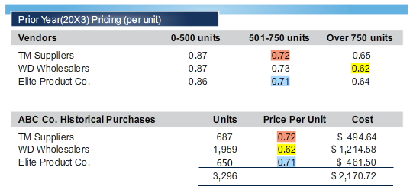

A quick validation demonstrates that 20X3 historical costs tie back to the appropriate per-unit costs noted in the 20X3 pricing schedule.

Next, we’ll take a look at the budgeted figures for the new 20X4 year.

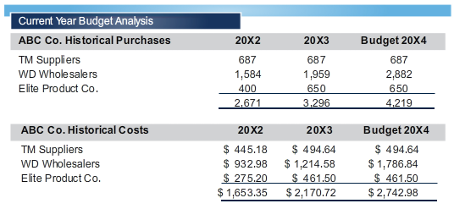

Our external Research department has provided us with the following information:
- Economic trends are expected to remain the same for 20X4.
- WD Wholesalers has been a primary supplier to ABC for more than 40 years.
- A hostile takeover of WD Wholesalers by Elite Product Co. is imminent in 20X4.

Based on all information provided to you in this scenario, which red flag(s) (if any) do you see with ABC's 20X4 budget? Discuss your answers with your team, and be prepared to present your findings to the class.

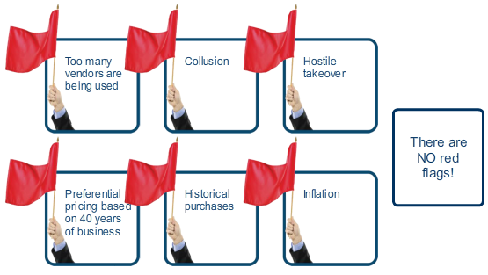

CONTRIBUTORS TO THE SCHEME

- Why would they have gone along with it?

- What should they have done?

FRAUD TRIANGLE

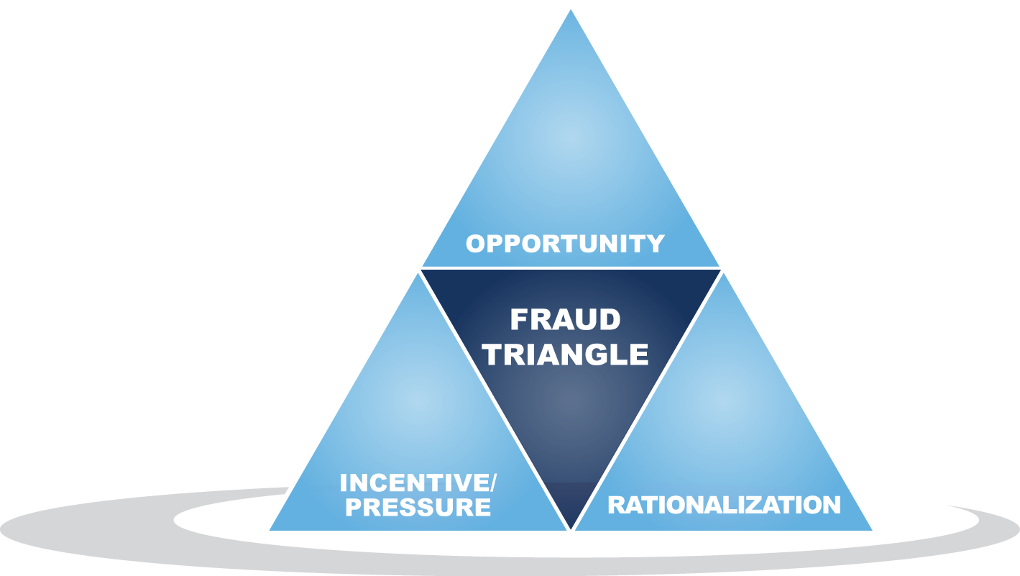

SCENARIO PRACTICE: RESOLVE AN ETHICAL DILEMMA
Now it’s your turn to choose an appropriate way to increase profits within GAAP and ethical guidelines. Let’s return to our red flag scenario and pose an ethical dilemma.

Suppose in a recent private meeting, you brought the red flags to the attention of your boss, Amy Dublin. Shortly after your discussion, Amy sends you an e-mail.

Re: 20x4 Budget Concerns
adublin@abc-company.com
Thank you for bringing the inflation and takeover issues to my attention. As you are aware, we face many challenges in the year ahead. Maintaining our shareholder value and protecting company assets and reputation are among them.
One of the ways we protect shareholder value is to set reasonable expectations for analysts on Wall Street. Since budgets are educated guesswork at best, we want to make certain we don't create unnecessary concerns by reflecting pricing increases that may never happen. Assumptions of this nature could compromise stock prices, the ability to acquire necessary capital resources to support growth, and perhaps create the need for employee downsizing plans.
I'm sure you understand the sensitivity of this matter and I'm counting on you to embrace the estimates provided in order to protect the well-being of this company. Any actions on your part which compromise our ability to properly manage the well-being of this company will not be well received and may result in disciplinary action including termination.

I trust you will make the right decisions and remain a valued and well-appreciated employee for many years to come.

Respectfully,

you@abc-company.com

A full evaluation of this scenario may require further research. Review the Statement of Ethical Practices from ABC’s Employee Handbook and the company’s organizational chart below to explore other information that may be helpful in determining the appropriate next step you should take.

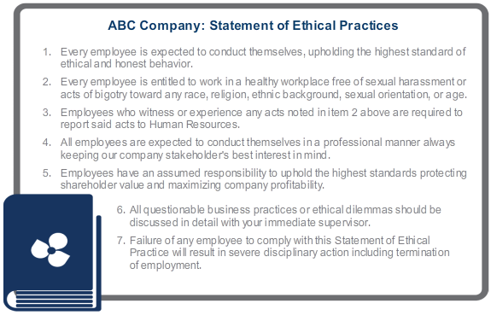

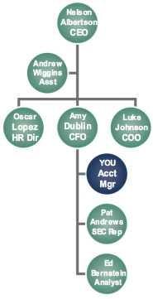

Ethical dilemmas often do not present options that are clearly right vs. wrong. From the logical choices displayed on the screen, select one of the options that best reflects the recommended next step in this ethical dilemma, despite the potentially negative consequences.

Option |  | Potential Consequences
 | Escalate your concern to the CEO to ensure proper and ethical accounting practices are being adhered to. | Selecting this option may be construed as violating items 4, 5, and 6 of the Statement of Ethical Practices. This may result in you receiving severe disciplinary action or perhaps being fired.
 | Do as you are told, and leave the calculations as they are. Should the action be questioned at a later date, it will be clear you were just following orders. | Selecting this option may be construed as aiding the deliberate misrepresentation of costs in order to meet analysts’ and management's expectations. This option could cause significant impact on stock prices as investors question the integrity of ABC's financial data. Knowingly misrepresenting costs is also a violation of items 1 and 4 of the Statement of Ethical Practices. This may result in you receiving severe disciplinary action or perhaps being fired.
 | Report the deliberate understated costs to the SEC. | Selecting this option may be construed as violating item 6 of the Statement of Ethical Practices. This may result in you receiving severe disciplinary action or perhaps being fired. In addition, this action could impact the company negatively as it compromises the integrity of information being reported to Wall Street, which may cause a drop in company valuations.
 | Change the figures to reflect more appropriate cost estimates, and don't tell anyone. | Selecting this option may be construed as insubordination. You've been instructed what to do by your boss, yet you've taken it upon yourself to make changes. Because you don’t have the authority to make changes that could directly impact stock price valuations, your actions may have a negative impact on the company and would demonstrate a deliberate violation of items 1, 4, and 5 of the Statement of Ethical Practices. This choice runs a high risk of you being fired.

MANAGEMENT ACCOUNTING TOOLS

- Variance Analysis
- Benchmarking
- CVP Analysis

SCENARIO PRACTICE: AUDIT A SAMPLE COMPANY
For this exercise, you will act as the auditor examining the current period financials of Company A. Company A is a small family-run business. The owner has expressed his pride in his company and his ability to negotiate incredible deals with vendors. This gives him a competitive edge on his direct competition (Company B and Company C), which operate in the same town, because his cost of goods sold runs about 4% lower than his competitors.

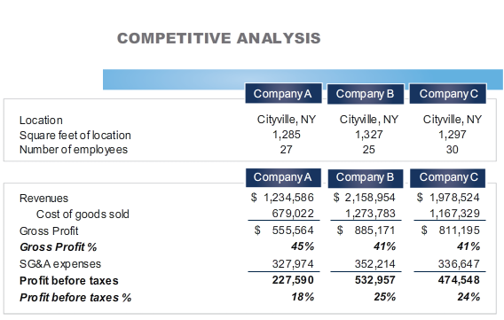

Company A’s profit before taxes is about 18%. The owner feels the business is doing well, and the new controller appears to be keeping costs in line.

Using the benchmark tools and details provided, follow the facts to conclusion and detect any issues along the way.

The benchmark tools provide comparable financial statement data for Company B and Company C.

Drill down into the details for each line item to obtain more detailed information driving the figures reported in Company A’s financial statement.

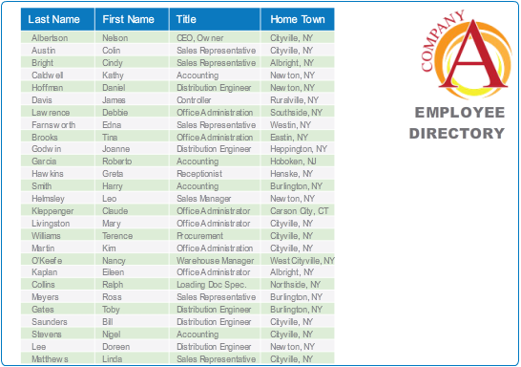

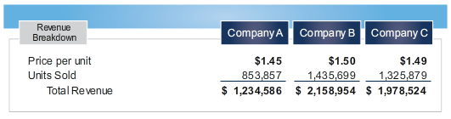

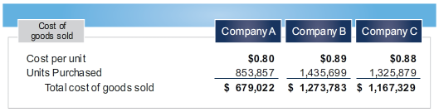

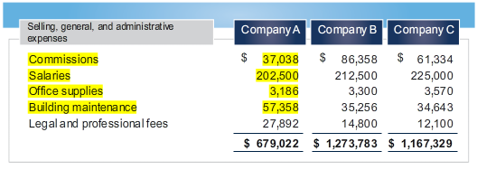

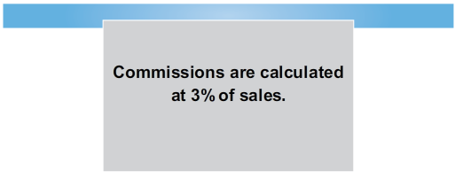

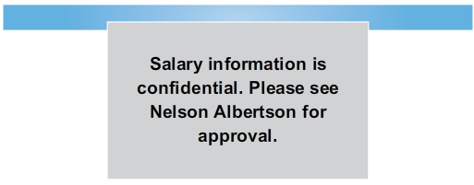
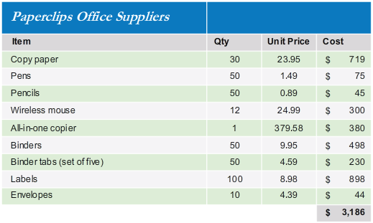

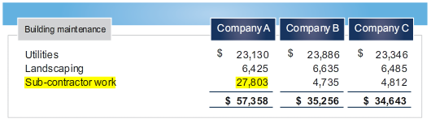

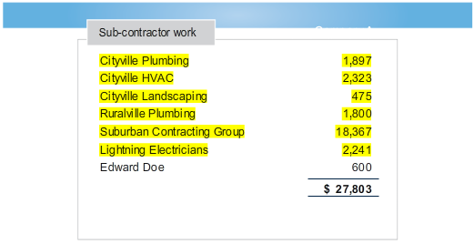

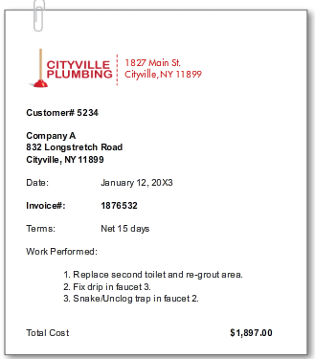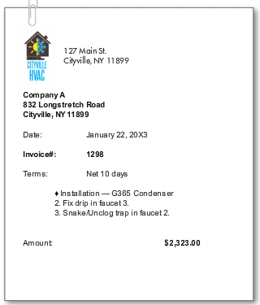
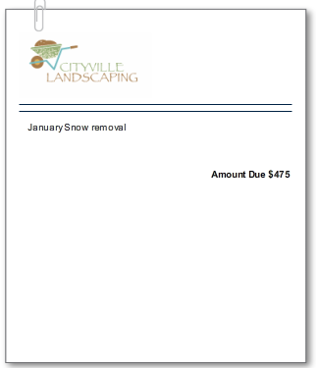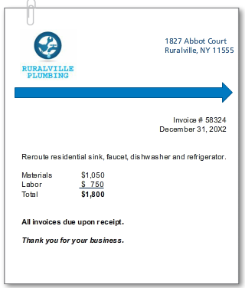
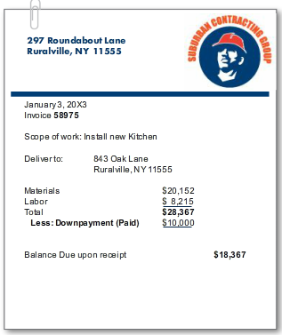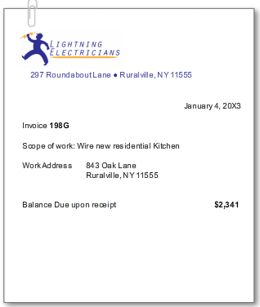

Based on the information you have reviewed, select the appropriate statement:

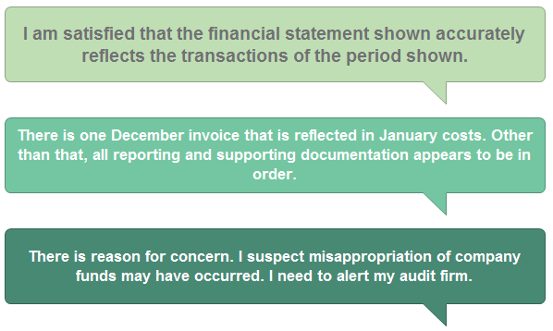

EPILOGUE

- What was the company impact?
- What was the personal impact to the CEO?
- What was the personal impact to the CFO?
- What are the key takeaways for you? How can you apply what you’ve learned to ensure ethical practices are followed at your company?

SUMMARY

- What guidelines should management accountants follow to uphold strict ethical practices?
- What are the four overarching ethical principles in the IMA Statement of Ethical Professional Practice?
- What are the four standards of ethical professional practice?

CASE STUDY LEARNING POINTS

- How were the overarching ethical principles circumvented in the Diamond Foods case?
- How did Diamond Foods deviate from each of the four standards of ethical professional practice?
COMPETENCE | CONFIDENTIALITY
INTEGRITY | CREDIBILITY

ACTION PLANNING

List things that you learned today or were reminded about.
3

What new strategies can you use to uphold ethical professional practices?
2

What thing are you going to do TOMORROW?
1

ACKNOWLEDGEMENTS
Presentation produced by Ignite It Group (www.igniteitgroup.com).

IMA would like to acknowledge the case study authors Dr. Jomo Sankara and Dr. Deborah Lindberg for their contributions to the development of this course.

CONTACT US

For more information about this or other programs, please contact IMA:

www.imanet.org
10 Paragon Drive, Suite 1, Montvale, NJ 07645-1760
U.S. (800) 638-4427 or International +1 (201) 573-9000

