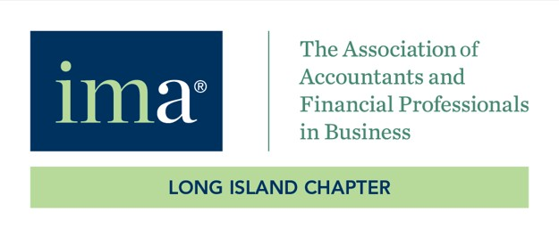

Long Island Institute of Management Accountants

2026 FEY Nomination Questionnaire

Milton Zipper Financial Executive of the Year Award

Event Date: 5/12/2026
Location: The Milleridge Inn
585 N. Broadway, Jericho NY 11753

- Please describe the candidate's participation in the financial reporting operation of the Company. Provide several examples of the candidate's superior performance in this area.

- Discuss the candidate's technical expertise as well as the candidate's ability to handle technical issues as they arise.

- Discuss the candidate's ability to participate in the strategic planning process of your organization.

- Discuss the candidate's commitment to professional education for the professional staff within the finance function and specifically address the importance of certification.

- Provide examples of the candidate's ability to contribute to the operational efficiency and profitability of the company.

- Furnish several examples of the candidate's demonstrated ability managing outside relationships on behalf of the company. Include interaction with outside auditors, company attorneys, vendors, consultants and other outside professionals. Include examples demonstrating public relation skills and/or involvement with the lending and investment community.

- Describe any other specific accomplishments or attributes that distinguish the candidate in the financial profession.

Please return completed application via email as follows:

EMAIL: gluckman@ForchelliLaw.com

