Department of Medicine
Student Evaluation for Residency Program

Applicant Name: AAMC ERAS ID:

Institution: Evaluator Name:

Email/telephone contact for more information:
- Background Information
- How long have you known the applicant?
- Nature of contact with applicant: (Check all that apply)
Residency Advisor
Direct observation of patient care
Direct observation in extramural settings (e.g. learning communities, informal groups)
Direct observation during didactics, small groups, simulations
Indirect through others / evaluations
Other

- COVID-Specific Details: ACGME Pandemic Level 2 (dates TBD).
- During: March 23rd students were discharged from clinical duties and not allowed back on clinical rotations until June 1st. During this time, students were enrolled in virtual enrichment electives for credit.
- After reintegration: Students were placed back on clinical clerkships on June 1st. This includes students who had their IM Clerkship interrupted midway through their rotation. Grading criteria was not revised. Future cohorts had their rotation reduced by two weeks.
- Core Medicine Clerkship
- Duration and Setting: The UT Southwestern Internal Medicine Core Clerkship is an 8-week rotation. The schedule includes a 4-week rotation on a general medicine wards service at Clements University Hospital, Texas Health Presbyterian Hospital, Methodist Dallas Medical Center or the Dallas VA Medical Center. Students also complete a 4-week rotation on a general medicine wards teaching service or an attending-only hospitalist service at Parkland Memorial Hospital (a high volume county hospital).

- Student roles and responsibilities: If on teaching service, students take call with housestaff and admit one to two patients per call cycle. Students take new admissions daily on attending-only hospitalist teams. For each patient they admit, they are required to complete an H&P and submit on EMR, write subsequent daily progress notes and complete oral presentations on rounds. Students are encouraged but are not required to write orders and complete discharge summaries. The average daily census per student is 2 to 4 patients.

- Student’s grades for the rotation: (include a chart with the final grade and separate components, excluding NBME IM Subject Exam if administered)
Final Grade | -------
Clinical Grade | -------

- Does your clerkship administer the NBME Internal Medicine Subject Exam?
Yes No

- If yes, what was the score?

- Core Clerkship Grading Criteria
- Clinical ward grade based on clinical competency on the RIME scheme, professionalism and communication as documented on workplace-based assessments by faculty and residents (60%)
- History and Physical Assignment and Team Oriented Teaching Sessions (10%)
- NBME Internal Medicine Subject Examination - minimum passing score 57, no cutoff for Honors (30%)

- Grade Distribution:
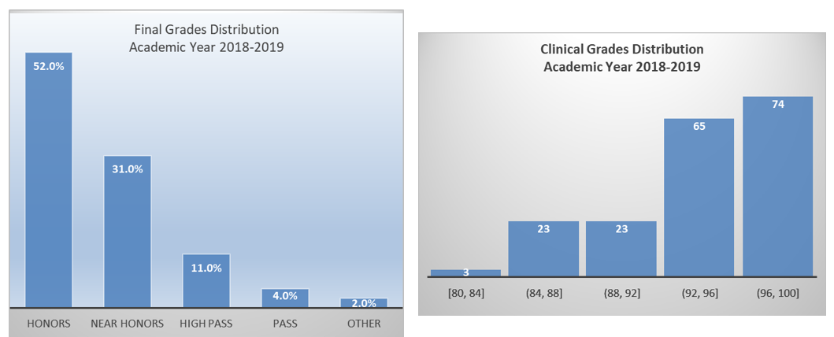

- Written comments: Should include information to contextualize grades, such as if student completed clerkship early in clinical year or if there were special circumstances surrounding performance. Can include condensed representative evaluation comments NOT included in MSPE. (200 words or less)

- Acting Intern Rotation
- Duration and setting: The UT Southwestern Internal Medicine Sub-internship is a 4-week rotation. Students rotate at one site for the duration of the 4-weeks: a general medicine wards service at Parkland Memorial Hospital, Clements University Hospital or the Dallas VA Medical Center or an attending-only hospitalist service at Parkland Hospital or Clements University Hospital.

- Student roles and responsibilities: If on teaching service, students take call with housestaff and admit two to three patients per call cycle. Students take new admissions daily on attending-only hospitalist teams. For each patient they admit, they are required to complete an H&P and submit on EMR, enter orders, write subsequent daily progress notes, complete oral presentations on rounds and write discharge summaries for all patients on their census. The average daily census per student is 3 to 5 patients.

- Student’s grade for the rotation:

- Acting Internship Grading Criteria
- Performance on competency-based workplace assessments by faculty on Entrustable Professional Activities 1-9

- Grade Distribution of Final Grade

- Written comments: Should include information to contextualize grades, such as any special circumstances surrounding performance. Can include condensed representative evaluation comments NOT included in MSPE. (200 words or less)

- Qualifications for IM: Compared to other internal medicine residency applicants at UT Southwestern for this application cycle
- Application of knowledge in clinical setting
Educator Manager Interpreter Reporter

- Teamwork/Accountability (collegiality, professionalism with peers/interdisciplinary team, performs administrative tasks in a timely manner, etc.)
Top 1/3 Middle 1/3 Lower 1/3

- Communication (establishes and maintains therapeutic relationships using effective communication behaviors, mitigates communication barriers, uses respectful verbal and non-verbal communication, etc)
Top 1/3 Middle 1/3 Lower 1/3

- Commitment to personal growth (actively seeks opportunities to improve, seeks performance data consistently with adaptability and humility, challenges one’s own assumptions, etc.)
Top 1/3 Middle 1/3 Lower 1/3
Global Assessment: As a candidate for residency in internal medicine, compared to the cohort of students at UT Southwestern who have completed their IM Clerkship and are applying to any residency specialty this year, this candidate is in the:
Top 10% Top 1/3 Middle 1/3 Lower 1/3

Number of students rated in each category the last academic year:
Top 10% Top 1/3 Middle 1/3 Lower 1/3

Written Comments: Overall assessment of applicant as candidate for residency in internal medicine. Include information to contextualize ranking. Any relevant non-cognitive attributes such as leadership, compassion, positive attitude, professionalism, maturity, self-motivation, commitment to service, likelihood to go above and beyond, altruism, recognition of limits, conscientiousness, etc. Can include comments regarding specific areas of interest or types of environment in which student thrives. Limit 250 words

APPENDICES
APPENDIX A. Statement of Letter Preparation
This letter of evaluation was prepared upon request of the student in support of an application to your residency program. The student has waived their right to review this letter under the Family Educational Rights and Privacy Act (FERPA). The letter was written in accordance with the 2013 APDIM-CDIM Guidelines for Department of Medicine Summary Letters, composed by the student’s primary advisor. The content of the letter is derived from clinical evaluations and comments from faculty and residents from the student’s Internal Medicine rotations (including the Internal Medicine Core Clerkship and MS4 Internal Medicine Sub-Internship or sub-specialty electives if available), their performance on the NBME Medicine Subject Examination, and personal interactions with and assessment of this student. The letter is reviewed by the co-chairs of the Residency Advising Committee, Drs. Reeni Abraham and Stephanie Brinker, and the Chair of Medicine, Dr. Thomas Wang

Rankings are derived from clinical evaluations and comments from faculty and residents from the student’s Internal Medicine rotations (including the Internal Medicine Core Clerkship and MS4 Internal Medicine Sub-Internship or sub-specialty electives if available) and consensus agreement of a residency advising committee on personal interactions with and assessment of this student.
² Has the insight to define important questions to research in more depth and the drive to seek out and scrutinize the quality of evidence behind clinical practice. Identifies knowledge gaps in others and effectively fills those gaps. Transition to educator is usually completed during residency.
Formulates a diagnostic and therapeutic plan independently on common medical problems based on standardized guidelines and evidence-based medicine; able to counsel patients appropriately on the plan of care
Asks questions and performs physical exam reflective of potential diagnoses; Formulates an appropriately broad and prioritized differential; provides appropriate clinical reasoning for current treatment plan; independently evaluates new data to modify their differential
Obtains thorough info from H&P but often asks question in a checklist format; rarely misses pertinent history details; consistently reports findings in organized SOAP format
Lang VJ, Aboff BM, Bordley DR, Call S, DeZee KJ, Fazio SB, Fitz M, Hemmer PA, Logio LS, Wayne DB. Guidelines for writing department of medicine summary letters. AJM. 2013;126(5):458-463.

