Click following link to join “IDUG Virtual” Slack workspace
https://join.slack.com/t/idugvirtual/shared_invite/zt-n4cf3dox-KgvOnRz_l~0o87uwdeib0Q

The main screen !

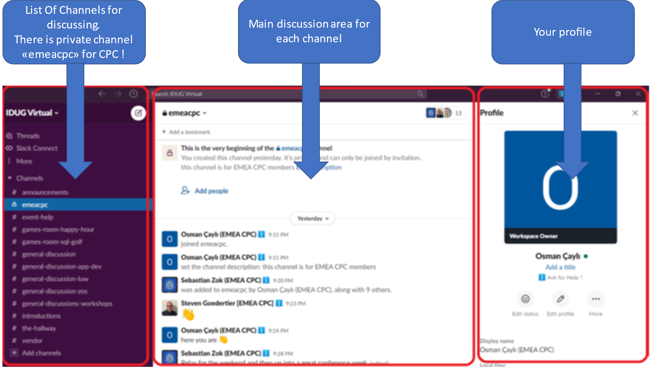

Please change your profile like following :

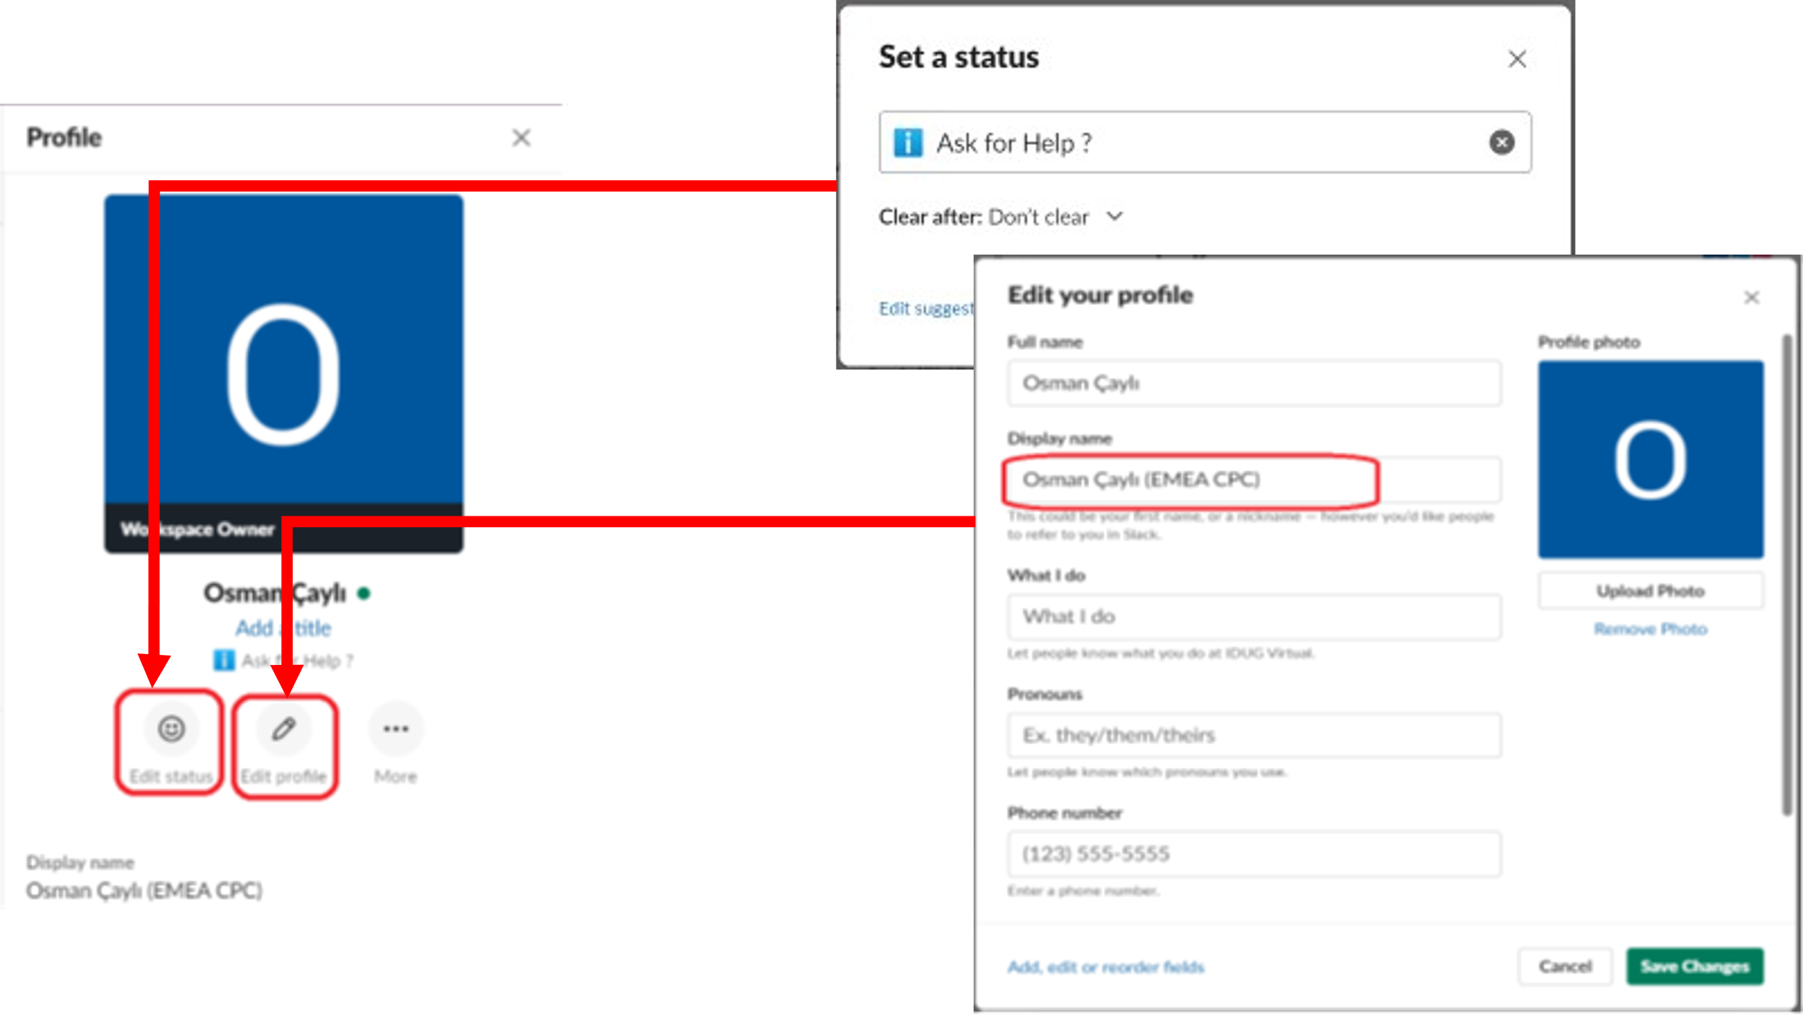

If you want to add a new channel to your workspace :
