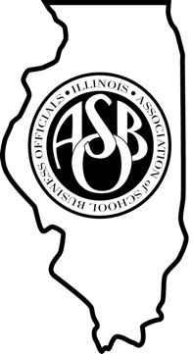

Grant Eligibility Requirements
Application Deadline: October 15, 2022

NOTE: These grant offerings were created to reduce financial barriers that may prevent people from actively participating in the Association and are designed to allow for the most flexibility to support applicants with their desired path.

REQUIREMENTS:
- Must be an active Illinois ASBO member in good standing.
- Recipient grant or scholarship must be used within 12 months.

The following are ineligible to receive any of the following grants/scholarships:
- Members of Illinois ASBO’s Foundation Governance Board
- Illinois ASBO Board of Directors
- Illinois ASBO Headquarters Staff
- Members of the immediate families of those stated above

Applicant’s Full Name, School, Mailing Address, Phone and Email
Race/Ethnicity (check all that apply)
African American/Black ___ Pacific Islander

Asian American ___ White (Non-Hispanic)
Arab/Middle Eastern/North African. ___ A Race/Ethnicity Not Listed
Hispanic/Latino ___ Unknown or Decline to State
What are you interested in using the grant towards? (rank all that apply in order)
___ Illinois ASBO Annual Conference Lodging

___ Illinois ASBO Annual Conference Registration Fee
___ Illinois ASBO Membership Dues
___ Leadership Institute Registration Fee
___ Tuition Assistance in an approved CSBO Educational Leadership Doctoral Program*

___ Other ______________________________________________________________________________

* If you are selected to receive tuition assistance in an approved CSBO Education Leadership Doctoral Program, you will be asked to send a current copy of your transcripts. If you are applying for a scholarship as a first semester NIU student and do not have official transcripts, go to your “MyNIU” account and print the courses you are currently registered for and submit it with your application.

Illinois ASBO Foundation

108 Carroll Avenue – NIU, IA-103 – DeKalb, IL 60115
ph: (815) 762-3360 | fax: (815) 516-0184 | www.iasbo.org

Describe your financial need.

What would receiving this grant mean to you?

Return your completed form by October 15, 2022, to Julie Warner at jwarner@iasbo.org,
fax to (815) 516-0184 or mail ATTN: Julie Warner to the address below.

