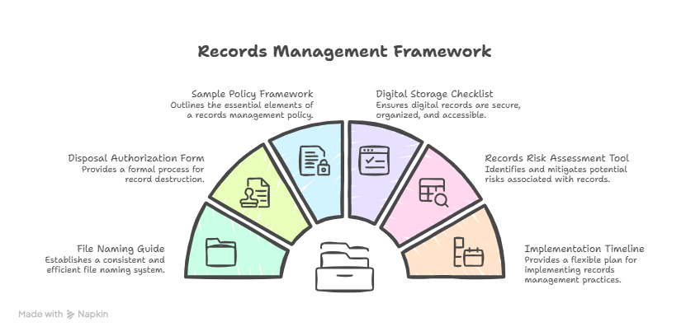
Digital Storage Checklist
- Follows procedure and approved retention schedules.
- Security & Access Control.
- Organization & Structure aligns.
- Searchability & Document Retrieval.
- Storage & Backup procedures in place.
- Digitization standards (indexing occurs at time of scanning, files, are complete, legible and verified.
- Retentions & Disposal Management.
- Department Specific Coverage.
- Proper training and introduction.

