August 28, 2025

Centers for Medicare & Medicaid Services
Department of Health and Human Services
Attention: CMS-1828-P
P.O. Box 8010
Baltimore, MD 21244-1850

Re: CY 2026 Home Health Prospective Payment System rule

To Whom It May Concern:

As President and CEO of the Home Care & Hospice Association of New Jersey, I have read and distributed the CY 2026 Home Health Prospective Payment System proposed rule to licensed home health agencies across every county in the State of New Jersey to solicit constructive feedback for your consideration.

Together, we have concluded that while the rule is valuable in its support of face-to-face encounter flexibility and its endorsement of anti-fraud enrollment screening enhancements, its 9% cut to the 30-day payment rate—which would result in a $1.135 billion decrease in payments for CY 2026 and approximately $36 million in lost revenue for the State of New Jersey alone—comes from a flawed methodology that disproportionately affects Americans’ access to fundamental health care at the later stage of life.

Equitably representing the interests of all New Jersey home health agencies, I offer the following comments urging you to withdraw the proposed 9% cut to the Medicare home health payment rates in the Calendar Year (CY) 2026.

- Rather than utilizing actual market basket data to update rates from CY 2020 through CY 2026, CMS relies on forecasted projections that are frequently inaccurate without thorough review of their reliability. The proposed 9% cuts is a transparent attempt to claw back payments made during 2020, at the height of the pandemic, using outdated data that threatens to undermine the very system that helped so many people to heal at home.
There is no justification for CMS to recoup payments from past years. Many of the agencies that supposedly benefited from overpayments either no longer exist or simply did not see the kinds of gains that CMS is claiming. It is unfair and disconnected from the reality we're living in to penalize both patients and providers for assumptions that were made five years ago, before the global pandemic.
- The proposed cuts fail to reflect current economic realities, including increased labor costs and the rising cost of doing business.
Operating costs for home health agencies are rising. The industry faces higher prices for medical supplies and equipment due to tariffs; increased fuel costs for traveling caregivers; and the impact of inflation on everything from materials to staffing.
Furthermore, the cuts exclude numerous variable costs that are essential to care delivery but not captured in the unit cost per discipline. For example, non-billable visits, mandated by state licensure but not reimbursed under Medicare, are critical to ensuring patient safety and compliance with regulatory standards.

- The proposed cuts would hit agencies from both sides, reducing their resources while also increasing the cost of care.
New Jersey already has one of the fastest-growing aging populations in the country; each year, over 75,000 Medicare beneficiaries in the state receive home health care, and nearly 90% of them live with three or more chronic conditions. These patients depend on skilled support to manage their health and keep their independence.
But home health agencies across the country are already stretched thin by staffing shortages and rising wages. Cuts of this magnitude will cut resources to hire skilled nurses and aids, cover equipment and travel expenses, and deliver frequent high quality home visits.

- While New Jersey agencies support CMS’ initiatives to improve care quality, patients only receive approximately six visits over a 30-day period on average; using a 30-day time period to assess provider performance leads to inaccurate conclusions in patient outcomes.
It is unreasonable to expect patients, particularly those with neurological and cognitive impairments, to return to baseline in a 30-day period. Research shows that 50% of older adults who experience delirium and post hospital syndrome continue to exhibit cognitive changes at three months post-discharge, with some persisting for up to a year. Improvement is most rapid in the first 4-6 weeks. A short span of 30 days and even 45 days is scientifically not reasonable for which to judge the performance of a provider. The patient will not be expected to return cognitively to baseline until after 30 days.

- CMS has a long-standing position that traditional Medicare should not be used to support the managed care industry. At present, however, managed care organizations receive substantial, allowable incentives, publicly reported and showing consistent growth and strong profit margins. The home health cuts therefore disproportionately affect this smaller segment of the health care industry and do not ensure fair policy, quality measures for all beneficiaries, or sustainable reimbursement structures across all delivery models.

Ultimately, home health care reduces hospital readmissions, prevents complications, and gives people the chance to heal where they’re most comfortable. It is one of the most cost-effective forms of care available. Strengthening home health services ultimately saves Medicare money by keeping people out of institutional settings and emergency rooms.

I urge CMS to support changes that strengthen—not weaken—home-based care, the preferred choice for patients and the highest-value option for our Medicare trust fund.

Respectfully,
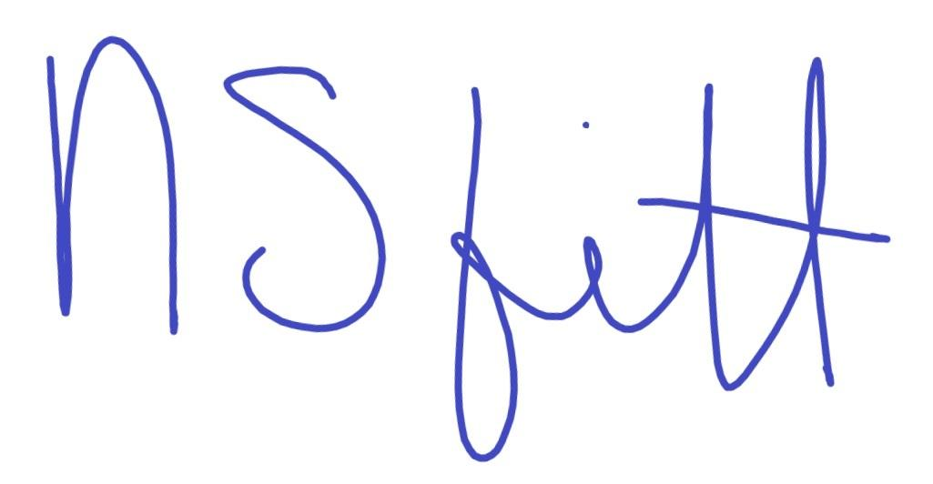
Nancy Fitterer
President & CEO
Home Care & Hospice Association of NJ

