Geological Society of America (GSA),  History, Philosophy, and Geoheritage Geology Division  Student Paper/Poster Award  Recommendation Letter | 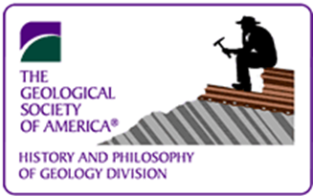

Instructions to referees: Please comment on the applicant's scholarly abilities, the originality of the research, and the applicant’s role in designing and carrying out the research to be presented. Please take as much space as necessary, then email the completed form as an attachment to chill2@boisestate.edu by the 31 August 2025 deadline.

Applicant’s name: | Applicant’s institution:
Referee’s Name: | Referee’s Institution
Referee’s Department: | Referee’s Telephone (with area code):
Referee’s Email: | Date:
Letter of recommendation:

