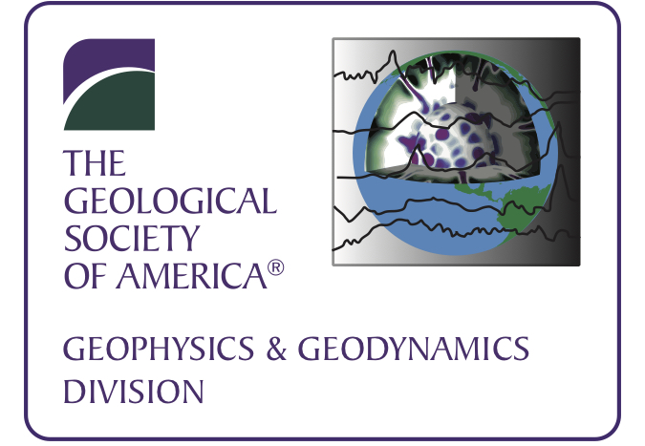 | GSA Geophysics & Geodynamics Division  Newsletter: September 2020

Dear Colleagues:

Opportunities at annual GSA meeting 2020
The 2020 annual GSA Meeting from October 26-30, 2020 will be fully online and open to anyone interested. Join us and your other colleagues!

Important Dates
Registration: now open. (https://community.geosociety.org/gsa2020/registration)
Early registration deadline: September 21
Cancelation deadline: September 28

1) Online, open to all: Tuesday, October 27, 2020 from 5-7PM EDT, the GSA Geophysics and Geodynamics Division Woollard Lecture and Business Meeting

- Dr. Donald Argus, JPL, this year’s George P. Woollard Awardee, will present “Change in water at Earth's surface from GPS elastic displacements and GRACE gravity California drought and Rise of the Great Lakes" Congratulations, Don!
- The Geophysics & Geodynamics Division Business meeting will be held immediately after the Woollard lecture. Our student award recipients this year are
Allan V. Cox Student Research Award:
Brandon Chase, University of Alberta
GSA Geophysics & Geodynamics Division Student Research Award:
Jeng Hann Chong, California State University Northridge
- The 2019 Phoenix, GSA G&G Outstanding Student Presentation Awards:
Emma Blackwell, Arizona State University
Sarah Ann Nolt-Caraway, Northern Arizona University
Awardees will be recognized during online meeting. Congratulations to all!

2) Best student presentation awards for our division.
For the first time G&G Division will award $200 to each for GSA meetings, registration, abstract fees or other conference expenses.
- Students members of G&G are eligible giving a presentation in which G&G is the main sponsor of the session. These seven sessions are listed below.
- We will be sending out a request for non-student members of the G&G division to help judge the presentations.

2021 Election plans
Consider rewarding service as an officer of GSA’s Geophysics & Geology Division.
Positions for Vice Chair and Secretary-Treasurer will be open for the 2021-2023 term, and two student representatives to be appointed for a two-year term. We will request nominations in late Spring 2021.

GSA Awards
Please consider nominating a colleague for GSA recognition:
- Nominations for GSA Fellows due February 1, 2021 (https://www.geosociety.org/GSA/About/awards/GSA_Fellows/GSA/Awards/Fellowship.aspx)
- Nominations for the 2021 Woollard award due February 1, 2021 (http://www.geosociety.org/GSA/About/Divisions/gsa/division/geophysics/awards.aspx)

Fund for Geophysics & Geodynamics Division
Last year our division has established a new fund to support our work. Previously only member dues supported all activities (except for the separate Allan V. Cox Student Research Award fund). Please consider donating when you renew annual membership or at any time during the year.

Our division exists to serve its members. We value your input. Please contact the Division Chair Donna Jurdy, or other officers, or visit our online community forum: http://community.geosociety.org/home

Regards,
GSA Geophysics Division Board
Donna Jurdy, Chair (donna@earth.northwestern.edu)
Ting Chen, Vice Chair (tchen@lanl.gov)
Benjamin Drenth, Secretary-Treasurer (bendrenth@gmail.com)
Carol Stein, Past Chair (cstein@uic.edu)

G&G Division Sponsored Sessions: (Students giving talks in these seven sessions are eligible to be considered for best student presentations.)
- T17: Evolution, Structure and Landscapes of the North Atlantic-Arctic Realm
- T89: Applying Near Surface Geophysics to Solve Geological Problems
- T90: The 2019–2020 Southwestern Puerto Rico Earthquake Sequence and the
Intersection between Geoscience Research, Education, and Communication
- T91: Using Geophysics to Evaluate and Explore for Mineral, Energy, and Groundwater
Resources
- T92: Structure and Dynamics of the Appalachian Orogen
- T93: Lithospheric Structure and Evolution of Cratons
- T94: Induced and Triggered Earthquakes in the United States and Canada

G&G Division Co-Sponsored Sessions:
- T1: The Multidisciplinary Approach of the Seismotectonics as a Key Tool to Expand
Horizons on Faulting Process Understanding and to Address an Effective Seismic
Hazard Assessment
- T2: Assembling Laurentia: Paleozoic Mobile Margins
- T3: Assembling Laurentia: Mesoproterozoic to Early Neoproterozoic Tectonic
Evolution of Laurentia and Its Role within the Supercontinent Rodinia
- T4: Fluids in Faults—The Role of Fluid Activity, Fault-Rock Composition, and
Alteration in the Earthquake Cycle
- T9: Assembling Laurentia: GEON 14 Enigmas and Advances in Understanding the
Crustal Evolution and Paleogeography of the Early Mesoproterozoic North America
- T12: Assembling Laurentia: Neoproterozoic to Cambrian Rifting and Continental
Margin Evolution during Breakup of Rodinia and Pannotia
- T13: Some like It HOT: The Role of Late Extensional Tectonics in Collisional Orogens,
with Special Emphasis on the Grenville Orogen
- T21: The Geology of Induced Seismicity
- T26: Structural Geology and Tectonics Division 40th Anniversary Symposium: Drivers
of Orogenesis
- T30: Assembling Laurentia: Neoarchean Crust Formation and Cratonization
- T35: Building the SZ4D Magmatic Drivers of Eruption Theme: Geologic Evidence from
Active and Exhumed Arcs
- T118: Impact Cratering across the Solar System
- T141: Three-Dimensional Geological Mapping to Support Societal Development.
- T142: Techniques and Results of Paleoseismological and Seismic Hazard Studies of
the Stable Craton of Eastern North America
- T180: Remote Sensing Applications in Hydrology
- T183: Coastal and Marine Hydrogeology in an Age of Rising Seas: From the Shore to
the Oceanic Ridge
- T192: Karst Hazards and Monitoring

Announcement: The U.S. National Committee for Geological Sciences (IUGS) presents the America’s Geoheritage II: Identifying, Developing, and Preserving America's Natural Legacy Distinguished Speaker Webinar Series throughout Fall 2020, many Tuesdays at 11:00 am EDT.
For a list of series webinar dates, topics, and speakers and to register: https://www.nationalacademies.org/our-work/americas-geoheritage-ii-a-workshop .

