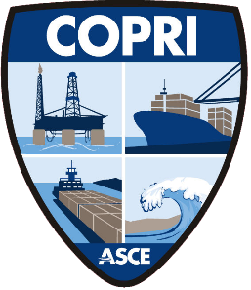
COASTS, OCEANS,
PORTS & RIVERS
INSTITUTE

ASSET MANAGEMENT TASK COMMITTEE
FALL WEBINAR 2020

“Tales of Success Along the Way to Strategic Asset Management”
Tuesday, December 8th
1:00 PM – 3:00 PM (Eastern)
Agenda:

- Welcome and Introduction
  - Erik Stromberg, AM Task Committee Chair and Executive Director, Center for Port Management, Lamar University, Beaumont, TX
- ‘Strategic Asset Management in North American Ports’
  - Ryen Tarbet, US Representative to ISO 55000 and Asset Management SME, SNC Lavalin
- ‘Seaport Asset Management Opportunity - Port of Seattle Asset Condition Tracking Program’
  - Anne Porter, Director of Seaport Project Management, Port of Seattle
- ‘The Winding Road of Asset Management - Port of San Diego’s Asset Management Journey’
  - Christopher McGrath, PE, Manager of Engineering Construction, Port of San Diego
- ‘Sustainability of Ports Infrastructure Assets - A Risk-based Asset Management Framework’
  - Mo Mofrad P.Eng., Project Manager, Vancouver Fraser Port Authority
  - Sean Smith, Asset Management GIS Integration Specialist Engineering, Vancouver Fraser Port Authority
- Wrap-up and Next Steps
  - Erik Stromberg

