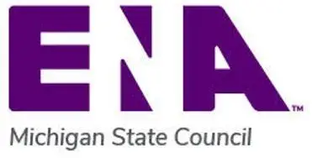
🎤✨ CALL FOR SPEAKERS ✨🎤
🏝️ Michigan ENA 2027 State Conference 🏝️
📍 Mission Point Resort, Mackinac Island, Michigan
📅 May 4–5, 2027
Ready to Inspire Emergency Nurses Across Michigan?
Share your knowledge, stories, innovations, and expertise with emergency nurses from across the state!

🌟 TOPICS OF INTEREST 🌟
👶 Pediatrics 🚑 Rural Medicine ❤️ Critical Care
👩‍⚕️ Human Trafficking and DEI🤝 EMS-Hospital Collaboration
💡 Innovation & Best Practices📚 Education & Quality Improvement

📲 Scan the QR Code or Click the link to Submit Your Proposal!
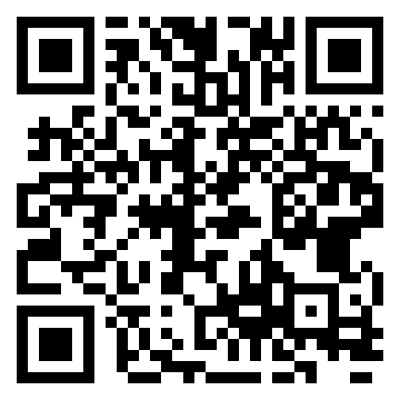
https://form.jotform.com/261543822753156

💜 Take the Stage on Mackinac Island! 💜

