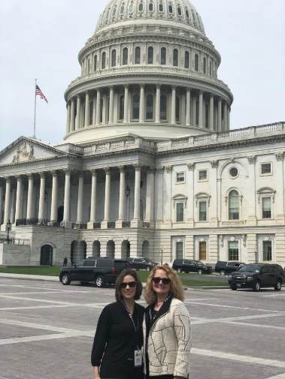
I hope this update finds you all doing well. Mary Berry-Bovia, MENA State President, and Brandi Uren, MENA Government Affairs Chair, attended Emergency Nurses Association (ENA) Day on the Hill in Washington D.C. It was an exciting, fun filled two days!
Emergency Nurses from 47 states advocated on behalf of our 43,000 members and 180,000 emergency nurses across the United States (U.S.). The Michigan delegation had the privilege of meeting with the legislative aides for Senator Debbie Stabenow, Senator Gary Peters and Representative Elissa Slotkin.
ENA advocated for two important bills. The first is the Emergency Medical Services for Children (EMS-C) Program Reauthorization Act – H. R. 776 & S. 1173. This program has been around since 1984 and reauthorized regularly. Its last renewal was in 2014. If this bill passes, it would ensure continuation of this critical program until 2024. EMS-C has made significant improvements in the quality of emergency care delivered to children. The program provides grants to states to help EMS agencies and emergency departments and providers to improve their ability to care for pediatric patients. The grant covers training for not only emergency department staff but also includes EMS providers. The grant also covers Pediatric Emergency Care Applied Research Network (PECARN). “PECARN is the only federally-funded network for pediatric emergency care in the U.S.” (ENA, 2019). According to the most recent data from the ENA, more than 30 million children and adolescents will visit an emergency department this year (2019). If you are taking your child into an ED you want staff to have the right knowledge and equipment to stabilize and transfer to a higher level of care if needed.
The second bill was the Workplace Violence Prevention for Health Care and Social Service Workers Act - H.R. 1309 & S. 851. “The occupational Safety and Health Administration (OSHA) found that although workers in the health care sector accounted for only 20% of workplace injuries, they make up about 50% of all victims of workplace assault” (ENA, 2019). ENA (2019) reports 82% of emergency nurses stated they have been physically assaulted within the past year. There is no national standard in place that mandates healthcare organizations have a plan to address workplace violence (WPV) or programs that prevent violence. The bill would require organizations to develop processes to identify and respond to risks and hazards, implement protocols to document and investigate occurrences, create non-retaliation policies and support colleagues who report WPV and ensure staff have adequate training.
The federal bills have shown increasing bi-partisan support, and the ENA estimates that their chances of passing the House and Senate is promising.
Here in Michigan, we still have lots of work to do regarding WPV. There are currently two WPV bills in the House and Senate. The house and the senate bills each take a very different approach.
House Bill # 4327 and #4328, introduced by Rep. Hank Vaupel (Livingston County) remains in the Judiciary Committee. These bills would make it a felony to assault, batter, wound, or endanger a health professional or medical volunteer. A hearing was held on April 23, 2019. Testimony was heard, though no vote was taken. The ENA offered support during the hearing. Legislators expressed had concerns regarding the mandatory felony penalty imposed and the bill’s future remains uncertain. Now is a great opportunity for all MENA members to reach out to their Michigan House of Representatives members and tell them how WPV affects their everyday lives and how it impacts patient care. MENA and other stakeholders will continue to engage with legislators to address their concerns to ensure the protection of everyone on the front lines of health care.
Senate Bill #80 introduced by Sen. Horn remains in the Senate Judiciary and Public Safety Committee. There have been no hearings to date. Bill #80 would also make assaulting a health care worker a felony; however, it includes only those health care workers employed in the emergency department and trauma department.
For change to occur on WPV, it will take a coordinated effort from all of us reaching out to our legislators. The message should be to ask your representatives to cosponsor HB 4327 and HB 4328. While you may not have time to visit Lansing, or meet with legislators in their districts, please consider calling their office which takes less than five minutes. If you are hesitant to speak to someone directly, consider sending an email and ask your representative to cosponsor HB 4327 and HB 4328. There are many options to utilize.
Emergency nurses know how to get things done. We have continued to care for our patients despite the increased frequency of assault and workplace violence. We should not accept this. We must act to protect ourselves, our colleagues and our patients. It’s time to Speak Up! If you would like to attend a coffee hour but scared to go alone please contact Brandi Uren brandi.s.uren@gmail.com OR Naomi Ishioka nurseomi@comcast.net we would be happy to attend with you!
Take action today!
Brandi Uren
Government Affairs Chair MENA

