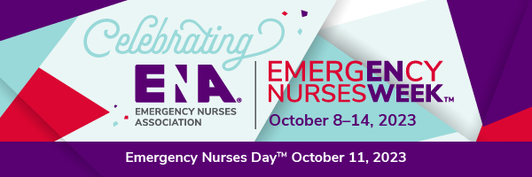
Hope you have a Happy Emergency Nurses Day!
As you know, that day is the kick off for the “Maryland ENA 2024 Outstanding Emergency Nurse” program. In preparation for this, we need everyone to sign up to distribute the applications in person to the emergency departments of each Maryland hospital.
We have included the list of each hospital and the address. As soon as you decide which hospitals you will visit, please check with Caroline Doyle to make sure no one else has signed up to visit them. Once she verifies that they are still open, your name will be assigned to those hospitals and they can be removed from the list so no one else visits.
When you deliver the application it should be printed on a brightly colored paper to post in the emergency department staff area. A second paper will be placed in an envelope with the name of the nurse manager for the charge nurse to deliver to that manager. The charge nurse will need to share the name of the nurse manager with you. I have attached a form for you to use for this information if you prefer.
After the delivery to the hospital, please text or email Caroline Doyle your completed form or
- the date of delivery
- the name of the charge nurse and
- the name and contact information (email and phone number) of the ED nurse manager
This information will be used for follow up to encourage that a nomination will hopefully be sent from each hospital. If you travel over 25 miles for this delivery, please include your mileage so that you may be reimbursed. If you are unable to print the announcement and application, please notify Pam Fox at foxprn@erols.com and a packet of these materials to distribute will be mailed to you.
The target date for completion of the hospital deliveries is January 15th, 2024. If you have any questions, please contact Caroline Doyle at rnnuclear@msn.com or Pam Fox.
Thank you and we look forward to a finding an awesome nurse who deserves this award.
Nurse Recognition Award Information ED Hospital Delivery
Hospital Name | Charge Nurse | Nurse Manager | Mgr Phone # | Manager Email

