Meeting Minutes
Friday, August 14, 2026
Teams Link will be emailed for Virtual attendance
Attendance: See below
- Call to Order – at 1001
  - Establish Quorum – Quorum was established according to by-laws

  - Welcome/Introductions – Dawn Day

  - Adoption of Meeting minutes from May
Discussion/Summary: none
Motion: Larry Faulkner
Action: Accepted with correction of the spelling of “Riedel” in Committee reports, ENPC Instructor course was held in Rolla not ENPC Provider course, and correction of spelling of membership in Education committee report.

  - Conflict of Interest Disclosure
Discussion/Summary: None

- President’s Report – Jeanne Fogarty
  - October meeting site – suggestions and feedback given on locations for the meeting

- Treasurer’s Report – Provided by Larry Faulkner, Treasurer. See Attached report. Taxes were filed and paid.

- ENA Board Update – provided by Ben Coe since Shante is not on the meeting. Reminder about EN26 in Phoenix. Emergency Nurse’s Week is October 11 – 17. Registration is open for the EN Week 5K. An Emergency Nurse Week planning guide is available on ENAs website. More information coming about Forensic Nurse’s Week in November. 2027 Leadership Conference Jan 28-29 in Schaumburg. ENA offers many awards that can be found on the website. Updated on the CEO search for National ENA goal is Sept 2026.

- Committee Reports and Discussion–
  - Compliance – Report by Angie Boren – Committee is working on the finance/investment policy, social media/communication policy, and creating a scheduled to review all policies. Reviewing examples from other state’s policies to brainstorm. Goal is to have the finance and social media policy posted in time for approval at October business meeting
  - Trauma/Pediatric – Report by Kristin Dawson – Updated on committee goals and how they were met. ENPC course on October 28-29 in Macon, MO. Two ENPC courses in Freeman and Macon are hosted in collaboration with Missouri EMS-C.
  - Education – Report by Kate Iden – Reviewed committee goals; recapped education to date for the year; currently accepting submissions for our poster presentation contest; ED collective is becoming a great platform for ED leaders to share ideas, best practices, and ask questions. See attached report.
  - Government Affairs – Report by Samuel Shaefer – Tracking multiple bills from inception; Shout out to David for all of his work in government affairs and presence in Jefferson City. See attached report.
- QSIP/ Nursing and Advanced Practice – Report by Rachel Kestner – Suture course will be held on November 6th in Kansas City. Waiting for information to be emailed for helmet safety and pediatric injury prevention to upload to the website. Working on a date for a Stop the Bleed course.
  - Marketing/PR – Report by Jeanne Fogarty - Prepping for GA 26 table giveaways. Working on a t-shirt contest for EN 27 in Kansas City; will start after returning from EN26. Decision made to send Christmas cards again this year. Increasing marketing and exposure on Facebook, ask for all members to like the Missouri Emergency Nurses Association page and share everything.
  - Membership – Report by Rachel Kestner – 703 members currently, numbers increasing steadily. The scholarship application is open until tomorrow; only 4 applicants. Looking to plan an awards ceremony but may have to shift gears on planning since we do not have a location for the October meeting. Continue to work on the mentor program, need someone to take the lead.
- Unfinished Business
  - Membership discount code
    - Special Group Membership Discount Code: MOENAGR26 (case-sensitive, no spaces)
    - Eligible Membership Packages: National and International Member - 1 Year Membership option only
    - Discount Amount: $35
    - Discount Code Valid: until 12/31/2026
    - Process for the nurses: Create an account/Login to www.ena.org and enter the discount code at checkout

- New Business
Appointee to the committee on Sex and Human Trafficking – House Bill 2273 resulted in the development of a committee on sex and human trafficking training. Committee includes people from the House of Representatives, the Senate, the Attorney General’s office, schools, MHA, and other organizations. Missouri ENA was invited to the table. The committee is being appointed by the governor. Lana Garcia was asked to be the MOENA representative on this committee and her name was submitted to the Attorney General. MOENA Board discussed creating a forensics committee.
2027 Open Board positions – Nominations are open for President – elect, Treasurer – elect, and Director-at-Large. Submit nominations to Angie by Sept 8th. Election will be held Sept 14 – Oct 5. Kelly Reidel was nominated for Treasurer-Elect.
ENPC Update – ENPC 6th edition is sunsetting at the end of the year. All instructors, course directors, and faculty will receive information about updating to the next edition within the next month.
General Assembly – call for any discussion concerning any of the resolutions in the GA Handbook for the delegates to consider. Request to send feedback on any of the resolutions to the MOENA President to share with the delegates representing us.
  - 2026 Meeting dates:
    - Feb 13th – Teams Only Meeting (1000-1300)
    - May 8th – In-person/Teams Meeting (1000-1300)
    - August 14th – Teams Only Meeting (1000-1300)
    - Oct 23rd – Strategic and Business Meeting In-person/Teams Meeting (0900-1200 & 1300-1500)
- Open Discussion - none
- Next Meeting: as above
- Meeting Adjourned – 1140

Respectfully submitted

Angela Boren
Immediate Past President

Members Present
Kate Iden
Angie Boren
Jeanne Fogarty
Kelly Reidel
Larry Faulkner
Lori Unruh
David Barnes
Rachel Kestner
Marie Frankenbach
Elli McDaniel
Nina Arnold
Samuel Shaefer
Viktoriya Stoycheva
Haley Strebler
Summer Thorp-Lancaster
Suzanne Weckman
Tracy Swetokos
Brooke Wilson
Amanda Dalton
Celeste Clelland
Carol Cleek
Ben Coe
Craig Foster
Kristin Dawson
Dawn Day
Beth Decker
Tom Emery
Jessica Elliott
Julie Robinson
Laura Wilson

Treasurer’s Report 08/10/2026
Submitted by: Larry Faulkner Current Balances (as of 08/10/2026)
Asset Accounts | Balance
Checking | $130,696.94
Money Market | $47,976.12
CD 4101 | $104,740.64
CD 4135 | $105,052.21
CD 4168 | $104,562.71
TOTAL Assets | $493,028.62

Since May 1, 2026 the following income was received:
Account | Total
Interest Income | $2,345.81
Course Operations | $20,425.00
Membership | $1,935.00
TOTAL INCOME | $24,705.81

As of May 1,2026, Current liabilities are:
Account | Total
Central Billing Account | $76.16
TOTAL Liabilities | $76.16

Expenses that have occurred since May 1, 2026 were:
Account | Total
Course Operations Expenses | $270.00
Finance | $265.70
General Assembly | $5,195.00
Gov’t Affairs | $3,946.58
Marketing | $126.16
Meals | $54.96
Membership | $155.73
TOTAL EXPENSES | $10,014.13

Meeting: | MOENA Education Committee
Date | August 14, 2026
Time | 10-1:30pm
Location | Virtual
Chair/Co-Chair:  Kate Iden  Julie Scovronski | Members:  Kelly Reidel  Pat Clutter  Jesse Godec | Dana Rolland  Craig Foster  Kendra Hagar  Summer Thorp-Lancaster  Shaylee Patterson
2026 Committee Goals
- Offer 2 certification review courses
- Offer 5 virtual education opportunities – “MO ENA Happy Hour”
- Provide education at one MOENA State Council meeting
- Host MOENA Virtual Poster Presentation in October
- Offer quarterly roundtable discussions for ED Leaders and Educators
Report: | - Certification Review Course - TCRN  - CEN Review held 3/18/26- 23 participants  - Virtual TCRN Review  - November 11-12, 2026  - Instructor Justin Milici  - Registration is open, Flyer posted on Facebook and MOENA website  - MO ENA Happy Hours  - Feb, April, and June Happy Hours completed  - Oct 13, 5-6pm – Self-care for Healthcare Providers  - Brittany Siddens  - Dec 8, 5-6pm – Trauma Case Studies  - MOENA State Council Meeting Education  - May Meeting – Restraint care and documentation  - August Meeting– 1:30-3:30pm  - Forensic Nursing Education – Kendra Hagar  - MOENA Second Annual Poster Presentation  - 2nd Annual Poster Presentation will be held in October  - Poster submission is open - due by 9/25/26  - Flyer posted on Facebook and MOENA website  - ED Leaders and Educators – “The ED Collective”  - Future Dates  - 9/3, 12/3  - 1:30-3:30pm
Flyers: | 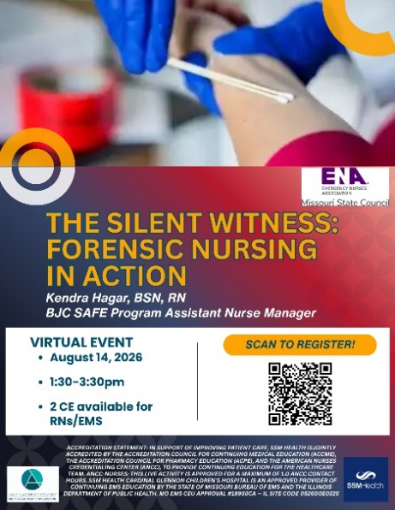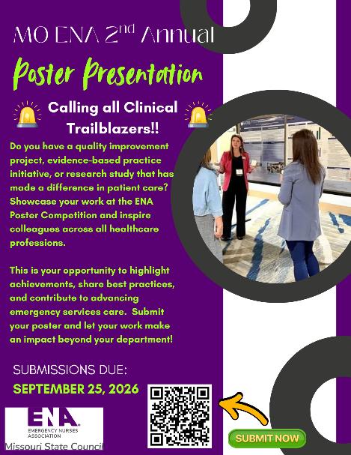  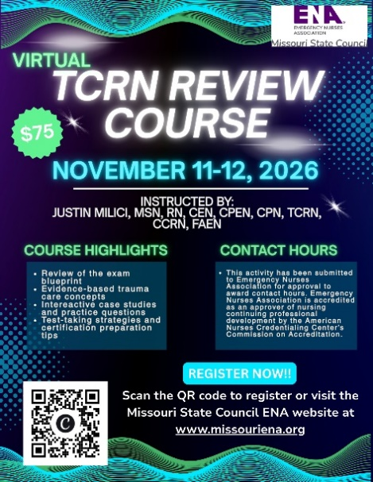

Report: Missouri ENA Government Affairs Committee, Aug 2026
Government Affairs Committee Report
Session Overview
So far, 2026 has been a solid year. We tracked multiple bills from their inception this session. Many didn’t make it all the way through—some only got a first or second read, while others got stuck in committee and never made it out. But we had real wins and significantly boosted our presence in both Jefferson City and D.C.
Shout-Out to David
Before getting into the bill highlights, I want to give a huge thank-you to David. He has essentially acted as our unofficial legislative aide and lobbyist this year and has done an amazing job.
- Jeff City Presence: Since he lives close, he made multiple trips to Jefferson City—far more than the rest of the group combined—and took that on willingly.
- Direct Access: He had multiple hallway chats with senators and representatives and got into a few closed-door meetings we wouldn't normally have access to, simply by being on the floor so often.
- DC Outreach: On top of that, whenever he traveled to DC for other things, he made time to drop by our national representatives' offices.
We wouldn't have gotten our name in front of nearly as many offices this year without him, so please show him some love!
Missouri State Legislative Highlights
- Major Legislative Win (Hospital Signage):
  - Rep. Phelps’ language requiring mandatory workplace violence warning signs in hospital ED and Labor & Delivery waiting rooms was included in the omnibus healthcare bill (HB 2372) and signed into law by the Governor. It goes into effect August 28.
- Assault in the 4th Degree (HB 2072):
  - For Rep. Phelps’ HB 2072, there was a party-line vote coming out of committee. David is checking in with a local representative about their specific objections so we can see where compromise or cleanup language might be needed for next session. (We are also keeping an eye on HB 2070 and HB 3401).

- SANE Advocacy & MOCADSV Connection:
  - David connected with the Missouri Coalition Against Domestic and Sexual Violence (MOCADSV) after the hearing for Rep. Williams’ HB 3434 and met with them.
  - This coalition connects with several state agencies and is a really valuable partnership for our SANE members.
- Other Bills on Our Radar:
  - Rep. Crossley’s HB 2088 and Rep. Byrnes’ HB 3457 both need our direct clinical feedback and input as a committee.
- Helmet Law:
  - The motorcycle helmet safety effort with Maureen Cunningham didn't gain traction this session, so we’ll need to re-evaluate our approach there.
Federal Level & D.C. Outreach
- Sen. Josh Hawley’s Rural Hospital Bill (S.4927):
  - Hawley’s office contacted us directly to read over draft language before the bill was proposed.
  - They moved fast and didn't use our suggestions, but being invited to the table during initial drafting is huge and shows our follow-ups are making a difference.
  - David attended the press conference, sat right behind the speakers, and connected directly with Hawley’s staff and other Missouri healthcare stakeholders.
- Meetings with Congressional Staff:
  - Met with the Legislative Assistant for Rep. Sam Graves to follow up on our April asks and pitch our three core bills.
  - Met with Legislative Aides for Rep. Wesley Bell and Rep. Jason Smith to pitch our core bills, the Hawley rural hospital bill, and Tyler’s Law.
- Office Drop-Ins:
  - Dropped off bill packets at the offices of Rep. Emanuel Cleaver II, Rep. Eric Burlison, Rep. Mark Alford, and Sen. Eric Schmitt.
Next Steps
- Comb through the other bills signed by the Governor this session to see what else impacts emergency nursing.
- Stay in contact with our partners at MOCADSV to align our SANE priorities.
- Prepare our priority list and draft language ahead of pre-filing for the 2027 session.

Appendix A:
The Bill Number Breakdown
- S. 4927 (Federal): Sen. Josh Hawley’s Rural Hospital Emergency Room Guarantee Act
(introduced June 24, 2026).
- HB 2372 (State Omnibus): The large healthcare bill signed into law on July 13, 2026, containing the mandatory ED/L&D hospital workplace violence signage provision.
- HB 2072 (State): Rep. Phelps’ bill modifying Assault in the 4th Degree for special victims/healthcare workers (the one with the 8–3 Rules committee vote).
- HB 2070 (State): Rep. Phelps’ bill on infectious disease exposure notification for healthcare workers and first responders.
- HB 3401 (State): Rep. Phelps’ healthcare workplace violence prevention bill.
- HB 3434 (State): Rep. Cecelie Williams’ statewide sexual assault response bill (the one MOCADSV worked heavily on).
- HB 2088 (State): Rep. Aaron Crossley’s court-ordered involuntary outpatient mental health treatment bill.
- HB 3457 (State): Rep. Tricia Byrnes’ medically complex pediatric patients bill.

