

NIGHT OF EDUCATION
OCTOBER 23, 2025 @ 1930

Mistake or Murder? Examining Cases of Nurses Charged with Crimes
Presented by:
Dr Gina Slobogin
DNP APRN FNP-BC NHDP-BC NEA-BC PGMT-BC BC-ADM TCRN CEN CPEN CFRN CTRN PHRN
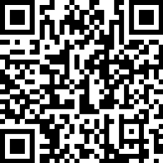
https://us02web.zoom.us/j/87627006331?pwd=6gcM2nRhbzB1cRXoyCB5j0wtw49UQg.1

