Session Prerecord Instructions for Zoom

As mentioned in previous communications, IDEA requires that all presentations provide us with a prerecorded version of their presentation. The prerecorded version will be available to all attendees to view (in case they missed your presentation), increasing your visibility.
The good news is you do not have to be Steven Spielberg or hire a film crew to produce your prerecorded session. One of the easiest ways to record is to utilize the recording options available in Zoom.
Scheduling and recording Zoom calls/meetings is how IDEA has recorded dozens of webinars over the past five years with great success (not to mention hundreds of presenters at past IDEA conferences). Here’s an example of an IDEA webinar, complete with speaker and slide share. This webinar is a good example of how your recording should look, with slides taking up most of the screen and the presenter on the side, preferably not covering the slide content.
This will be our 8th conference with presenters providing a prerecord of their presentations. While most use Zoom, we are also seeing more individuals use Microsoft Teams, and some recording directly in PowerPoint (with video share, for single presenter only). If you click on either link, you’ll access instructions on how to record in either platform. If you feel more comfortable – and are more familiar with – these recording options or others, that’s perfectly acceptable.
In the end, however you choose to record your video, it should include both presenters and slides onscreen, with the recording delivered to IDEA in .mp4 format. As you record, we strongly suggest recording a test run of a few minutes and view it to make sure the settings/look/feel/audio/video are what you hope they will be.
This document features instructions for recording your presentation in Zoom. As Zoom is ubiquitous to so many of us now, we won’t go into the particulars of setting up a Zoom account. If you need assistance in setting up a Zoom account or are not familiar with the platform, please contact Jason Beal directly at jason.idea@districtenergy.org.
This document will provide instructions on how a presentation featuring a single speaker should record their presentation in Zoom, followed by brief instructions on how to make it happen with multiple presenters (many of the instructions are the same).
Where to upload: When you have finished recording, you will upload the video into Education Harvester, as you did your PPT files.
Once you have completed your recording, we encourage you to edit the file yourself (if you have a bit at the beginning or the end that needs to be cut off). If you have any questions about editing, please contact Jason Beal at jason.idea@districtenergy.org.
If you already know how to record your session using Zoom, you do not have to review this document. However, we highly recommend that you make sure your ‘share screen settings’ are set to have slides and speaker screen side by side (see section 7 of this document).

Single Presenter – Zooming with Yourself (with Slide Share)
These instructions are for those recording their session on a computer where you are only utilizing one computer screen to work Zoom and their slides (not using dual screens).

- First, we recommend getting your slides ready to go first. Bring up your PPT slides on screen, go to “Slide Show” on the top menu bar, and then make sure the “presenter view” is not selected (yellow arrow); once deselected, click the ‘start slide show’ icon (blue arrow).
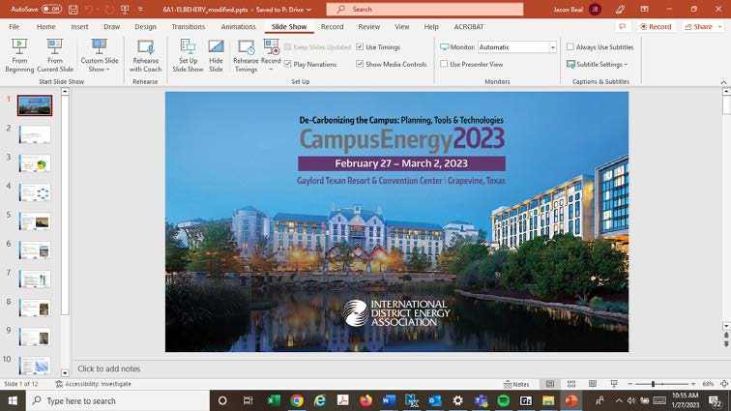

- After hitting ‘start slide show’, your entire screen is likely to be filled out with the first slide from your PPT. If so, to ensure you can access Outlook and PPT easily, right click on your computer screen and select “Screen – Show Taskbar”. The icons of applications you have open should appear.


- Log in to your Zoom account. Helpful hint - if you have Zoom integrated with your Outlook account, in Calendar View select “Start Instant Meeting’; select with Video On.

- Screen refreshes to the Zoom interface, click ‘ESC’ button on your computer so that Zoom doesn’t cover your full screen.

- On the Zoom menu bar, you’ll see the Share Screen button (illuminated in green) and the record button to the right of it. You’ll also see the Mute and Share Video buttons on the far left.
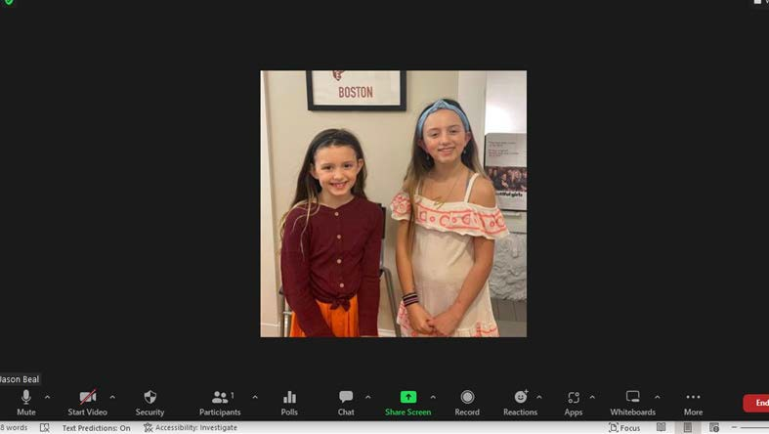

- Next, you need to make sure that the speaker/camera view does not spill over the slides, obscuring content. Click the ^ carrot in the “Start Video” box, and select “Video Settings”

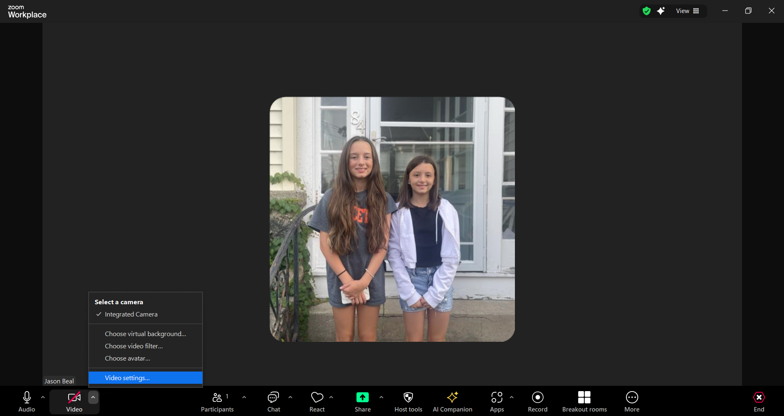

- Then go to the ‘Share Screen’ option on the menu bar and make sure ‘Maximize Window” is selected, along with “Scale to fit shared content to Zoom window” and “side by side mode” and “silence system notifications when sharing desktop”. In addition, “Share individual window”, “Show all Sharing Options” should be selected (those are likely default settings anyway).

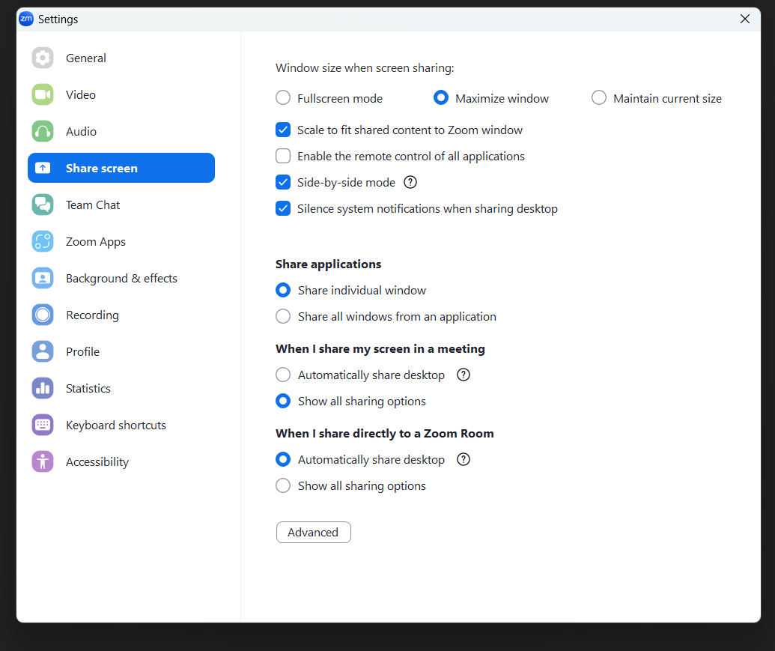
- After exiting “video settings”, we recommend that you share screen before you start recording, your screen will refresh as seen below. Make sure you select the PPT file that has your slides as you would want them to appear on screen (the window with the PPT icon in the bottom right corner- not your screen).
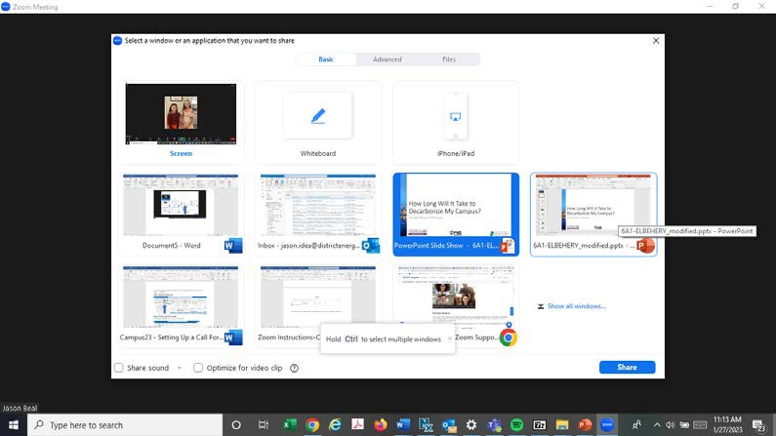

Your screen will refresh with the Zoom menu bar showing up in the middle of your slides (you may need to hover over it to see it)
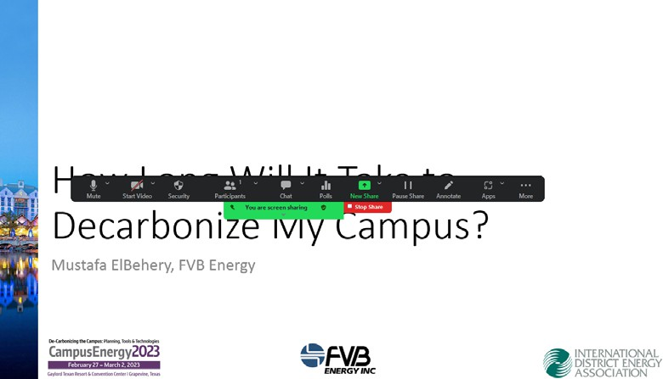
From there you can click on the “…More” button on the far-right corner of the menu bar and select the “Record to the Computer” option (this will save the .mp4 file to your local computer, in your C drive, under the Zoom folder).

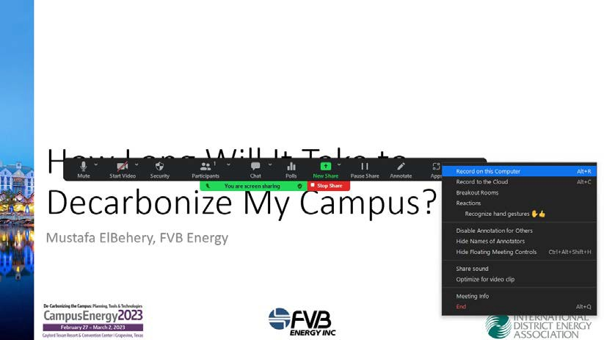

Once you hit the record button, you’re ready to go. Your image should so up on screen (don’t worry where your image shows up on screen, it will not record the image on screen in that part of the screen)
You can then start your presentation, using your mouse clicker or forward button to advance the slides on your screen.
Once you’re done, you can end the meeting and Zoom should save the file automatically to your C drive, in the Documents/Zoom folder. Review the files and make sure the video and audio are good.
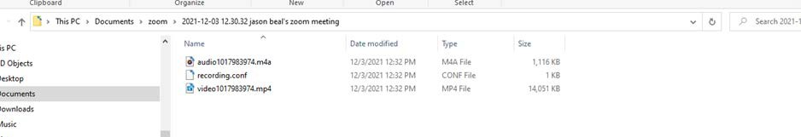

We strongly recommend a test run of a minute or two before recording your entire presentation.

Multiple Presenters – Setting Up a Zoom Call (with Slide Share)
If you have a dual screen set up on your computer - the instructions are basically the same, except you have more control over moving screens around, and you can view your slides in ‘presenter mode’ (the version that allows you to view your notes) on one screen, while sharing the regular screen through Zoom (do not share the “Presenter Mode” when sharing slides.
If you are recording a session with multiple presenters, you simply need to schedule a Zoom meeting with all the participants, establish who will screen share the slides and have someone in the group record the meeting.
We strongly recommend having one presenter move the slides as handing control back and forth between presenters can be clunky.
Scheduling a Zoom Meeting with Multiple Presenters through Outlook
- Once everyone is logged into the meeting, test audio/video for each presenter.
- Bring up your PPT slides on screen, go to “Slide Show” on the top menu bar, and then make sure the “presenter view” is not selected (yellow arrow); once deselected, click the ‘start slide show’ icon (blue arrow).

- After hitting ‘start slide show’, your entire screen is likely to be filled out with the first slide from your PPT. To ensure you can access Outlook and PPT easily, right click on your computer screen and select “Screen – Show Taskbar”. The icons of applications you have open should appear.

- On the Zoom menu bar, you’ll see the Share Screen button (illuminated in green) and the record button to the right of it. You’ll also see the Mute and Share Video buttons on the far left.

- Next, you need to make sure that the speaker/camera view does not spill over the slides, obscuring content. Click the ^ carrot in the “Start Video” box, and select “Video Settings”

- Then go to the ‘Share Screen’ option on the menu bar and make sure ‘Maximize Window” is selected, along with “Scale to fit shared content to Zoom window” and “side by side mode” and “silence system notifications when sharing desktop”. In addition, “Share individual window”, “Show all Sharing Options” should be selected (those are likely default settings anyway).

- After exiting “video settings”, we recommend that you share screen before you start recording and your screen will refresh as seen below. Make sure you select the PPT file that has your slides as you would want them to appear on screen.

- Screen will refresh with the Zoom menu bar showing up in the middle of your slides (may need to hover over it)
- From there you can click on the “…More” button on the far-right corner of the menu bar and select the “Record to the Computer” option (this will save the .mp4 file to your local computer, in your C drive, under the Zoom folder).

- Once you hit record, you’re ready to go. All presenters should show up on screen at along with the slides (don’t worry where your image shows up on screen, it will not record the image on screen as it’s located; your image should be on the side).
You can then start your presentation, using your mouse clicker or forward button to advance the slides on your screen.
Once you’re done, you can end the meeting and Zoom should save the file automatically to your C drive, in the Documents/Zoom folder. Review the files and make sure the video and audio are good.
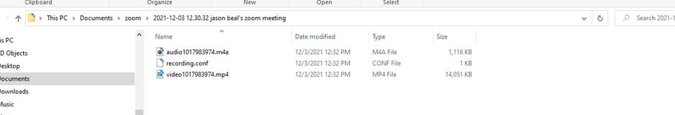

We strongly recommend a test run of a minute or two before recording your entire presentation.

