Financing Our Energy Future Act
A bipartisan bill to level the playing field for clean energy projects by giving investors access to a decades-old, tax-advantaged corporate structure currently only available to fossil fuel-based energy projects.

At a time when the United States needs to increase domestic energy production and leaders of both political parties say they support an all-of-the-above energy strategy, Congress should level the playing field and give all sources of domestic energy a fair shot at success.
“Master limited partnerships carry the fund-raising advantages of a corporation: ownership interests are publicly traded and offer investors the liquidity, limited liability and dividends of classic corporations. With average dividends of just 6 percent, these investment vehicles could substantially reduce the cost of financing renewables.”
– Dan Reicher and Felix Mormann, Stanford University’s Steyer-Taylor Center for Energy Policy and Finance, New York Times, June 2, 2012
The federal government should not be in the business of picking winners and losers in the energy market, but for more than 30 years, that’s exactly what it has been doing with a provision in the tax code that authorizes the formation of master limited partnerships (MLPs).

By statute, MLPs have only been available to investors in energy portfolios such as oil, natural gas, coal extraction, and pipeline projects. Because their units can be publicly traded, these projects get access to larger and more liquid sources of capital than are available for traditionally financed energy projects. Investors in clean energy projects, however, have not been authorized to form MLPs, starving a growing portion of America’s domestic energy sector of the capital it needs to build and grow. By allowing additional forms of energy to access this market tool, we can go beyond political rhetoric and start delivering an all-of-the-above energy strategy.

How do master limited partnerships work?
An MLP is a business structure that is taxed as a partnership, but whose ownership interests are traded like corporate stock on a market. Whereas profit from publicly traded C corporations is taxed at both the corporate level and the shareholder level, income from MLPs is taxed only at the shareholder level because it is treated as a partnership for tax purposes.

Because MLPs are so attractive to investors, they have been proven to bring new capital into American energy projects. This is especially important in the case of renewable energy generation, where projects are often dependent on high-interest financing and it is harder for investors to see as quick a return as compared to fossil fuel-based generation, for which much of the processing and transportation infrastructure was built decades ago. Constructing the same level of critical infrastructure for renewable energy sources will take time and investment. Given that, the Financing Our Energy Future Act levels the playing field and helps address that problem.

How the Financing Our Energy Future Act helps
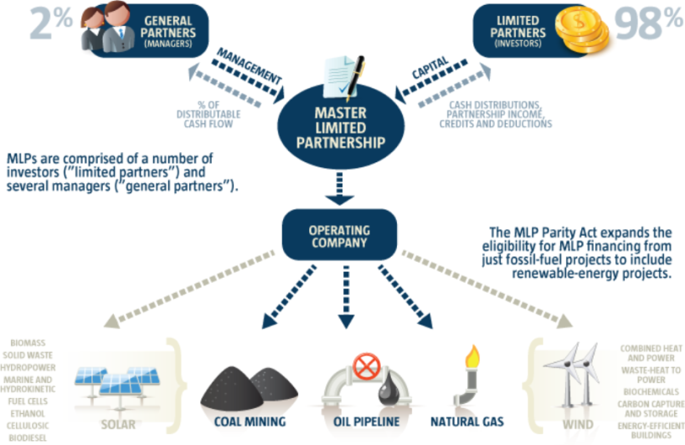
Currently, an MLP must generate at least 90 percent of its income from qualified sources, such as real estate or natural resources, including crude oil, natural gas, petroleum products, coal, timber, and other minerals.

The Financing Our Energy Future Act simply expands the definition of “qualified” to include clean energy resources and infrastructure projects. Specifically included are those energy technologies that qualify under Sections 45 and 48 of the tax code, including wind, closed and open loop biomass, solar, municipal solid waste, hydropower, marine and hydrokinetic power, fuel cells, and combined heat and power. The legislation also includes waste-heat-to-power; energy storage; carbon capture, utilization, and storage; renewable chemicals; and energy-efficient buildings. Finally, the legislation allows for a range of transportation fuels to qualify, including cellulosic, biodiesel, and algae-based fuels.

The Master Limited Partnership Association estimates there are approximately 125 MLPs currently being traded on major exchanges primarily focused on energy-related industries and natural resources. Of the estimated $460 billion in MLP capital currently in the market, approximately $370 billion (or about 80 percent) is from businesses involved in qualifying energy and natural resource activities. Of that, approximately 90 percent relates to energy midstream and infrastructure.

The legislation is a powerful tweak to the federal tax code that could unleash significant private capital into the energy market. It would level the playing field between traditional and new energy businesses by helping energy projects form MLPs, which combine the funding advantages of corporations and the tax advantages of partnerships.

IN THE SENATE: | IN THE HOUSE:
Senator Chris Coons (D-DE)  Contact: David Brown  202-224-5042 or David_Brown@coons.senate.gov | Rep. Mike Thompson (D-CA-05)  Contact: Miriam Wheatley  202-225-3311 or Miriam.Wheatley@mail.house.gov
Senator Jerry Moran (R-KS)  Contact: Jordan Ebert  202-224-6521 or Jordan_Ebert@moran.senate.gov | Rep. Ron Estes (R-KS-04)  Contact: Nicholas O’Boyle  202-225-6216 or  nicholas.o'boyle@mail.house.gov

