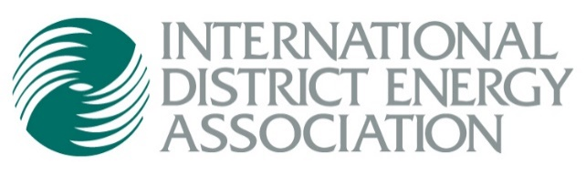
1800 West Park Drive, Suite 350
Westborough, MA 01581
Phone +1 (508) 366-9339
Fax (508) 366-0019
idea@districtenergy.org
www.districtenergy.org

How to Submit Data for District Energy Space
Submission Deadline EXTENDED: Friday, August 13, 2021
- Please download the appropriate District Energy Space Submission Form for your organization. The form is in Microsoft Excel format. Note that the first line item is provided only as a SAMPLE guide to the type of information requested in each cell of the form:
  - 2020 North America Submission Form
  - 2020 Beyond North America Submission Form

Identify buildings that committed or renewed district energy service during the previous calendar year including the following information:
- Building Name, Location and Service Contract Type (New or Renewed*)
- Total Building Area Added (sq. ft.): Please include all residential villas, flats or apartments as one complex. (Example: “Wolf Run” may contain 200 villas, flats or apartments, but is entered as one building complex named “Wolf Run.”)
- Area Served by Building Type – Re-enter Building Area (sq. ft.) corresponding to each building type
- Services provided – Check all that apply; space heating, space cooling, domestic hot water, humidification, process, kitchen, refrigeration, other (examples: laundry, ice-making, pool warming, etc.)

- Please save the completed Excel spreadsheet with your organization’s name and year. For example: “ABCEnergy-2020.xlsx”

- Please save a separate spreadsheet for each operating region or state.

- Please send photos! Be sure the filenames of your photos include the organization and building name. For example: “ABCEnergy – Building A.jpg” Photo format should be JPEG, as produced by a smartphone or digital camera. Please note that the resolution of images from PowerPoint presentations or websites is typically low and not useable.

- Complete the Submission Certification form.

- Email the completed Submission Form and photos to Jason Beal at Jason.idea@districtenergy.org

Questions? Email us at idea@districtenergy.org or call us at +1 (508) 366-9339
_____________________________________________________________________________________
*DEFINITIONS OF NEW and RENEWED
NEW: A new building is defined as a building that is physically connecting to a district energy system for district heating or cooling service the first time. The building must have been occupied and in operation during the year in which it is being reported. These building(s) should not have been previously reported under DE Space to IDEA.
RENEWED: Renewed in the context of District Energy Space means that the end use building space served by the district energy system (the square foot area being counted) was under a service agreement that was near to conclusion or termination and the service agreement to serve the building space was renewed to district energy service for a minimum of 10 additional years.
However, please note replacement of the named end-user on the contract (for example, Sheraton takes over operation of a Hilton Hotel served by district energy) but the length of the service contract was not extended, would not qualify as "renewed".
Likewise, the acquisition of an operating district energy system by another operating district energy system does not meet the standard of Renewal (or New), unless the system acquisition triggers a new contract term with named end-user buildings for a term that is equal to or greater than 10 years.
_____________________________________________________________________________________

