Help Us Create a European Insight Exchange Buzz!

CXPA invites European Insight Exchange attendees, sponsors, speakers, and friends to help us create social media buzz surrounding our 2019 event 13-14 March 2019, in Dublin, Ireland!
Connect with us on social media and take a look at the hashtags, posts, and images you can use below to create a “buzz” around the European Insight Exchange. Feel free to customize your posts so your networks can know more about the European Insight Exchange.
What and When is the CXPA European Insight Exchange?
The CXPA European Insight Exchange is the only customer experience conference by members, for members. The conference is a perfect opportunity for customer experience professionals to expand their knowledge, repertoire of tools, and network. This year’s event is 13-14 March, in Dublin, Ireland. Our theme this year is “Where is the Human in CX?”
How Can You Help?
- Follow CXPA on LinkedIn, Twitter, Facebook, and Instagram.
- Like, comment, retweet, and share our Insight Exchange posts!
- Tag your friends and colleagues!
- Create your own posts with the #CXPA or #EIE2019 hashtags.
Below are some example posts and promotional graphics you can share or use to inspire your own posts!
Example Tweets
- I’m going to the 2019 #CXPA Insight Exchange in Dublin and can’t wait to connect with my #CX colleagues from across Europe! https://bit.ly/2zEIOYG #EIE2019
- “Where is the Human in CX?” Can’t wait to join my CX colleagues at the 2019 CXPA European Insight Exchange 13-14 March in Dublin! https://bit.ly/2zEIOYG #EIE2019
- This conference has the most excellent networking around! Anyone else going? The 2019 #CXPA European Insight Exchange 13-14 March in Dublin! https://bit.ly/2zEIOYG #EIE2019
- Want to be a better #CX pro in 2019? Then the #CXPA European Insight Exchange should be on your list of must-attend conferences! https://bit.ly/2zEIOYG #EIE2019
- My company is a proud sponsor! The 2019 #CXPA European Insight Exchange 13-14 March in Dublin! https://bit.ly/2zEIOYG #EIE2019
Example Facebook, LinkedIn, or Instagram Posts
- There are a lot of customer experience conferences out there. I can’t wait to be part of the #CXPA European Insight Exchange with 150+ of my closest #CX pro pals, innovators, and some of the most experienced thought leaders in our profession, 13-14 March in Dublin. This year’s theme is “Where is the Human in CX?” Are you going? https://bit.ly/2zEIOYG #EIE2019
- I just signed up for the 2019 CXPA European Insight Exchange 13-14 March in Dublin. I’m really looking forward to the keynote and breakout presentations, Learning Labs, and networking with other customer experience pros. This year’s theme is: “Where is the Human in CX?” Want to join me at the European Insight Exchange? Sign up here! https://bit.ly/2zEIOYG #EIE2019
Preferred Hashtags
#CXPA and #EIE2019 are the preferred hashtags for the 2019 European Insight Exchange. We invite you to use them on your posts before, during, and after the Insight Exchange!
Sample Graphics for Your Use
Feel free to dress up your social posts with a European Insight Exchange graphic. Here are some you can download and use to accompany your social posts.
General
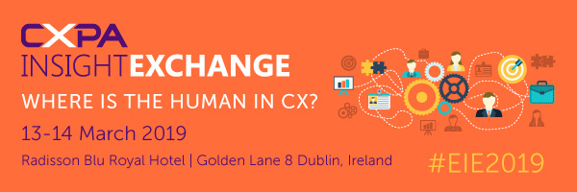
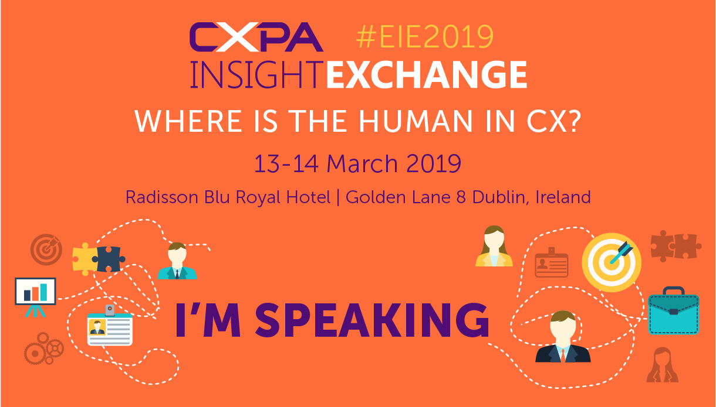
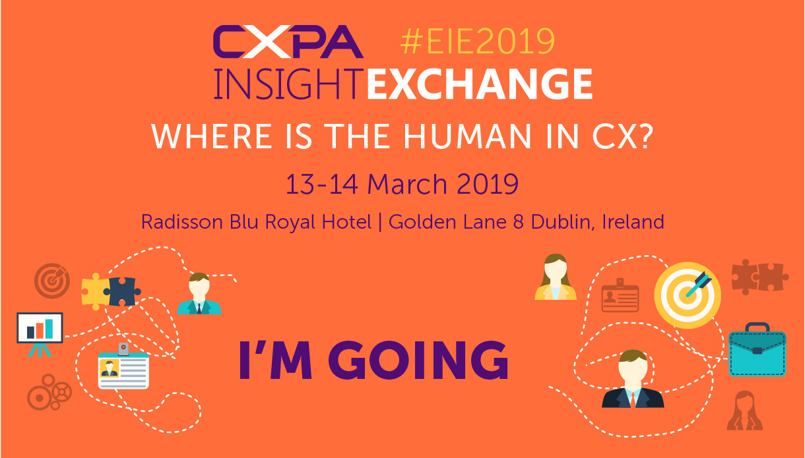
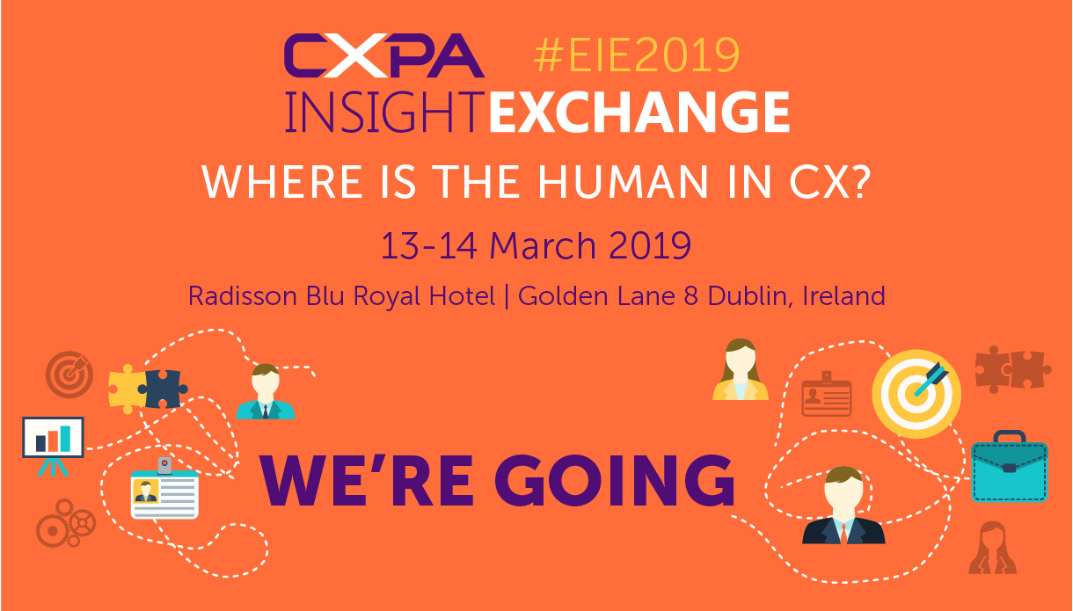
Facebook
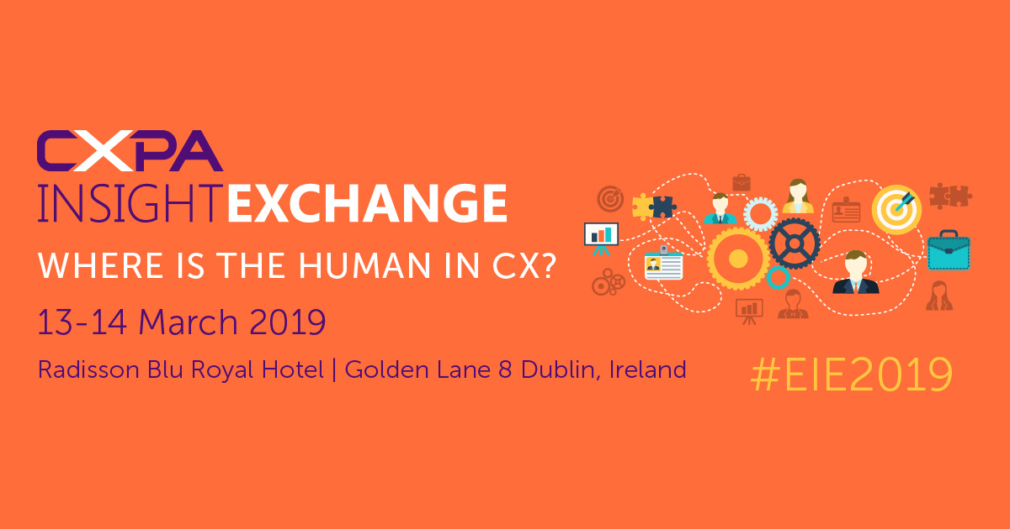
Twitter
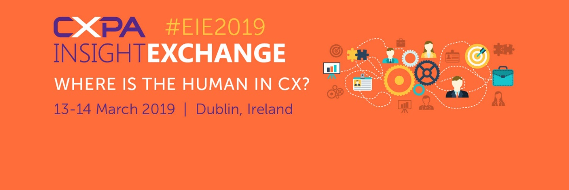

LinkedIn
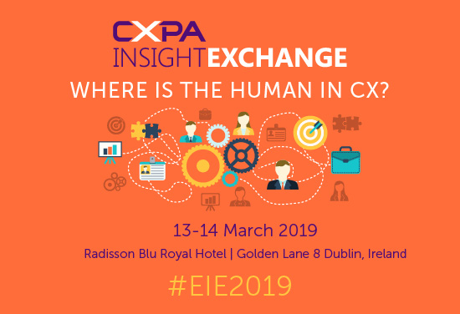
Instagram

