NEW RESOURCE! CUES is now available to all staff!
CUES (Credit Union Executives Society) has offered informational and educational benefits to credit union leadership teams for many years. At the beginning of 2020, CUES adjusted their membership structure allowing credit unions to invest in broader staff opportunities. [CU Name] purchased the CUES Unlimited+ membership as an investment to provide the greatest possible opportunity for all of us to enjoy informational, educational, and networking opportunities – all through the CUES online portal.
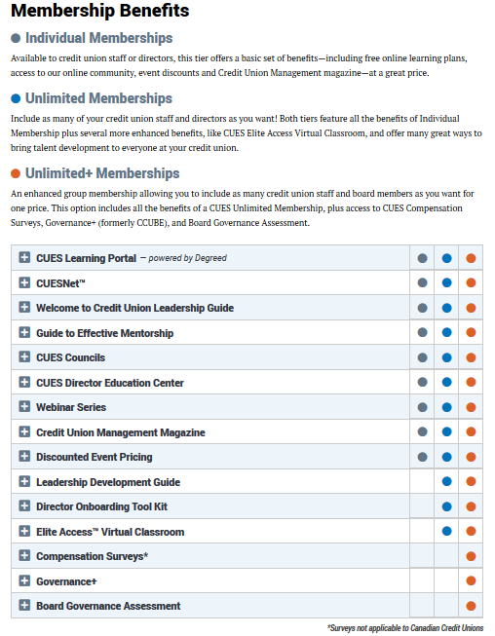
Learning Opportunities:
- CUES Learning Portal (powered by Degreed) – Provides a blend of learning pathways and content on hundreds of topics to enhance personal knowledge and skills. Engage with others in groups, develop skills on specific topics using curated pathways, recommend learning to others, or save learning to review later. (The CUES Leaning Portal appears above the navigation row once you login.)
- CUES Elite Access (virtual classroom) – Live real-time sessions where peers can interact with the instructor and each other online.
- CUES Webinars – Features live and recorded educational webinars covering relevant topics led by industry experts.
Informational and Networking Opportunities:
- CUESNet – Provides a platform where members may discuss ideas, share documents, and network in this online community network.
  - CUES Communities offer daily chat forums where questions can be posted and members may reply. Once your membership is activated, you will be added to the CUES Member Community. This community publishes a digest of posts daily that reflect a wide variety of CU topics. Additional communities are available to you as well. *Please ensure that you follow [CU Name] social media policy prior to posting questions or comments on this forum.
- CUES e-Newsletters – Expect to receive the following communications
  - Content Emails – Weekly email that shares a variety of content. Examples include links to the monthly magazine, latest blog posts, daily online-only articles and columns to news from CUESolutions partners, the CUES quarterly Advancing Women publication and newly released whitepapers.
  - Membership Emails – Collection of best discussions and resources to help you get the most out of your CUES membership. Examples include links to upcoming webinars and Elite Access classroom training, as well as tips and tricks on how to use your membership benefit.
  - On Target e-Newsletter – Provides information about CU’s designed to assist CU suppliers understand CU needs.
  - CUES Councils Emails – Occasional emails to keep you informed about events near you that are offered by regional CUES Council groups.
- CUManagement.com – To access, enter CUESNet, select Content, and CUManagement.com.
- Credit Union Management Magazine – Stay on top of the latest CU news through CUES digital monthly magazine. The magazine offers articles covering general management, board, operations, marketing, and human resources topics.
- CUES Councils – Councils are regional groups that network and discuss challenges and opportunities facing the CU industry. Each council is run by local CU leaders who volunteer to organize educational and networking events. To learn more, follow the councils link or contact councils@cues.org.
- Notifications – CUES will reach out to inform you when your membership is expiring or to encourage you to use your benefits.

HOW TO GET STARTED:

You will receive an email from CUES when your membership is active. Follow these steps:
- Visit cues.org and click the Log In dropdown box to complete the Password Recovery process.
- Once logged in you should see “YOUR NAME ACCOUNT”. Click that box and select Access My Benefits to begin exploring your new benefits. Staff members, complete this scavenger hunt to learn more! Board members, complete this scavenger hunt to learn more!

