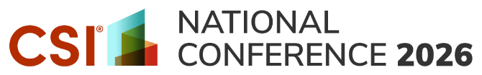

Dear <NAME>

I would like to attend the upcoming 2026 CSI National Conference, October 7-9, in Phoenix, AZ, and hope you will approve this professional development opportunity.

The conference offers a great mix of peer-reviewed sessions designed to help me improve my work while also offering networking opportunities to connect with experts and colleagues in the AECO industry.

Many of the education sessions focus on <insert areas specific to your profession>, which will help me reach my professional development goals of <insert benefit/lesson, new tools, work improvements, etc.>.

For 2026, the conference has added a full day of enhanced workshops and an expanded product showcase where I can meet with solution providers at no additional cost.

In addition to the knowledge I gain, I am eligible to earn CSI and AIA Learning Units.

The presentations are led by industry experts and association colleagues with extensive experience and similar work challenges. The full agenda is available at csinationalconference.org.

Attending this conference costs <$xxxx> if I register by <date>. All meals are included. Here is the breakdown of the other costs:
- Conference Registration: <$xxxx>
- Roundtrip Airfare: <$xxxx>
- Transportation: <$xxxx>
- Hotel: <$xxxx>
- <Optional: CDT Fundamentals Course: $xxxx>
- <Optional: Tour: $xxxx>
Overall, this will be an impactful opportunity for me to develop new contacts, strengthen relationships, and gain industry knowledge.
Sincerely,
<Your Name>

