Sample Facebook Post:

By the numbers:
2 U.S. Senators
15 CA Congressional members,
14 CA State Senators and
32 CA State Assembly members, support funding special districts
743 strong coalition of statewide organizations, local businesses, local government, and individuals
$75 billion state surplus
$27 billion in federal American Rescue Act funds to the state for pandemic relief
$21.7 billion has been allocated to cities and counties in federal COVID-19 relief funds
$0 allocated to special district local governments

When special districts are excluded from relief, essential frontline workers and community residents are excluded from relief. Click here to join a growing coalition of communities and local leaders to urge the State of California to extend special district access to Coronavirus fiscal relief.

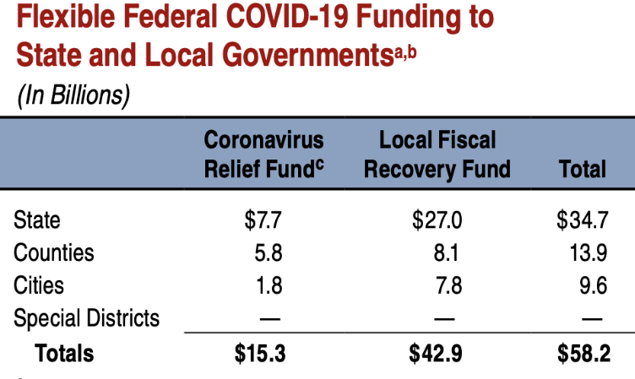

Sample Tweets:

Ready for summer? Closed public pools, water shortages, reduced fire preparedness and public park closures could be a reality if the special districts that provide our community with these essential services don’t receive COVID-19 relief funding. Click here and Support your community by joining our coalition today.

Ready for summer? Rising water bills, reducing fire protection, and closing park services could be in the forecast if the #SpecialDistricts that provide our community with these #EssentialServices don’t receive #COVID relief funding. Click here to Support your community by joining our coalition today.

Social Media Hashtags:

#FundEssentialServices
#FundSpecialDistricts

