
Essential Records Webinar
Session 4
Instructor Guide
Final, July 2010

Course Number: AWR-210-2

Table of Contents

Session 4—Administration Page 4-1
Duration 4-1
Scope Statement 4-2
Session Objectives 4-3
Instructor-to-Participant Ratio 4-4
Methods 4-4
Practical Exercise 4-4
Sources of Course Content 4-4
Instructional Materials 4-5
Equipment 4-6
Session 4 Introduction 4-7
Session 4 Welcome and Overview 4-7
Take-Home Activity Debrief 4-15
Session 3 Activity: Determine Protection Strategies and Measures—Part 2 4-15
Module 3—Access Essential Records 4-19
Module 3 Introduction and Objectives 4-21
Module 3 Introduction 4-21
Module 3 Objectives 4-22
Lesson 1: Ensure Access to Essential Records 4-23
Make Essential Records Available 4-24
Prioritize Access to Essential Records 4-26
Prioritize Based on the Type of Essential Record 4-26
Priority Levels and Timeframes for Accessing Essential Records 4-28
Your Stakeholders Are Resources 4-31
Access Records in Storage 4-32
Access Priorities: Putting It All Together 4-33
“Grab and Go” Kits 4-35
Cycling 4-37
Develop a Duplication Schedule 4-38
Develop Procedures to Ensure Access to Essential Records 4-39
Activity: Determine Timeframes for Accessibility 4-41
Activity Setup 4-43
Answer Sheet—Determine Timeframes for Accessibility Activity 4-47
Module 4—Incorporate Essential Records into COOP Plans 4-49
Module 4 Introduction and Objectives 4-51
Module 4 Introduction 4-51
Module 4 Objectives 4-52
Lesson 1: The Essential Records Template 4-55
Essential Records and COOP Plans 4-56
Sample COOP Plans 4-58
Essential Records Template 4-61
Don’t Forget Your Stakeholders 4-63
Course Summary 4-67
Course Review 4-67
Next Steps 4-72
Course Evaluations and Course Certificates 4-75
Essential Records Post-Test 4-77

Session 4—Administration Page
Duration | 110 minutes
The following is a suggested time plan for this session. We encourage the instructor to adapt it as needed.
The blank “Start Time” column is provided as a worksheet on which you can create a schedule for your specific session. Using the scheduled start time of your session and the suggested durations provided in Table 1, calculate the start time of each topic and enter it in the “Start Time” column. Also record the start times in the blank Start Time fields provided throughout this document, at the beginning of the topics. This will help you keep track of your progress and help you check whether or not you’re on schedule.
Table 1: Suggested Time Plan
Topic | Duration | Start Time
Session 4 Introduction
- Session 4 Welcome and Overview | 5 minutes
Take-Home Activity Debrief
- Session 3 Activity: Determine Protection Strategies and Measures—Part 2 | 15 minutes
Module 3—Access Essential Records
- Introduction and Objectives | 3 minutes
- Lesson 1: Ensure Access to Essential Records | 15 minutes
- Activity: Determine Timeframes for Accessibility | 15 minutes
- Break | 5 minutes
Module 4—Incorporate Essential Records into COOP Plans
- Introduction and Objectives | 2 minutes
- Lesson 1: The Essential Records Template | 10 minutes
Table 1: Suggested Time Plan (cont’d.)
Topic | Duration | Start Time
Course Summary
- Course Review | 10 minutes
- Next Steps | 5 minutes
- Course Evaluations and Course Certificates | 5 minutes
- Essential Records Post-Test | 20 minutes
Total Duration | 110 minutes

Scope Statement | Session 4 focuses on ensuring access to essential records during an emergency, and it provides a template for incorporating essential records into a Continuity of Operations (COOP) Plan. It includes:  - Session 4 Introduction  - Take-Home Activity Debrief  - Module 3—Access Essential Records  - Module 4—Incorporate Essential Records into COOP Plans  - Course Summary
Session 4 Introduction
The Session 4 Introduction quickly reviews the material covered in prior sessions and previews the material to be covered in Session 4.
Take-Home Activity Debrief
The Take-Home Activity debrief provides participants with the opportunity to share the results of their homework assignment with the class, receive feedback from the instructors, and discuss any issues or questions they may have about the activity.

Module 3
Module 3 focuses on the need to access essential records during and after an emergency. It explains how to prioritize essential records in order to determine a timeframe in which they will be needed in the event of an emergency. The module also addresses the importance of developing procedures to ensure access to essential records.
Module 4
Module 4 introduces the Essential Records Template, a generic framework for capturing essential records information (lists of essential records, protection strategies, priorities, timeframes, etc.) for incorporation into COOP Plans.
Course Summary
The Course Summary reviews the key points covered in the Essential Records Webinar. Additionally, participants complete the Course Evaluation, take the Essential Records Post-Test, and learn how to obtain Certificates of Completion.
Session Objectives | Module 3—Access Essential Records  Terminal Learning Objective:  - Participants will be able to develop priorities, timeframes, and procedures for accessing essential records during and after an emergency.  Enabling Objectives:  - Prioritize essential records.  - Specify timeframes for essential records availability.  - Develop procedures to ensure access to and security of essential records.  Module 4—Incorporate Essential Records into COOP Plans  Terminal Learning Objective:  - Participants will be able to complete the Essential Records Template for incorporation into COOP Plans.

Enabling Objectives:
- Identify the components of the Essential Records Template.
- Determine the information needed to complete the Essential Records Template.
- Explain how to integrate protection of essential records into an agency COOP Plan.
Instructor-to-Participant Ratio | 2:30—We suggest that at least two instructors lead each webinar, with no more than 30 participants.
Methods | The following instructional methods are used in this session:  - Instructor presentation  - Polling question  - Group discussion  - In-Session Activity
Practical Exercise | Session 4 contains one In-Session Activity, Determine Timeframes for Accessibility, in which participants practice determining accessibility priorities, accessibility timeframes, and cycling frequencies to ensure access to essential records.
Sources of Course Content | - National Archives and Records Administration’s (NARA) course, Vital Records (April 2008)  - Federal Emergency Management Agency’s (FEMA) COOP Plan Template  http://www.fema.gov/doc/government/coop/coop_plan_blank_template.doc  - National Institute of Standards and Technology’s (NIST) Contingency Plan Template  http://csrc.nist.gov/groups/SMA/fasp/documents/contingency_planning/contingencyplan-template.doc

Instructional Materials | - Session 4 Instructor Guide (for instructors)  - Session 4 Participant Guide (for participants)  - Session 4 Slides  - Handout(s):  - Handout 1.1—Essential Records  - Handout 1.3—Potential Candidates for Essential Records Status  - Handout 1.5—Essential Records Questionnaire  - Handout 1.6—The Division of Public Recreation (DPR) Overview  - Handout 3.2—Determine Protection Strategies and Measures Activity  - Handout 4.1—Access Priorities Table  - Handout 4.2—Establishing a Duplication Schedule for Essential Records  - Handout 4.3—Determine Timeframes for Accessibility Activity  - Handout 4.4—Essential Records Template
- Reference(s):
- Reference 01—Resource Center, References, Reading List
- Reference 02—Key Terms for the IPER Courses
- Reference 03—Participant Webinar Reference Guide
- Reference 04—iLinc Quick Reference for IPER Instructors (instructors only)
- Reference 05—Webinar Troubleshooting Guide (instructors only)
- Polling question(s):
- PQ 4.1—“Priority 2 records are typically needed when?”
- Prepared PowerBoard file(s):
- PB 4.1—Course Review
- Evaluation(s):
- Essential Records Post-Test

Equipment | - Required equipment:  - Internet-enabled computer  - Telephone (Each instructor should have his or her own telephone. If you want to use the telephone hands-free, you should use a headset instead of a speakerphone to reduce background noise that will distract the participants.)  - Optional equipment:  - A second Internet-enabled computer, logged into the webinar as a participant, so you can see what the participants see.

Session 4 Introduction

Instructor Notes | Participant Guide
  PG 4-1 | Session 4 Welcome and Overview
(Duration: 5 minutes)
START TIME: ______________
Log in to iLinc 30 minutes prior to the start of the webinar session to make sure there are no technical issues.
Launch the Session 4 slides file in iLinc.
Show slide 4-1.
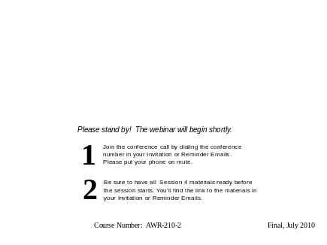
Required materials for Session 4:
- Session 4 Participant Guide
- Session 4 handouts:
- Handout 4.1—Access Priorities Table
- Handout 4.2—Establishing a Duplication Schedule for Essential Records

- Handout 4.3—Determine Timeframes for Accessibility Activity
- Handout 4.4—Essential Records Template
- Materials from prior sessions:
- Handout 1.1—Essential Records
- Handout 1.3—Potential Candidates for Essential Records Status
- Handout 1.5—Essential Records Questionnaire
- Handout 1.6—The Division of Public Recreation (DPR) Overview
- Handout 3.2—Determine Protection Strategies and Measures Activity, with Table 2 completed
REMINDERS TO INSTRUCTOR:
- Before class begins, be sure to check (1) the IPER Resource Center for special announcements to Instructors about the course and (2) the Frequently Asked Questions (FAQs) to see if there are any newly posted items that may be relevant to your course or participants.
- When you are not speaking to the participants, remember to have your phone on mute.
- When you are speaking to the participants, remember to reduce or eliminate background noises, such as pages being turned, co-workers talking, etc.

- If you are recording this session, remember that discussions conducted via iLinc’s Chat tool are captured in the session recording. When using the Chat tool, make sure to maintain a professional dialog that is appropriate for everyone to view.
- When using iLinc’s WebSync function, participants cannot see any actions you perform (such as moving your cursor or scrolling); therefore, when you interact with a web page or document, you will need to provide instructions to the participants on what to do (“scroll down,” “select this,” etc.) so their view will match your view.
Continue to show slide 4-1 until all participants have joined the session (or until it’s time to start the webinar).
Welcome participants as they enter the webinar.
- Tell them that the webinar will begin shortly.
Five minutes prior to the start of the session, check the Attendee panel in iLinc and compare it to the class roster to see if all of the participants have entered the webinar.

If all of the participants have entered:
- Say: Hi, everybody. This is <your name>. I know it’s a couple of minutes early, but since everybody’s here, I’d like to get started, if that’s OK with everyone.
- Begin the session (see the “Begin the Session” Instructor Note below).
If all of the participants have not yet entered:
- Say: Hi, everybody. This is <your name>. We are waiting for a few more people to join us, and then we’ll get started.
- Monitor the Attendee panel until all participants have entered the session or until the start time is reached.
- Begin the session (see the “Begin the Session” Instructor Note below).
BEGIN THE SESSION:
Start the iLinc recorder.
Say:
- Welcome to Session 4 of the Essential Records Webinar.
- To refresh your memory, I’m <your name> and teaching with me today is <name of Instructor 2>.

- Before we get started, I’d like to remind everyone to mute their phones and not to put your phone on hold during the webinar. If you need to take another call or a break during the session, please hang up and call back to rejoin.
Remind participants that they should have the Session 4 course materials ready (either printed or open on their computer) so they can access them when needed.
- Remind participants that the Reminder Email provided a link to the materials.
Say: We don’t recommend that you print the materials now, but if you do, please make certain your phone is on mute.
Remind participants that recordings of the sessions are available on the Intergovernmental Preparedness for Essential Records (IPER) Resource Center, and if they missed the prior session, they can view a recorded version at: http://www.statearchivists.org/resource-center
Transition: Let’s do a quick review of what we covered in our past sessions and take a look at what we’re going to discuss today.

PG 4-2
Show slide 4-2.
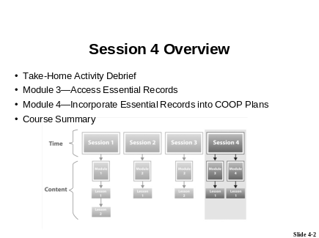
Say:
- In Session 1, you learned how to identify your essential records.
- In Session 2, we focused on identifying and assessing the hazards and risks to your essential records.
- Last week, in Session 3, we took a look at protecting your essential records against those risks and hazards.
- We learned about two basic strategies for handling risk—acceptance and mitigation—and we discussed several prevention and mitigation measures.
- We also looked at duplication options and storage options for essential records.

Go over what will be covered in Session 4:
- Say: Today, we will focus on ensuring access to your essential records during an emergency and incorporating your essential records into COOP Plans.
- Say: The session includes the following:
- Read the Session 4 Overview, as provided on the slide.
Say: Today’s session is 1 hour and 50 minutes in duration. We will have a short break about midway through the session.

[This page intentionally left blank.]

Take-Home Activity Debrief

PG 4-3 | Session 3 Activity: Determine Protection Strategies and Measures—Part 2
(Duration: 15 minutes)
START TIME: ______________
Show slide 4-3.
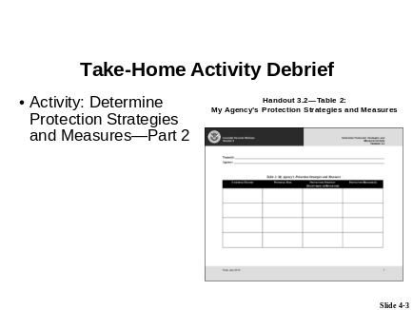
 Tell participants to go to Handout 3.2 (from the Session 3 materials) and locate Table 2: My Agency’s Protection Strategies and Measures on pages 7-8.
- Remind participants that this is the table they should have completed for Part 2, the take-home portion, of the Session 3 activity and emailed to you by yesterday.

Ask participants to raise their hands (or use the “Public” tab of the Chat tool) if they had any difficulties completing the Take-Home Activity.
- If anyone had a problem, make sure to resolve it before continuing.
Debrief the activity by conducting a group discussion:
- Say: The goal of this activity was to practice determining protection strategies and measures for risks to your agency’s essential records. Using two of the essential records you identified in the Session 1 Take-Home Activity and the risks you identified in the Session 2 Take-Home Activity, you were to complete the Protection Strategies and Measures table.
- Say: I need a volunteer to share his or her answers for one of the risks he or she identified.
- Tell participants to share the following:
- A brief description of the essential record they selected
- A risk they identified for that record

- The protection strategy they chose
- The protective measures they selected
- The rationale behind their selections
- Tell participants to raise their hands to answer or to type their answers in the Chat tool, using the “Public” tab.
- Call on participants who have their hands raised.
- Remind participants to take their phones off mute before speaking.
- Acknowledge any responses provided in the Chat tool.
- Confirm or correct responses, as appropriate.
- OPTIONAL: If no participants volunteer, you may opt to share a response from one of the homework sheets submitted by the participants.
Continue to debrief the activity in the same manner.
- Have at least three participants share their protection strategies and measures.
- Make sure different participants share, so the same few don’t do all the talking or chatting.
Ask for and resolve any questions.

Remind participants why it is important to do the homework, as assigned. The activities are designed to:
- Apply what was discussed in a particular session
- Build on each other
- Take you through the initial steps of identifying and protecting your essential records
Transition: Let’s get started with Module 3, and examine accessing essential records.

Module 3—
Access Essential Records

[This page intentionally left blank.]

Module 3 Introduction and Objectives

PG 4-7 | Module 3 Introduction
(Duration: 3 minutes)
START TIME: ______________
Show slide 4-4.
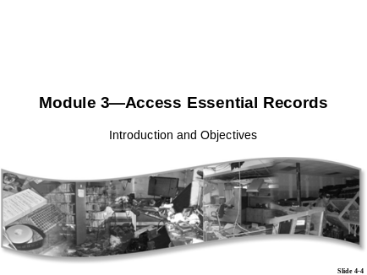
Introduce the module:
- Say:
- In Module 3, we will focus on ensuring access to essential records during and following an emergency.
- We will begin by examining how to prioritize records for access.
- Then we’ll discuss developing procedures for accessing records. We’ll also discuss cycling.
- Finally, we’ll do an In-Session Activity to practice determining timeframes for accessibility.

Transition: Let’s take a look at the objectives for Module 3.
PG 4-8 | Module 3 Objectives
Show slide 4-5.
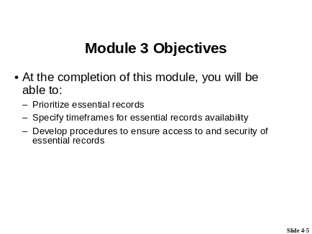
Review the module objectives. | At the completion of this module, you will be able to:  - Prioritize essential records  - Specify timeframes for essential records availability  - Develop procedures to ensure access to and security of essential records
Transition: Let’s get started with Lesson 1 and examine determining access priorities and timeframes.

Lesson 1: Ensure Access to Essential Records

PG 4-9
(Duration: 15 minutes)
START TIME: ______________
Show slide 4-6.
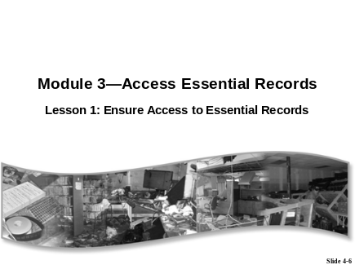
Introduce the lesson.
Say:
- You have identified your essential records, analyzed your risks, and put your protective measures in place. If an emergency were to happen, are you sure you could access those records?
- This lesson will explain how to ensure access to your records during an emergency by prioritizing which records you need when.
- Let’s start by taking a look at the importance of ensuring access to essential records.

PG 4-10 | Make Essential Records Available
Show slide 4-7.
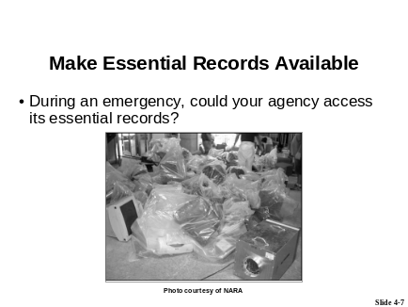
Explain that essential government services can be interrupted by disastrous events.  Ask: In the event of an emergency, could your agency access the essential records it needs to perform its mission? | As we know, essential government services can be interrupted by disastrous events ranging from something as small as a burst pipe to something as catastrophic as a terrorist attack. Such disruptions may last for a short time, or they may result in a complete stoppage of government operations.  In the event of an emergency, could your agency access the essential records it needs to perform its mission?
Show slide 4-8.
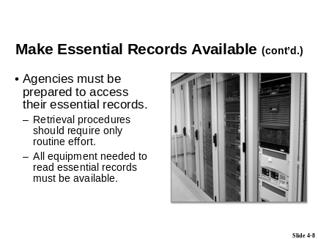
Say: Agencies must continue to function and provide services to the public under emergency operating conditions, and must be able to resume normal business afterward. | Regardless of the scale of the emergency, agencies must be able to respond to the situation, continue to function and provide services to the public under emergency operating conditions, and resume normal business afterward. Essential records make this possible, so agencies must be prepared to access their essential records.

Say: Essential records allow this to happen.  Explain that accessing essential records should require only routine effort.  Say: Providing for the ready availability of essential records will allow recovery personnel to focus on restoring operations rather than wasting precious time searching for documents and records, and/or working with nonessential records. | Agencies should ensure that retrieval procedures for essential records require only routine effort to locate needed information, especially since individuals unfamiliar with the records may need to use them during an emergency.
Explain that agencies should also ensure that all equipment and keys or access codes needed to read essential records will be available in case of emergency. | Agencies should also ensure that all equipment needed to read essential records will be available in case of emergency. For electronic records systems, agencies should also ensure that system documentation adequate to operate the system and access the records will be available in case of emergency and that they have the keys or access codes required.
Explain that FEMA has described the requirements for access to essential records in its Continuity Guidance Circular 1, issued in January 2009. FEMA includes access to computer networks and email, electronic and hard copies of essential records, and supporting systems and data.  Point out that the URLs for this and other FEMA guidance documents are available in Reference 01—Resource Center, References, Reading List. | Federal Emergency Management Agency’s (FEMA) Continuity Guidance Circular 1 (CGC1) recommends:  “As soon as possible after continuity of operations activation, but recommended within 12 hours of such activation, continuity personnel at the continuity facility should have access to the appropriate media for accessing vital [essential] records, such as:  a. A local area network,  b. Electronic versions of vital [essential] records,  c. Supporting information systems and data,  d. Internal and external email and email archives,  e. Hard copies of vital [essential] records.”
Transition: Let’s look at prioritizing access to your essential records.

 | PG 4-12 | Prioritize Access to Essential Records
 |  | Prioritize Based on the Type of Essential Record
Show slide 4-9.
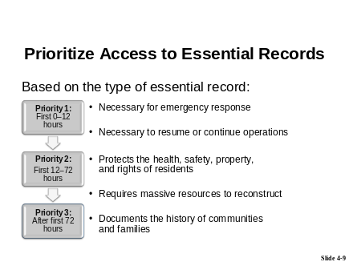
Explain why access to essential records should be prioritized. |  | During an emergency, you have limited time and resources to access your essential records, so it’s important to prioritize which essential records need to be accessed when. You will have to determine which essential records are needed immediately and which essential records may not be needed for several days or even weeks. That way, you can focus your energies on accessing only the records needed at that particular time.
Explain that access to essential records is prioritized based on the type of essential record. |  | Access to an agency’s essential records is prioritized based on the type of essential record involved.
Review the five types of essential records. |  | In the first session, we identified the five types of essential records:  - Records that are necessary for emergency response  - Records that are necessary to resume or continue operations  - Records that protect the health, safety, property, and rights of residents  - Records that would require massive resources to reconstruct  - Records that document the history of communities and families

Refer participants to Handout 1.1—Essential Records.
Explain that Handout 1.1 contains prioritizing guidance, based on the type of essential record. | As you may recall, Handout 1.1—Essential Records provides an overview of the types of essential records and examples of each, and also provides prioritizing guidance.
Explain that what’s shown on slide 4-9 is an excerpt from Handout 1.1.
Explain that the left column in Handout 1.1 and on the slide shows the priorities for accessing essential records.  Point out that, in general, the priorities for accessing essential records follow the same order as that in which the types of essential records are listed in the handout and on the slide. | The column on the left of the table in Handout 1.1 shows the priorities for accessing essential records. In general, the priorities for accessing essential records follow the same order as that in which the types of essential records are listed in this table.
Explain that the priorities start with Priority 1 and progress down to Priority 3. | The priorities start at the top with Priority 1, those records which are needed immediately for emergency response, and progress down to Priority 3, those records which will be needed later as the agency and community recover.
Point out that the priorities shown in the handout and on the slide are only guidelines, and that priorities will differ across agencies. | This ranking is meant to suggest only an overall pattern, not a rigidly hierarchy. Administrative responsibilities and particular circumstances will affect each agency’s approach to setting priorities. For instance, in November of an election year, voting records are likely to be of higher priority than at other times.
Say: The timeframes associated with each priority level aren’t hard and fast. They represent a continuum from immediate to longer term. There will also be overlaps between categories.

Some records will be needed right away to launch the response, while others won’t be needed for several hours, days, or even weeks, but are still essential.
Say: Let’s take a closer look at each priority level, and the associated timeframes for access.
 | Priority Levels and Timeframes for Accessing Essential Records
Show slide 4-10.
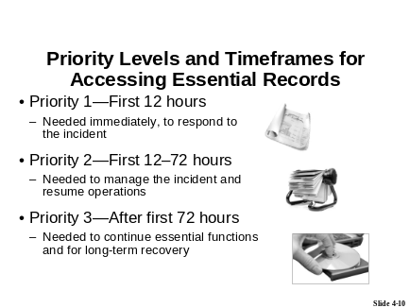
Go over the priority levels and corresponding timeframes for accessing essential records.
 | Priority 1—Needed in the first 12 hours
Explain Priority 1:  - Priority 1 essential records are those that are needed in the first few hours of a crisis or emergency.  Go over the records included in Priority 1. | Priority 1 essential records are the records essential for emergency operations and are therefore needed immediately—in the first few hours of a crisis or emergency—to respond to that emergency. Sometimes referred to as COOP vital information, these Priority 1 essential records may include:  - Continuity of Operations (COOP) or Occupant Emergency Plans  - Telephone trees  - Delegations of authority

- Security clearance rosters
- Building blueprints
- Utility maps and diagrams
- Media policy directives
- Essential records inventory lists
- Contact information for disaster recovery vendors
 | Priority 2—Needed in the first 12–72 hours
Explain Priority 2.  - Priority 2 essential records are those that are needed to manage the incident and resume operations. | Records classified under Priority 2 include records that are needed to manage the incident and resume operations.
Go over the records included in Priority 2. | Examples include:  - Systems manuals for databases and LANs  - Personnel records  - Time and attendance records  - Combinations to restricted areas or equipment  - Combinations and/or keys for building entry
 | Priority 3—Needed after the first 72 hours
Explain Priority 3:  - Priority 3 essential records are those records that would be needed to continue essential functions if normal agency records were unavailable for a prolonged period due to a catastrophic event (causing long-term displacement of personnel and equipment from the worksite to a new operating location). | Priority 3 essential records are those that would be needed to continue essential functions if normal agency records were unavailable for a prolonged period due to a catastrophic event (causing long-term displacement of personnel and equipment from the worksite to a new operating location).

Go over the records included in Priority 3. | These include records that are needed off site to work on specific programs or projects most critical to your agency’s mission. They also include records that would take such massive resources to reconstruct that they should receive special protection against damage or destruction.  Also included among Priority 3 records are those that are needed for long-term recovery of the agency and broader community, including those that document the history of the community and its residents.
Conduct a group discussion by asking:
- What types of essential records would most likely be Priority 3 at your location?
- Tell participants to raise their hands to answer or to type their answers in the Chat tool, using the “Public” tab.
- Call on participants who have their hands raised.
- Remind participants to take their phones off mute before speaking.
- Acknowledge any responses provided in the Chat tool.
- Confirm or correct responses as appropriate (sample answers are provided below).
- If no participants respond, give the correct answers (provided below).
Correct answers:
- Say: Correct answers will include records that fall mainly within the following three categories. Specific examples for each are provided in Handout 1.3, as 3, 4, or 5.

- Records that protect the health, safety, property, and rights of residents
- Records that would require massive resources to reconstruct
- Records that document the history of communities and families
 | Your Stakeholders Are Resources
Explain how stakeholders can help with setting priorities and timeframes. | Some of the same stakeholders you included in identifying essential records—Agency head, mission-critical program or department heads (Information Technology [IT] Director and systems analysts, etc.)—are also important to include in setting priorities and timeframes.
Say: Those stakeholders you identified at our first session and may have queried using Handout 1.5 are the stakeholders who can help with setting priorities and timeframes. | If you gathered information previously using a questionnaire like the one provided in Handout 1.5—Essential Records Questionnaire, you will already have the basic information you need. You will already have asked, “How soon would you need access to the records (hours, days, weeks)?” Given the essential records you’ve identified, you should determine which stakeholders you may need to revisit.
Transition: Now let’s take a look at accessing records in storage.
Remind participants that we discussed storage options in Session 3, and that there are two options for agencies to store their essential records:
- On-site storage
- Off-site storage

PG 4-16 | Access Records in Storage
Show slide 4-11.
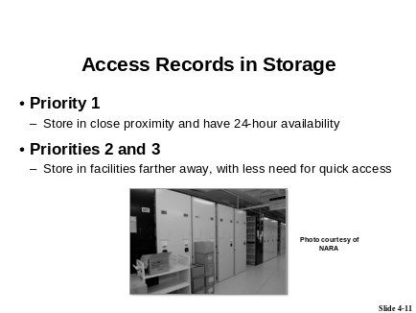
Explain that the priority of the essential record typically determines the storage option. | Generally, how you prioritize your essential records determines the type of storage option you select to protect them.
Remind participants that:
- They may be accessing copies of essential records rather than the originals, depending on whether the records were duplicated or simply transferred to an off-site or on-site storage facility.
- The preference is to access the originals if possible, but records emergencies often affect the original records, making them inaccessible. If so, accessing well-documented copies that meet the standards of preserving the evidential value of the originals is acceptable.

You need to access your Priority 1 essential records during and immediately following an emergency. Therefore, you will want to store those records in close proximity to your office and have 24-hour availability (which may mean storage at a “hot” site, and may mean storing the records in a format that does not rely on special equipment to be read).
Typically, you would not need your Priority 2 and 3 essential records as quickly as you would your Priority 1 essential records, so Priority 2 and 3 essential records could be stored in facilities farther away.
Transition: Now let’s take a look at a Prioritization Table to determine access priorities.
PG 4-17 | Access Priorities: Putting It All Together
Show slide 4-12.
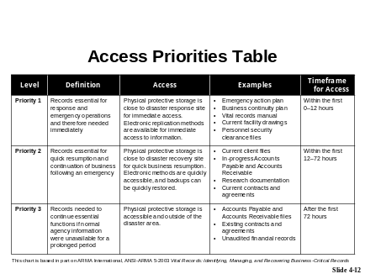
Review the prioritization table shown on the slide.
- OPTIONAL: When possible, use the iLinc Pointer and/or Highlight Tool to point out key elements.

Refer participants to Handout 4.1—Access Priorities Table for an example of a prioritization chart.  - Point out that the chart shown on the slide is also available in the handout. | The Access Priorities Table shown on the slide and in Handout 4.1—Access Priorities Table summarizes the timeframe and storage considerations for each priority level.
Explain that priority levels should be assigned to each of an agency’s essential records. | You should assign priority levels to each of your agency’s essential records. This allows both agency staff and emergency responders to identify quickly and easily which essential records should be retrieved and when. These are decisions you don’t want to have to spend time making during an emergency.
Explain that once priorities are assigned, participants should develop an Access Priorities Table. | Once priorities are assigned, you should develop a table based on Handout 4.1 that could be incorporated in your agency’s COOP Plan.
Say: Let’s do a quick check to see what you remember.
NOTE TO INSTRUCTOR:
Conducting the following polling question is optional.
Launch polling question in iLinc:
- PQ 4.1 —Priority 2 records are typically needed when?
- Tell participants to answer the question by selecting the appropriate response from the choices displayed in the “Polling” tab.

- Wait a few moments until most or all participants have answered; then share results with the participants via iLinc.
- Provide the correct answer:
- Within the first 12–72 hours
When done, close the “Polling” tab for everybody by selecting “Close All” when prompted.
Transition: Now that we have discussed prioritization and storage, let’s take a look at another very important component of ensuring access to essential records: “Grab and Go” kits.
PG 4-18 | “Grab and Go” Kits
Show slide 4-13.
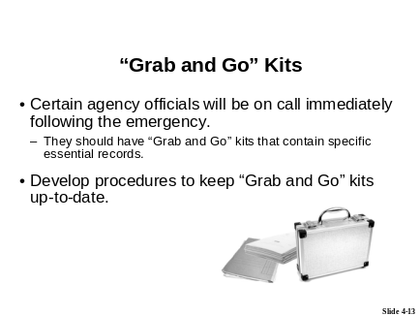

Review “Grab and Go” kits.  Say: General “Grab and Go” kits contain more than just essential records. They contain a water supply, medical supplies, etc. Developing the kits is mainly the responsibility of a safety manager or COOP planner. However, records management can contribute to what goes into them. | Immediately following an emergency, certain agency officials will be on call. To guarantee that these essential personnel have access to the necessary essential records, they should be provided with “Grab and Go” kits that contain copies of specific essential records.  “Grab and Go” kits should be kept by all essential personnel “on their persons” (at home or in their vehicles), and should include specific Priority 1 documents (those needed during and immediately after an emergency) and supplies (water, medical materials, etc.).  The essential records in these kits should be updated or cycled on the same schedule as all your essential records so that the kit remains current.  Development of the kits is mainly the responsibility of a safety manager or COOP planner. However, records management can contribute to what goes into the kits.
Review the types of essential records and information to include in a “Grab and Go” kit. | Examples of the types of essential records and information to include in a “Grab and Go” kit are:  - COOP Plan  - Delegations of authority  - Media procedures  - Emergency telephone lists  - Passwords  - Access codes  - Emergency passes  - Directions to a “hot” site
Point out the security precautions necessary for some “Grab and Go” kit documents. | Keep in mind that some of these documents may contain highly sensitive security information. Though they must be readily available in an emergency, you must take precautions so that sensitive information does not fall into the hands of unauthorized personnel. If you store the information on an electronic device, make sure that it is password-protected.

Transition: Another important element of essential records accessibility is “cycling.”
PG 4-20 | Cycling
Show slide 4-14.
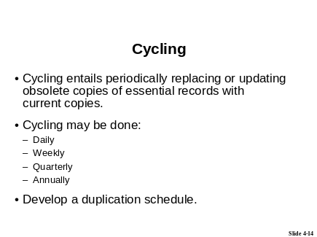
Define cycling.  Explain that essential records don’t stay “essential” forever.  Explain that agencies must cycle their essential records as a matter of routine to ensure that the records are kept up-to-date. | Cycling is the periodic replacement or updating of obsolete copies of essential records with current copies.  Essential records don’t stay “essential” forever. Many essential records have limited time value: They are essential only for a specific period of time, and once that time has passed, the copies become valueless for post-emergency resumption of activities.
In order for the most current or up-to-date essential records to be available during an emergency, agencies must ensure that their essential records are cycled as a matter of routine. Cycling may be done on a daily, weekly, quarterly, or annual basis—depending on the content of the records, the media on which they are stored, and access priorities.
The agency is responsible for periodically cycling (updating) essential records by removing obsolete items and replacing them with the most recent versions, when necessary.

Remind participants that essential records are typically copies and the outdated copies may be destroyed. | Remember, the essential record copy is typically a duplicate of the original record, and therefore may not be subject to your agency’s records schedule. If that is the case, it should be destroyed or deleted when it is replaced by an updated copy.
 | Develop a Duplication Schedule
Open a document from the “Course Handouts and References” WebSync file in iLinc.  - Document name: Handout 4.2—Establishing a Duplication Schedule for Essential Records  - Tell participants to go to Handout 4.2—Establishing a Duplication Schedule for Essential Records for additional guidance on developing a duplication schedule.  - Review the guidelines provided in the handout.  When done, close the document for everybody by selecting “Close All” when prompted. | One way to implement and track this requirement is to develop a duplication schedule or calendar. A duplication schedule simply allows you to set up cycling frequency—daily, weekly, or monthly—and to document that action formally.  Refer to Handout 4.2—Establishing a Duplication Schedule for Essential Records for additional guidance.
Transition: Once your access priorities are established, your cycling schedule determined, etc., your next step is to document the procedures for using essential records.

 | PG 4-22 | Develop Procedures to Ensure Access to Essential Records
Show slide 4-15.
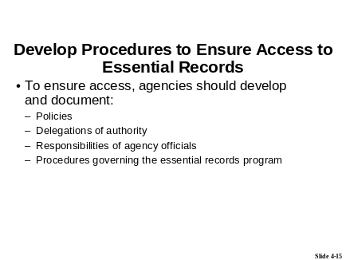
Review the development of procedures to ensure access. |  | Agencies must develop and document procedures for the use of essential records during an emergency.
Say: Examples of what the procedures should cover include:
- What the guidelines on how to handle the records are
- Who is in charge of what activities
- What each person’s specific responsibilities are
Agencies should make responsible personnel familiar with these procedures.
Each agency should document the following essential record information in appropriate issuances, such as directives or procedural manuals:
- Policies
- Delegations of authority
- Responsibilities of agency officials
- Procedures governing the essential records program

The issuances should clearly assign responsibility for coordinating essential records recovery plans and activities. They should also designate the members of the essential records team to be activated in time of need. Agencies should distribute this essential records information to all appropriate staff members.
Refer participants to the IPER Resource Center for examples of essential records policies and procedures, delegations of authority, etc.
- OPTIONAL: You may opt to launch the IPER Resource Center web page in iLinc and show the examples.
Ask: Before moving on, are there any questions about what we’ve covered so far?
Resolve any outstanding questions.
Transition: Let’s do an activity to apply what we’ve learned.

PG 4-23 | Activity: Determine Timeframes for Accessibility
(Duration: 15 minutes)
START TIME: ______________
Show slide 4-16.
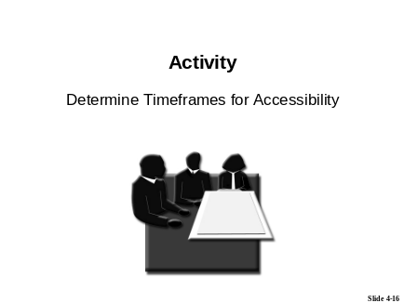
Introduce the activity.  Facilitate the activity using the Activity Instructions on page IG 4-44. | Activity materials:  - Handout 4.3—Determine Timeframes for Accessibility Activity
[This page intentionally left blank.]

Activity Setup

Activity Snapshot:
Activity Name: | Determine Timeframes for Accessibility
Activity Purpose/Goal: | Practice determining accessibility priorities, accessibility timeframes, and cycling frequencies to ensure access to essential records.
Notes: | This activity is conducted as a large-group discussion. The Instructor leads the discussion by providing sample essential records and asking participants to determine the records’ accessibility priority, accessibility timeframe, and cycling frequency. Participants provide their responses via the phone or the Chat tool. The sample essential records used in the activity are pulled from the fictitious agency information provided in Handout 1.6—The Division of Public Recreation (DPR) Overview.
Prerequisite for Subsequent Activities  (name and location of subsequent activities): | None
Group or Individual Activity: | Group activity
Time to Complete Activity: | 15 minutes total:  - 5 minutes for introduction  - 10 minutes for discussion and debrief
Required Materials  (name and location): | - Handout 4.3—Determine Timeframes for Accessibility Activity
Activity Scenario  (if applicable): | N/A
Activity Debrief: | Group discussion

Activity Instructions
Instructions:
Say: Let’s take a look at the materials you’ll be using for the activity.
Show slide 4-17.
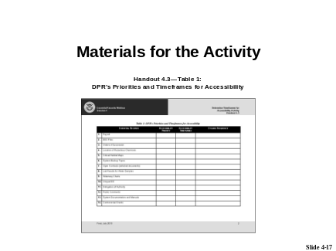
Tell participants to locate the materials for the activity:
- Handout 4.3—Determine Timeframes for Accessibility Activity
Tell participants to raise their hands when they’ve located all the documents needed for the activity.
- Assist any participants having trouble locating the necessary documents.
Point out the following in the handout:
- The instructions for the activity on page 1.
- The DPR’s Priorities and Timeframes for Accessibility table (Table 1) on page 2.
Explain that the records shown on the table are pulled from the DPR agency information provided in Handout 1.6—The Division of Public Recreation (DPR) Overview, from their Session 1 materials.
Say: The purpose of this activity is to practice determining accessibility priorities, accessibility timeframes, and cycling frequencies to ensure access to essential records.
Tell the participants that this activity will be conducted as a group discussion.
Explain that you will select several records from the DPR’s Priorities and Timeframes for Accessibility table and will ask participants to determine the records’ accessibility priority, accessibility timeframe, and cycling frequency.
Continued on next page...

Review an example before beginning the activity:
- Select one essential record from the DPR’s Priorities and Timeframes for Accessibility table, located on page IG 4-54, and provide the record’s accessibility priority, accessibility timeframe, and cycling frequency.
Ask: Are there any questions before we get started?
Begin the activity.
Select an essential record from the DPR’s Priorities and Timeframes for Accessibility table and tell the participants the name of the essential record and the corresponding row number (to help participants locate the record on the table).
Say: I need a volunteer to tell me what they think the accessibility priority, accessibility timeframe, and cycling frequency are for this record.
Tell participants to raise their hands to answer or to type their answers in the Chat tool, using the “Public” tab.
Say: I’ll give you a moment to think about it.
Allow a moment for participants to formulate their answers.
Call on participants who have their hands raised.
- Remind participants to take their phones off mute before speaking.
Acknowledge any responses provided in the Chat tool.
Ask participants to provide the rationale for their answers.
After a participant has shared his or her answers, ask if anyone got a different answer.
- Ask participants with differing answers to share their answers and their rationale.
Confirm or correct responses as appropriate.
- Answers appear in bold in the Answer Sheet—Determine Timeframes for Accessibility Activity, located on page IG 4-54.
- NOTE: The answers appear only in the IGs. The corresponding version of the table that is provided for the participants’ use does not contain the answers.
- Explain any correct answers that differ from the answer given by the participants.
Continued on next page...

NOTE TO INSTRUCTOR: Use differing answers as an opportunity to remind participants that there aren’t always “correct” answers when determining access, and that agencies must make decisions based on their unique records and needs.
For non-presenting Instructor: Open a new Powerboard and record the correct answers on the Powerboard.
Tell participants that they are welcome to record the correct answers in Handout 4.3, but that they will also be receiving an email with the correct answers following the session.
Continue the activity in the same manner, until you’ve completed at least five or six records (time allowing).
- Make sure to select at least one record from each priority level.
Ask for and resolve any questions.
End the activity.

Transition: Let's take a 5-minute break, and when we come back, we'll move on to Module 4, and take a look at the incorporation of essential records into a COOP Plan.
Tell participants that class will resume in 5 minutes, at <time when class will resume>.
Pause the iLinc recorder.

When 5 minutes have passed, reconvene the class.
Restart the iLinc recorder.

Answer Sheet—Determine Timeframes for Accessibility Activity
Table 2: DPR’s Priorities and Timeframes for Accessibility
 | Essential Records | Accessibility Priority | Accessibility Timeframes | Cycling Frequency
 | Payroll | Priority 2 | 12–48 hours | Replace with new data
 | EEO Files | Priority 3 | 72 hours till recovery | Update with new files as opened
 | Orders of Succession | Priority 1 | 0–12 hours | Replace when updated
 | Location of Hazardous Chemicals | Priority 1 | 0–12 hours | Replace as hazardous chemicals change
 | Critical Habitat Maps | Priority 3 | 48 hours till recovery | Scan and store off site; re-scan when changes are made
 | System Backup Tapes | Priority 1 | 0–12 hours | Replace when system changes
 | Open Contracts (selected documents) | Priority 3 | 48 hours till recovery | Update with new contract information weekly
 | Lab Results for Water Samples | Priority 2 | 12–72 hours | Replace with new test data
 | Waterway Charts | Priority 3 | 48 hours till recovery | Scan and store off site
 | Unique EIS | Priority 3 | 72 hours till recovery | Update with new EIS when issued
 | Delegation of Authority | Priority 1 | 0–12 hours | Replaced when updated
 | Public Comments | Priority 3 | 72 hours till recovery | Update with new public comments as received
 | System Documentation and Manuals | Priority 1 | 0–12 hours | Replace as system changes
 | Controversial Grants | Priority 3 | 48 hours till recovery | Update when new controversial grants are added, remove expired grants

[This page intentionally left blank.]

Module 4—
Incorporate Essential Records into COOP Plans

[This page intentionally left blank.]

Module 4 Introduction and Objectives

PG 4-27 | Module 4 Introduction
(Duration: 2 minutes)
START TIME: ______________
Show slide 4-18.
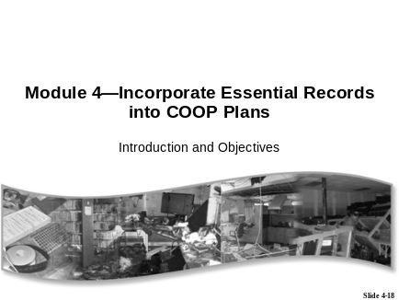
Introduce the module:
- Say:
- In Module 4, we will focus on incorporating essential records into a COOP Plan.
- We’ll take a look at some sample COOP Plans, to see how a typical COOP Plan addresses essential records, and then we’ll review the Essential Records Template as a way for you to incorporate records into your COOP Plan.

- Finally, we’ll identify the stakeholders who will play a role in integrating your essential records emergency planning into the COOP Plan.
Remind participants: If they don’t have a COOP Plan, they can:
- Contact the officials that oversee emergency management for their agency or department
- Find sample COOP Plans on the IPER Resource Center at: http://www.statearchivists.org/resource-center
Transition: Let’s look at the objectives for Module 4.
PG 4-28 | Module 4 Objectives
Show slide 4-19.
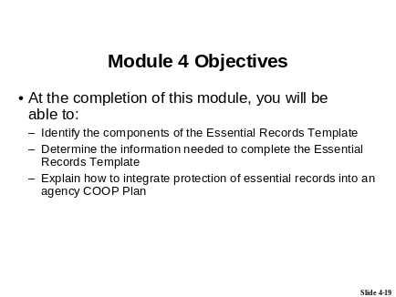

Review the module objectives. | At the completion of this module, you will be able to:  - Identify the components of the Essential Records Template  - Determine the information needed to complete the Essential Records Template  - Explain how to integrate protection of essential records into an agency COOP Plan
Transition: Let’s get started with Lesson 1 and examine the Essential Records Template.
[This page intentionally left blank.]

Lesson 1: The Essential Records Template

PG 4-29
(Duration: 10 minutes)
START TIME: ______________
Show slide 4-20.
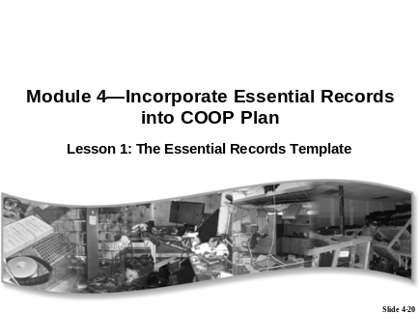
Introduce the lesson.
Say:
- In this lesson, we’ll see how all the essential records information we’ve gathered can be pulled into a single document—the Essential Records Template—for inclusion in a COOP Plan.
- Let’s get started by taking a look at COOP Plans and essential records.

PG 4-30 | Essential Records and COOP Plans
Show slide 4-21.
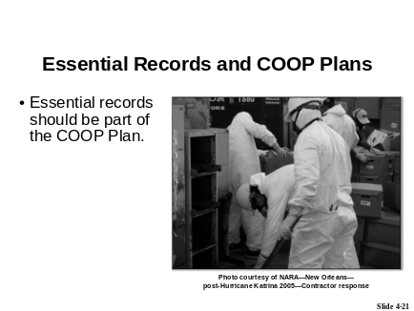
Explain why essential records should be part of a COOP Plan. | Essential records should be part of an agency’s COOP Plan, because records are critical for responding to an emergency and for continuing operations. These include the COOP Plan itself, as well as occupant emergency plans, telephone trees, delegations of authority, security clearance rosters, building blueprints, media policy directives, and essential records inventory lists.  In addition, residents of our states and communities depend on us to keep records that are critical to protecting their health, safety, property, and rights.  Many agencies, states, and localities require essential records to be part of their COOP Plan, but even if yours does not, operations cannot continue without essential records and it is important to include them in your COOP Plan.
Explain that you’re going to display a COOP Plan, to see how or whether agencies include essential records.

Launch web page in iLinc:
- Web page: IPER Resource Center
- URL: http://www.statearchivists.org/resource-center
- Browse to the COOP Plan that applies to your state or jurisdiction and open the document.
- IMPORTANT NOTE: If your state or jurisdiction does not have a COOP Plan, use a COOP Plan from another state, or another county within your state, or the FEMA template (provided below on page IG 4-59).
- Point out where the COOP Plan refers to essential records.
- NOTE: If the COOP Plan does not include essential records, explain that, since Katrina, including essential records has become the standard; however, the standard is still evolving and many COOP Plans have not yet caught up.

- NOTE: If the COOP Plan does include essential records, compare the information contained in the COOP Plan with the information participants have learned is necessary for protecting essential records (access information, format information, backup
protection information, etc.). Point out where the COOP Plan is missing this information. Explain that the Essential Records Template, which you will discuss shortly, encompasses all of this information.
When done, close the web page for everybody by selecting “Close All” when prompted.
 | Sample COOP Plans
Explain that you’re going to display some sample COOP Plan Templates to show more fully how agencies include essential records.  Point out that the templates come from federal agencies, and therefore demonstrate that federal agencies are including essential records in their COOP Plans. This could be used to help make your case for incorporating essential records in your COOP Plan. | Let’s take a look at some sample COOP Plan Templates to see where and how essential records are incorporated.

Introduce the first example, FEMA’s COOP Plan Template.  Launch web page in iLinc:  - Web page: FEMA’s Continuity of Operations (COOP) Plan Template  - URL: http://www.fema.gov/doc/government/coop/coop_plan_blank_template.doc  - Scroll to the table of contents (page ii).  - Scroll or jump to section VII.B.2—Vital Files, Records, and Databases (page 4).  - Point out the table for capturing essential records information.  - Compare and contrast the essential records information contained in the FEMA Template with that in your COOP Plan, if one exists.  - Remind participants that the records we’re calling “essential records” are referred to by FEMA and other agencies as “vital records.”  When done, close the web page for everybody by selecting “Close All” when prompted. | COOP Example 1  FEMA’s COOP Plan Template: http://www.fema.gov/doc/government/coop/coop_plan_blank_template.doc

Introduce the second example, NIST’s COOP Template.  Launch web page in iLinc:  - Web page: NIST’s Contingency Plan Template  - URL: –http://csrc.nist.gov/groups/SMA/fasp/documents/contingency_planning/contingencyplan-template.doc  - Scroll or jump to section 5.4.1—Vital Records/Documentation.  - Point out that this template includes information and guidelines on essential records.  - Compare and contrast the essential records information contained in the NIST Template with that in your COOP Plan.  When done, close the web page for everybody by selecting “Close All” when prompted. | COOP Example 2  National Institute of Standards and Technology’s (NIST) Contingency Plan Template: http://csrc.nist.gov/groups/SMA/fasp/documents/contingency_planning/contingencyplan-template.doc
Point out that the URLs for the FEMA COOP Template and the NIST COOP Template are provided in the Participant Guides and on the IPER Resource Center.
- Provide the URL for the sample COOP Plans located on the IPER Resource Center.
- Type the URL in the Chat tool, using the “Public” tab.

NOTE TO INSTRUCTOR:
- If your state or locality has a COOP Plan that incorporates essential records, you should show that plan to the participants too, either in addition to the FEMA and NIST documents or in place of the NIST document.
Transition: Now that we know why essential records should be part of a COOP Plan, let’s take a look at how to include them.
 | PG 4-32 | Essential Records Template
Show slide 4-22.
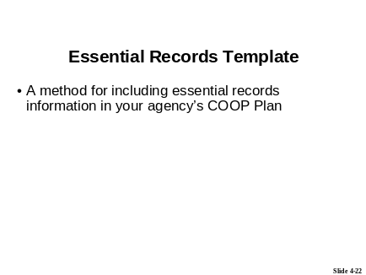
Explain that the Essential Records Template is a suggested method for including essential records information in an agency’s COOP Plan; it is a concise layout that is easy to understand and easy for your |  | The Essential Records Template is a suggested method for including essential records information in your agency’s COOP Plan. Use this template if your agency does not already have a template in place.

COOP manager or emergency manager to incorporate into the plan, whether in the records section or as an appendix.
Point out that agencies may want to add/remove information from the template to fit their needs.
Show slide 4-23.
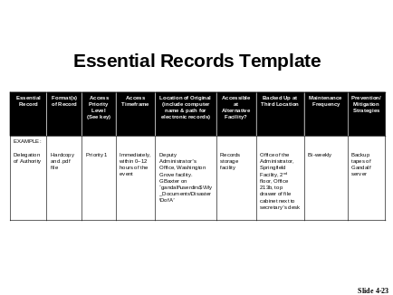
Review the information needed to complete the template.
- Point out that the participants practiced gathering this information via the course activities.
- Point out that not every distinct essential record needs to be listed. Record series may suffice if they are at the same location and in the same medium or media.
- Explain the need to provide keys to any rating systems included in the template.
- Point out that the Priority Level key referenced in the table is not shown on the slide, but is included in the handout.

Refer participants to Handout 4.4—Essential Records Template.  - Explain that the table shown on the slide is also provided in the handout.  - Point out that FEMA’s Continuity Guidance Circular 1 includes a similar—but much less comprehensive—template. | Refer to Handout 4.4—Essential Records Template, for a copy of the template.
 | Don’t Forget Your Stakeholders
Show slide 4-24.
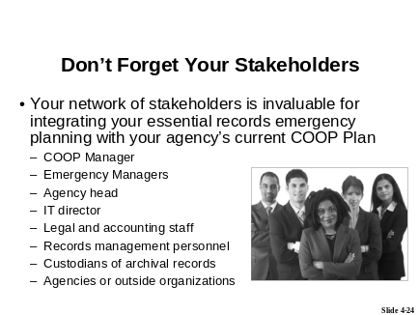
Explain the importance of including the stakeholders in this stage of records emergency planning. | At this point, your primary interest is to ensure that the essential records emergency planning you’ve completed and documented in your template is presented in a way that can be integrated with your agency’s current COOP Plan and other emergency plans, so that essential records procedures are clear to all those preparing for and responding to emergencies.  Again, your network of stakeholders will be invaluable. The COOP Manager and Emergency Manager in your agency should be consulted, so that they see how to integrate your work with the current emergency plan and training. The agency head (or designate) and IT Director should be briefed fully on aspects of your plan that will require resources—especially the recommendations for protecting records.

Review the stakeholders who should be involved in incorporating your Essential Records Template into your agency’s COOP Plan. | As noted during Session 1, your agency’s “stakeholders” include both the agencies and people you serve AND the agencies and people on whom you depend to provide that service, including:  - The COOP Manager for your agency, who should be involved from the beginning so that you can ensure that essential records are fully addressed in the COOP Plan  - Emergency Managers for your agency, as well as those in federal, state, and local government agencies, who should be consulted so that they can integrate your work with existing emergency plans and include essential records considerations in training courses
- First responders, who might be called in the event of an emergency, including police and fire fighters
- Agency head (or designate), who should be briefed fully on aspects of your plan that will require resources—especially those recommended for protecting records
- IT Director, who will also need to understand special considerations for providing access to essential records, beyond routine backup procedures
- Legal and accounting staff, who will ensure that all obligations are addressed in the plan
- Records management personnel who understand all of the records systems in the agency, understand who creates them, and knows how long they must be retained
- Custodians of the agency’s archival records—i.e., those records that are worthy of permanent retention—who will be able to identify the records that have an overriding historical or cultural significance to the agency or the community
- Agencies or outside organizations that come to you often for information or services, and who can help you identify which records are essential to their operations and cannot be found elsewhere

If your agency depends on records in other agencies to support your ongoing operations, you’ll want to ensure that that agency’s records remain available during an emergency, or to make provisions to obtain critical information elsewhere.
Finally, one of the most important groups of stakeholders is the public. Residents of your state or locality depend on government to maintain and make available critical information that they will need to sustain their families and businesses after an emergency.
Conduct a group discussion by asking:
- What do you plan to do to ensure that that essential records information is incorporated into your agency’s COOP Plan or emergency plan? How will your stakeholders be able to help?
- Tell participants to raise their hands to answer or to type their answers in the Chat tool, using the “Public” tab.
- Call on participants who have their hands raised.
- Remind participants to take their phones off mute before speaking.
- Acknowledge any responses provided in the Chat tool.
- Confirm or correct responses as appropriate.
- If no participants respond, provide some personal insight on how best to approach particular stakeholders and on what can be done to convince them to get involved in protecting essential records.

Ask: Before moving on, are there any questions about what we’ve covered so far?
Resolve any outstanding questions.
Transition: Let’s review what we covered in the Essential Records Webinar. Then we’ll take a look at our next steps and complete the Course Evaluations; then finally, we’ll complete the Post-Test.

Course Summary

PG 4-37 | Course Review
(Duration: 10 minutes)
START TIME: ______________
Show slide 4-25.
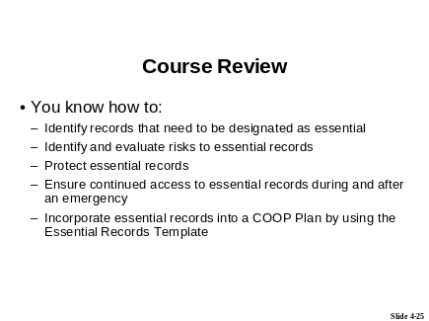
Review the key points covered in the course, as shown on the slide.
Say: In this course, we focused on identifying, protecting, and providing access to essential records in the event of an emergency.
NOTE TO INSTRUCTOR:
- The Course Review can be conducted as a question and answer (Q&A) session or as an Instructor presentation. Instructions are provided below for each approach.

Q & A instructions:
If time allows, facilitate the review by turning some or all of the bullet points into questions.
- For example:
- Ask: Who can tell me how to identify records that need to be designated as essential records? Answer via the Chat tool, using the “Public” tab.
Open a prepared Powerboard in iLinc:
- PB 4.1—Course Review
- Review the key points covered in this course, as provided on the Powerboard.
- Turn the bullet points into questions, as appropriate.
- As participants answer the questions, type the correct answers on the Powerboard, under the appropriate bullet.
- Use the notes from the Instructor presentation section to help formulate your questions and as a source for correct answers.
When you are done with the review, close the Powerboard for everybody by selecting “Close All” when prompted.
- Do not save the Powerboard.

Instructor presentation review instructions:
Review the key points covered in the course, as shown on the slide.
Elaborate on the bullet points as follows:
- How to identify records that need to be designated as essential  Say:  - In Session 1, we focused on identifying essential records.  - We learned that essential records are the critical agency records needed during emergency conditions. They contain the information necessary to respond to an emergency and to continue operations.  - We learned that essential records are deemed essential based on the value of the information they contain.  - We discussed the types of essential records, and learned that the records that support your essential functions are your essential records. | In the Essential Records Webinar, you learned:  - How to identify records that need to be designated as essential
- How to identify and evaluate risks to essential records | - How to identify and evaluate risks to essential records

Say:
- In Session 2, we focused on identifying and evaluating risks to essential records.
- We learned the categories of hazards and risks and we examined three techniques for identifying risk.
- We learned that risk analysis is performed through a risk probability and impact assessment, and we took a detailed look at the steps for performing that assessment.
- How to protect and ensure continued access to essential records  Say:  - In Session 3, we focused on protecting essential records.  - We discussed the two basic strategies for handling risk (acceptance and mitigation), and we looked at the prevention and mitigation measures available to protect your essential records (dispersal, evacuation, tape backup, and so forth).  - We learned that when we talk about safeguarding essential records, we are often, but not always, talking about safeguarding well-documented copies of the records, not the original records, and we looked at the formats you can use to create backup copies of original essential records. | - How to protect essential records

- How to ensure continued access to essential records during and after an emergency  - Say:  - In this session, Session 4, we focused on developing priorities, timeframes, and procedures to access essential records during and after an emergency.  - We learned about the prioritization system, and how to determine timeframes for access, based on the system.  - We discussed the importance of developing procedures for the use of essential records. | - How to ensure continued access to essential records during and after an emergency
- We also learned about the Essential Records Template, and that it can be used to incorporate essential records into a COOP Plan. | - How to incorporate essential records into a COOP Plan by using the Essential Records Template
Ask: Before moving on, are there any questions about what we’ve covered?
Resolve any outstanding questions.
Transition: It’s extremely important that you continue to identify and protect your essential records after this course is over.

PG 4-38 | Next Steps
(Duration: 3 minutes)
START TIME: ______________
Show slide 4-26.
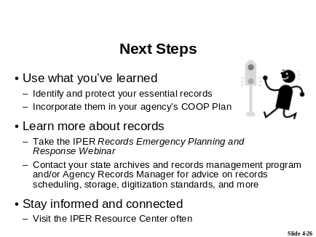
Say: We hope that you’ll use what you’ve learned during this course to improve the care of your essential records and incorporate them into your agency’s COOP Plan.
Say: To learn more about how to protect records and recover them after an emergency, you’ll want to take the other IPER course, the Records Emergency Planning and Response Webinar.
- Provide the date and time of the next available offering of the Records Emergency Planning and Response Webinar in your state if one is scheduled.
_______________________

- If you do not have one scheduled soon or all slots are full, tell participants that they can take the course on their own using the self-directed CD or online version (as soon as those are available).
Explain that the Records Emergency Planning and Response Webinar is a
four-session webinar, just like this course, that focuses on developing a Records Emergency Action Plan (REAP) to protect, mitigate damage to, and recover records in the event of an emergency.
Refer participants to the IPER website to learn more about the Records Emergency Planning and Response Webinar and to register for the course.
- URL: http://www.statearchivists.org/iper
- Type the URL in the Chat tool, using the “Public” tab.

Say: Be sure to contact your state or territorial archives and records management program with any additional questions about records regulations and services in <name of state or territory>. If your agency has a Records Manager, he or she will of course be of great help to you in managing your records.
Say: We hope that you’ll continue to explore the IPER Resource Center and refer your colleagues to it.
NOTE TO INSTRUCTOR:
- If you are opting to run a state-based discussion forum, then remind the participants now about the forum and how they can use it to maintain interaction with their Instructors and classmates even after the course has ended.
- Also remind them of how to access it.
Transition: Let’s move on to the Course Evaluations and Certificates.

PG 4-39 | Course Evaluations and Course Certificates
(Duration: 5 minutes)
START TIME: ______________
Show slide 4-27.

Say: Because we value your opinion, we ask you to complete the Course Evaluation Form. This form will help us continue to improve our content and presentation.
Say: You’ll have 5 minutes to complete the Evaluation.
Explain that the Evaluations must be completed for participants to receive their Certificate of Completion.
Say:
- I want to remind you that you can request your Certificate of Completion through your participant dashboard on the IPER Resource Center after you complete the course. You will need to fill out a form on which you will confirm you have done the following:

- Attended all sessions of the course (or viewed a recording for those you missed)
- Completed all homework assignments (whether or not you turned them in to the Instructors)
- Completed the course evaluation
- Completed the Pre- and Post-Tests
- The form can be accessed by selecting the link provided on your participant dashboard.
Provide the URL to the Certificates:
- URL: http://www.statearchivists.org/resource-center
- Type the URL in the Chat tool, using the “Public” tab.
Set up the Feedback Tool in iLinc.
- Select the “Assignment status” answer set.
Tell participants to select “Completed” in the Feedback area when they have completed the evaluation.
Launch the Evaluation in iLinc.

Pause the iLinc recorder.
When 5 minutes have passed, make sure all participants have completed the Evaluation; then close the Evaluation.
Reconvene the class.
Restart the iLinc recorder.
Transition: Let’s take care or our final piece of business: the Essential Records Post-Test.
PG 4-39 | Essential Records Post-Test
(Duration: 20 minutes)
START TIME: ______________

Show slide 4-28.
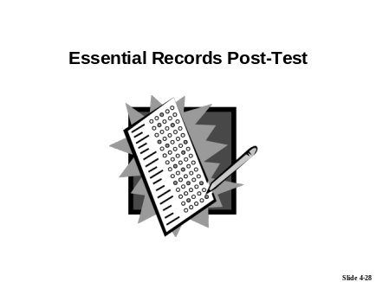
Introduce the Essential Records Post-Test.
- Say:
- The Essential Records Post-Test is conducted to assess what you learned from this course about identifying and protecting essential records. The results of the Post-Test will be compared with the results of the Pre-Test to determine the effectiveness of this training course.
- As with the Pre-Test, we will not share your Post-Test grades with other participants or anyone else outside the project. Reports to FEMA will include composite scores for the entire class, but will not identify individual participants' scores.
- On your Participant Dashboard in the IPER Resource Center, there is a link to the Post-Test Answer Sheet. When the test is over, I will provide the password that allows you to access the answer sheet.

NOTE TO INSTRUCTOR:
The following “Says” are extremely important to convey to participants.
Say:
- Remember, when you are taking the test, you will need to select “Next” to advance to the next question, and you will need to select “Submit” when you’ve finished the last question.
- Also remember not to switch to another content tab (i.e., don’t leave the “Test” tab) before completing the test, because if you do, you will not be able to return to test.
- Select “Completed” in the Feedback area when you have completed the test.
- Please do not talk during the test. If you need to communicate with an instructor during the test, please do so via the Chat tool.
- You will have 20 minutes to complete the test.
- Class will resume in 20 minutes at <time when class will resume>.
- Please start the test now.

Set up the Feedback Tool in iLinc.
- Select the “Assignment status” answer set.
Type the following reminder in the Chat tool, using the “Public” tab:
- Remember to select “Completed” in the Feedback Tool when you’ve finished taking the test.
Pause the iLinc recorder.
Launch TestLinc in iLinc:
- Test: Essential Records Post-Test
When 20 minutes have passed, and if all participants have completed the Post-Test (based on the input from the Feedback Tool), close TestLinc and resume the class.
- NOTE: If, after 20 minutes, people are still taking the Post-Test, allow a few extra minutes beyond the allotted 20 minutes. If, after the extra time, there are still people taking the test, move forward with the class, and allow them to continue taking the test.

Provide the password to the Post-Test Answer sheet:
- Password: ER_test1112
- Tell it to the participants and type it into the Chat tool, using the “Public” tab.
NOTE TO INSTRUCTOR:
- It’s OK to provide the password if some participants are still taking the test.
Restart the iLinc recorder.
Show slide 4-29.

Thank participants for their participation.
Ask for and resolve any outstanding questions.

Say: Please don’t hesitate to contact us, should you have any questions about the content we covered today or about the course in general. Our names and contact information are provided in the Chat tool, on the “Public” tab.
- Type your names and contact information in the Chat tool, using the “Public” tab.
Say: The folks at IPER want to keep in touch. So, in six months they’ll be sending out follow-up surveys to those of you who have participated in both IPER courses to see how you’re doing with incorporating your essential records into your COOP Plan. We ask that you please take the time to complete the survey, as your input is invaluable.
Remind participants that they can access course materials, as well as contact instructors and IPER Staff, through their own Participant Dashboard on the IPER Resource Center.
Say: That wraps up the Essential Records Webinar. As we said, please don’t hesitate to contact us should you have any questions. We've enjoyed working with you on this webinar and wish you well on your essential records endeavors!
- NOTE: If any participants are still taking the Post-Test, tell them that you will keep the session open for an additional 10 minutes, to allow them to complete the test.

NOTES TO INSTRUCTOR:
- You may, for any reason, conduct a follow-up session with this class (to review a topic, touch base on progress, etc.). If you elect to do so, please contact IPER Staff to arrange the session.
- If you do choose to conduct a follow-up session, inform the participants about it at this time. Be sure to provide the date, time, and purpose of the session.
Stop the iLinc recorder.
End the webinar session.
- Remember to dismiss all the participants in iLinc.
NOTE TO INSTRUCTORS:
Immediately after the conclusion of Session 4, do the following:
- Email the answer sheet to the Determine Timeframes for Accessibility activity to the participants.

[This page intentionally left blank.]

