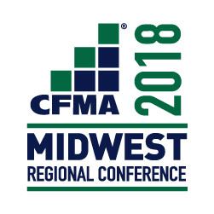
2018 CFMA Midwest Regional Conference
Exhibitor Registration
September 24, 2018
Exhibit Time: 7:00 a.m. – 5:30 p.m.

Exhibit space is limited and will be assigned on a first-come basis.
Exhibit space is $300.00
Includes: one 6ft. skirted table, two chairs, breakfast, lunch and one ticket to the
Networking Cocktail Reception on Sunday, September 23, 2018 (time and location TBD)

Contact Name
Exhibitor Name
Organization
Address
City, State
Zip |  | Phone
Email
I am an exhibitor representing the following CFMA Chapter (select one)
Chicago Fox Valley Milwaukee Madison Western Michigan SW Michigan
Quad Cities Other – Please specify:
Payment Method
Please invoice me at the address listed.
I wish to pay by credit card. Please contact Deb Hypke at 815-806-4908 to pay by phone.
I wish to pay for additional representatives to attend the Networking Reception at $50 each
Please include names of additional attendees: ____________________________________________________________________________

Payment must be received by September 16, 2018 to guarantee spot.
Please reply by returning this form and payment to:
CFMA Chicago Chapter
20960 S. Frankfort Square Road, Suite B ♦ Frankfort, IL 60423 ♦ (815) 469-1901 Fax
Questions? Contact Deb Hypke at (815) 806-4908 or dhypke@managementservices.org

Exhibitors will receive a confirmation email with set-up instructions, exhibit hours and cancellation policy.

