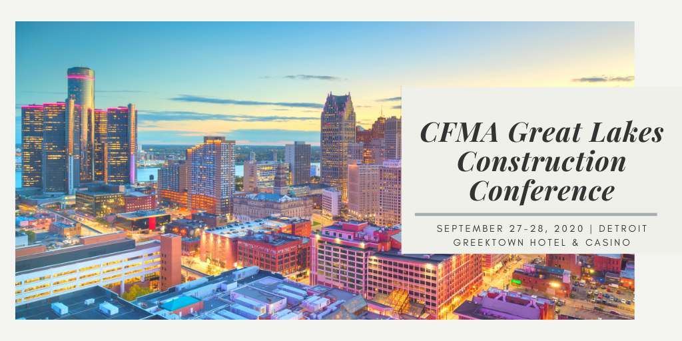
Great Lakes Conference Agenda

Sunday, September 27, 2020
2:00-4:00 CFM Challenge
4:00-6:00 Discover Detroit: Pedal Pub & Round Table
6:00-8:00 Dinner in Detroit - Red Smoke

Monday, September 28, 2020
7:00 Registration and breakfast
8:00 - 9:00 Become Unmistakable: Mike Novakoski, President & CEO of EV Construction
9:00 - 10:00 Leadership & Motivation: Herman Moore, Team 84
10:00 - 10:15 Break
10:15 - 11:15 Data Analytics for Construction Industry: Bob Tinglestad , Plante Moran
11:15 - 12:15 Accounting Methods for the Const Industry: John Gallo, UHY
12:15-1:15 Lunch/Detroit Construction
1:30 - 3:00 Cyber Security Panel: Bill Kowalski, Rehman, Hylant, FBI
3:00 - 3:15 Break
3:15 - 4:30 Worker's Comp Do's/Don'ts for CFM's: Mike Sanders, Foster Smith

Schedule and topics are subject to change; Session information will be updated with more detail soon

