TOP TIPS FOR FILMING AN INTERVIEW
This guide has been put together to help ensure consistency of the interviews across all contributors and will cover some basic filming guidelines as well as best practices for your working group and the interviewee.

The Process to follow

CFA UK staff all have Zoom licenses that can be used to create online recordings. Using Zoom you can either create a video recording using webcams or an audio recording simply using a microphone.

Arranging your recording in eight steps:
- Decide on the objectives for your recording – what do you want the audience to learn?
- Select your speaker(s) / Interviewee(s)
- Email the team at CFA UK to notify us of the new content – we ask that you contact us two or more weeks ahead. You can email the volunteer team (volunteer@cfauk.org) and they will put you in contact with the right staff members if you need any guidance.
- Prepare the format and the questions or points to be covered – make sure interviewee/s are briefed. Decide if you will be interviewing or introducing etc.
- Ensure anyone being recorded has appropriate equipment – microphone, headset, webcam etc.
- Arrange a quick test with the staff and speaker a few days before the recording to check the equipment is producing high enough quality video and sound
- Ensure you have time booked out on the day to do a few takes – it is fine if anything needs to be redone as this can be edited out
- Shorter is better for engagement – aim for each recording to be no more than 20 minutes and five-minute recordings are very welcome
- When you run the test, make sure all of the conditions are the same that will be used on the day including the room and lighting
- Once the recording is complete, the editing process will be handled by the staffed office

EXTRA TIPS FOR PRODUCING A QUALITY RECORDING (volunteers and interviewees)

Performance

- Please keep your questions/answers as concise as possible.
- Speak at a comfortable pace.
- Leave a few seconds before and after you speak, maintaining eye contact with the lens. Keep a good posture, this is helped by finding a nice simple chair to do the interview on. We can always cut out content but we can’t add it in if it's not recorded.
- It's better to be warm unless the content requires a stern voice
- Sincerity is important, be yourself.

Framing - must be landscape
Try to position yourself so that you're comfortable, and also a medium distance away from the camera, so that you appear as slightly more than head and shoulders.
Try not to leave too much headroom or cut off the hairline by having too little headroom.

Your eyes should be focused on the lens of the camera. The camera should be just below eye level so that you are not looking up or down at the camera.

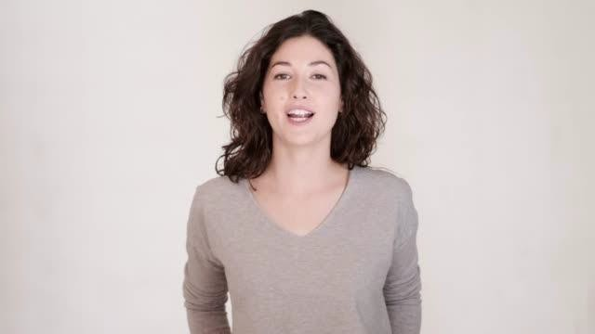

Clothing
Wear a block-colour dress or top or a plain shirt and no heavily patterned ties (they pixilate on camera).

Location
This is very important as it will have a huge impact on sound and image quality.

The most ideal location is:
- Quiet with no air conditioning, traffic, people, or fridge humming
- Soft furnishings and a carpet (reduce echo)
- Light and open with lots of windows and a simple and light-coloured background

Sound
- Good sound is critical for a clear and clean film.
- The suggestions in the Location section above are a good start to improving audio.
- You will have to monitor your own sound meaning that you will need to restart the line or section if you hear a noise (Kids, car horn, aeroplane...etc.).
- Speaking loudly and clearly (avoid shouting) will help as background noise will be quieter in comparison.

Image
Image will largely depend on equipment and location.

Most webcams are able to produce high-quality video and audio. Having someone else to check the framing and lighting whilst you are sat down will really help make sure the image looks as good as possible.
Schedule your calls for daytime, so that you can take advantage of natural light.
Position your laptop so that you're comfortably facing a window, but not in direct sunlight. This is going to bath your face in natural daylight and give the camera in your laptop the best chance of recording high-quality video.
It's best to be lit using natural light rather than indoor lights (They make your skin tones look orange).
If you do need to record in the evening, then try to find a desk lamp, ideally one with diffuse, soft light, and place that behind your laptop, so that you're facing it.

