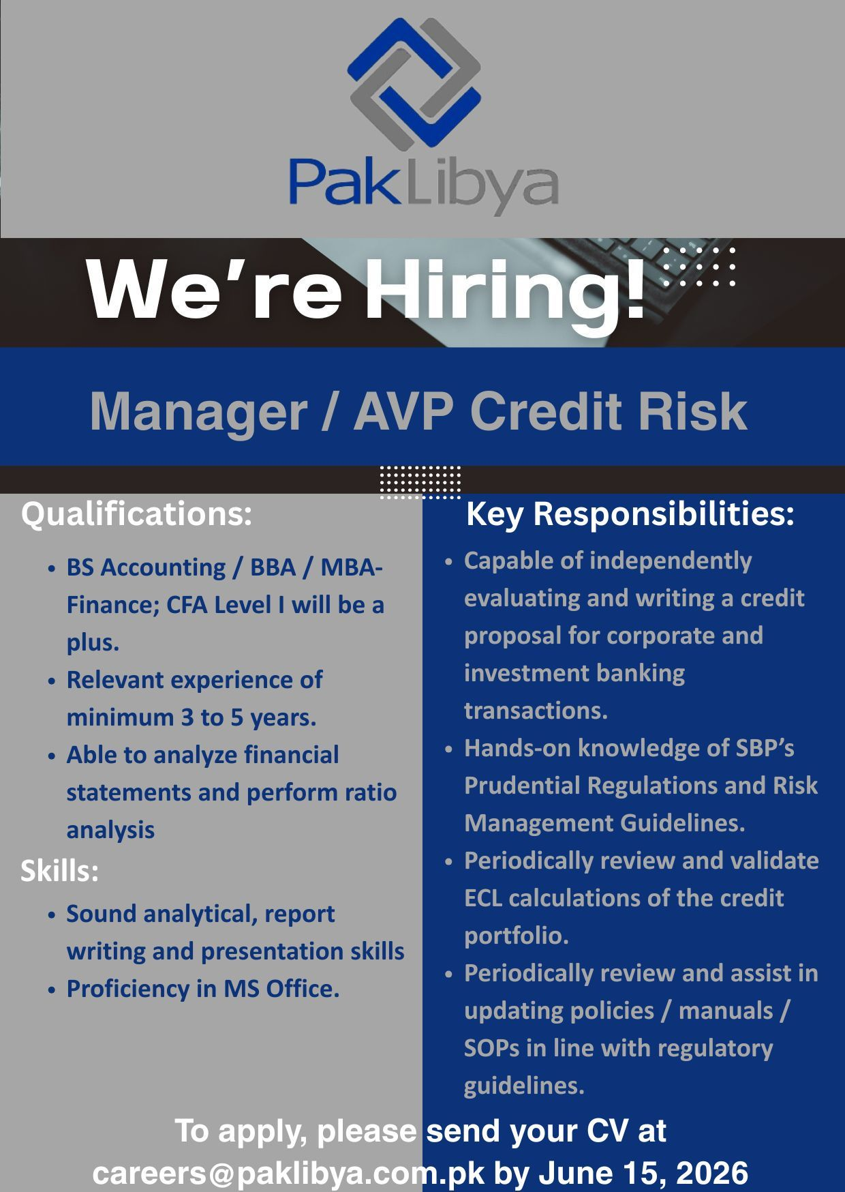


Apply here: https://www.linkedin.com/posts/paklibya-holding-company-pvt-limited_creditrisk-avp-manager-activity-7468651371421134848-HbMP?utm_source=share&utm_medium=member_desktop&rcm=ACoAAFZbl4cBL-0IaTm162tHHKU0V8N-rlQPnVY

