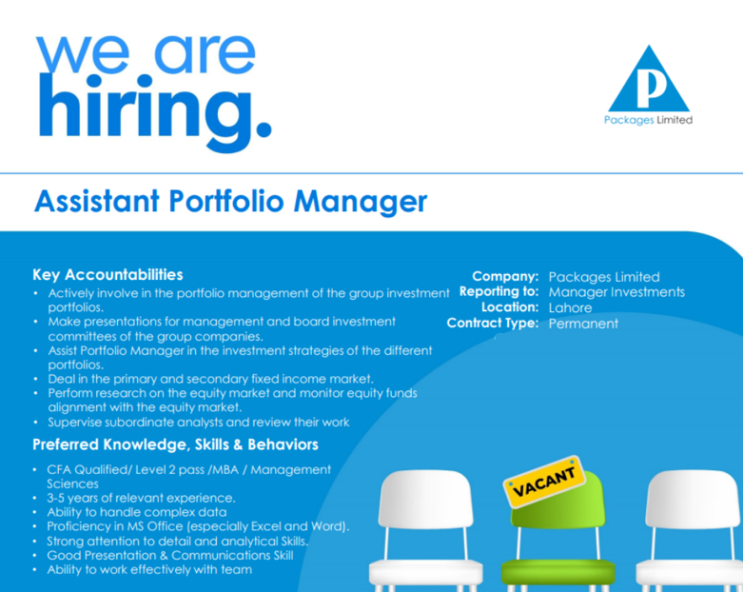
Experience on the equity side will be an added advantage
Application Details:
Interested candidates are requested to apply by emailing their resumes to nataliya.farrukh@packages.com.pk by 28-Apr-2026.

