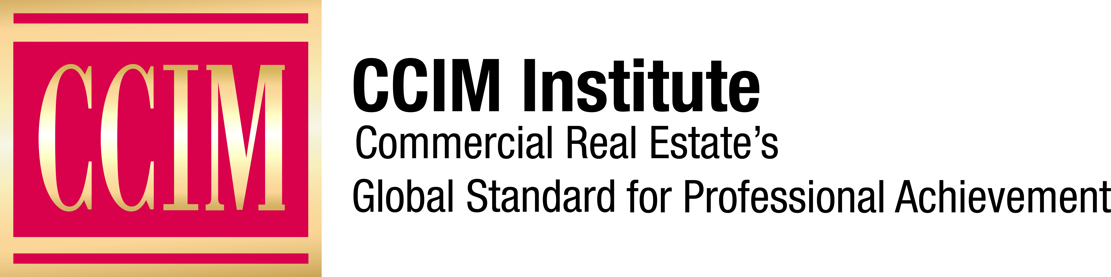

Contact: [Name of Chapter Contact] at [Phone number] or [Email address]

[Chapter name] CCIM Chapter Honors New CCIM Designees

The CCIM Designation signifies expertise in the Commercial Real Estate Profession.

[City, State], [Date] — The [Chapter name] CCIM Chapter is pleased to announce that a group of its members have been awarded the CCIM Designation. This unrivaled achievement highlights the hard work and dedication of our members in maintaining the highest standards of professionalism in their commercial real estate professions.

The CCIM Designation is earned by individuals who have committed the time, resources, and affirm themselves at the forefront of commercial real estate with confidence and authority. In addition, they all have met the rigorous requirements set by The CCIM Institute, which includes extensive education, experience, and a commitment to ethics and deal-making.

The following [Chapter Name] CCIM Chapter members have earned their CCIM Designation:

- [List names, CCIM, title, firm, city, state, for new CCIM Designees]

We congratulate these members for their outstanding achievements and look forward to their continued contributions to [Chapter name] CCIM Chapter and The CCIM Institute. As they continue to grow and advance their commercial real estate profession, these CCIM Designees will exemplify success, excellence, and experience within the commercial real estate industry.

“CCIM Designees are recognized as an elite group of experts in commercial real estate and are proven to help individuals and businesses minimize risks, maximize ROI, and close more deals,” says David Schnitzer, CCIM, 2023 Global President of The CCIM Institute. “We are so excited that these individuals who earned the CCIM Designation are now part of our elite family that distinguishes itself with its clients, businesses, and the communities they serve.”

[OPTIONAL: Add Quote from Chapter President]

To earn the CCIM Designation, commercial real estate professionals must complete more than 160 hours of case-study-driven education covering topics such as interest-based negotiation, financial analysis, market analysis, user decision analysis, investment analysis, and ethics in commercial investment real estate. They must also compile a portfolio demonstrating the depth of their commercial real estate experience and pass a comprehensive examination.

###

About The CCIM Institute
Founded in 1967, The CCIM Institute is a professional association advancing all disciplines of commercial real estate. The CCIM Institute provides education, technology, and a global network for its 13,000 members and 59 chapters worldwide. For more information, please visit www.ccim.com.

