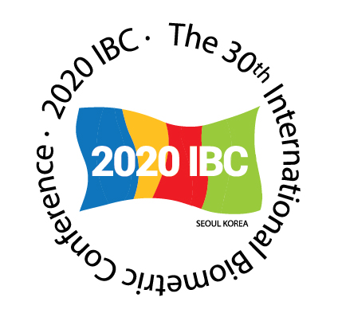
INTERNATIONAL BIOMETRIC SOCIETY
Short Course Proposal
30th International Biometric Conference
Seoul, South Korea, 2020

Please submit your proposal for a Short Course by email to the Education Committee Chair, Annette Kopp-Schneider at kopp@dkfz-heidelberg.de with a copy to the International Biometric Office (IBO) at conference@biometricsociety.org.
Proposals should be submitted on or before 11 February 2019.
TITLE:

Instructor(s) in presentation order:
 | Instructor 1 | Instructor 2
Name
Address
Phone
Email

Proposed length of course, select one: HALF DAY FULL DAY

ABSTRACT: In 200 words, describe the motivation or the course. Why is it important and timely to present this topic, with reference to current developments in theory and applications? Also, provide an overview of the proposed course content.

TARGET AUDIENCE
Assessed on a 5-point scale
- Primary target audience
- Possible target audience
- Might benefit from the course
- Difficult to assess/do not know
- Unlikely to be the target audience

Mark the appropriate score for each category below with X.
 | 1 | 2 | 3 | 4 | 5
Academic statisticians working on the development of statistical methodology (including graduate students)
Epidemiologists/statisticians working in the field of epidemiology
Statisticians working on applications from clinical medicine
Statistical geneticists/statisticians working on genomic data
Statisticians working in the pharmaceutical industry
Statisticians working on applications from ecology/forestry/agriculture
Providers of statistical education: university lecturers, teachers, etc.
Statisticians from developing countries
Statisticians from South Korea, the host region for the conference
Other (please specify):

PREREQUISITES: Describe the difficulty level of the course and what prior knowledge/experience is required by the participants.
OUTLINE: Provide a detailed description of what will happen in each course session.

LEARNING OBJECTIVES: Please provide a clear and concise statement of the learning outcomes. Identify what knowledge, skills and/or attitudes participants are expected to achieve/demonstrate as a result of the course.

INSTRUCTORS: Include a brief paragraph about the background of the instructor(s), including subject matter experience, as well as teaching experience. Previous course taught with details of dates/locations must be included. If the instructor is not from an English-speaking country, state whether they have taught any courses in English.

REFERENCE(s): Provide names and email addresses of one – two individuals who have attended a course by you and would be able to provide comments on you as an instructor.

AUDIOVISUAL (AV) EQUIPMENT: A data projector will be provided; please list any additional equipment needed.

TEXTBOOK: If a textbook is required/recommended, include author(s) name(s), publisher and contact information and retail or special discounted cost. The textbook must be available on or by October 2019 in order to be included with the course.

LAPTOP: Specify if you recommend/require the participants to bring a laptop.

Please submit proposals by email to the IBS Education Committee Chair, Annette Kopp-Schneider at kopp@dkfz-heidelberg.de with a copy to the International Biometric Office (IBO) at conference@biometricsociety.org, no later than 11 February 2019.

