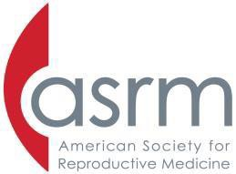
The American Society for Reproductive Medicine
Research Institute Grant

Proposed YEAR 1 BUDGET Summary

 | Grant Request | Institutional Contribution | Total Available for Project
Personnel
(itemize individuals’ compensation, benefits and include % effort on separate page)

\
Subtotals
Supplies (itemize and list on separate page)
Subtotals
Other Expenses (itemize, justify and list on separate page)
Subtotals
Overhead (not to exceed 10%)
TOTAL | (Not to exceed $250,000)

Applicant Printed Name Department Chairman Printed Name

Applicant Signature and Date Department Chairman Signature and Date

Institutional Official Printed Name

Institutional Official Signature and Date

Electronic submission is required to apply for this research grant. Please submit all required documents in a single pdf file in the order designated in the RFA to: asrm@asrm.org by midnight May 7, 2019 (extended deadline).

Budgetary requests are not to exceed $250,000 per year for up to three years including overhead costs NOT to exceed 10%. Any additional institutional budgetary commitment(s) to the project should be described and included in this page. A signed letter by the relevant institutional officer responsible for this commitment should also be included with the application. If distribution of costs for years 2 and/or 3 are different from year 1, please submit detailed separate description and justification.

