2020
Student Scholarship Application

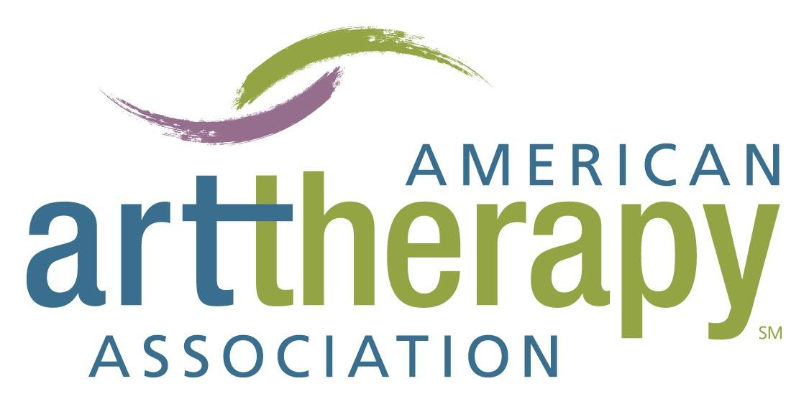

The American Art Therapy Association and its generous donors provide a number of scholarships annually which are presented at a special ceremony during the Annual Conference to encourage the growth of the profession by rewarding excellence and enabling access to information and resources for the members who are selected by the Scholarship Committee. The scholarship awards process is highly competitive.

2020 SCHOLARSHIP APPLICATION OVERVIEW AND DIRECTIONS

APPLICATION DIRECTIONS
Scholarship award applicants must be current members of the American Art Therapy Association. All applications, with full attachments must be received by May 1, 2020. Students applying for awards must be enrolled for fall 2020 classes in an Undergraduate, Graduate or Doctoral Art Therapy Program (details below). Student applicants must be first or second year students (for the upcoming term of fall 2020), and if part-time, enrolled in 3 courses for the fall academic term. Enrollment in 2 courses will be considered based on the school's typical plan of study and at the discretion of the scholarship working group. Awards are granted only to active Student members of the Association. Attendance at the Association’s Annual Conference, where the awards will be given, is strongly encouraged. Attendance is considered in the application selection process, and in some cases, attendance is mandatory for acceptance of the award.

DEADLINE
May 1, 2020 is the deadline for applying for all scholarships. All applications, including all attachments, must be mailed or emailed to the address below and received in office by May 1, 2020. Incomplete application packets will not be considered.

DATE AWARDED
Scholarships are announced each year at the American Art Therapy Association Annual Conference Awards ceremony. Recipients will be notified in June about the decision on their application.

SCHOLARSHIP AWARD LEVELS
Scholarships are determined each year through the Association’s annual budget process. The maximum scholarship award levels for 2020 are noted below after each scholarship definition requirement.

TO BE CONSIDERED COMPLETE, ALL APPLICATION PACKETS MUST INCLUDE THE FOLLOWING:
- APPLICATION FORM
A completed Application Form indicating the scholarship(s) the applicant is applying for must be submitted. One application is sufficient for all scholarships for which a student is applying. If a student is interested in being considered under more than one scholarship category then that should be noted on the application form. Only one scholarship is given per individual per year.

- OFFICIAL TRANSCRIPT
The official academic transcript indicating the most recent university enrollment and attendance must be included with the application. Transcripts must be sent to the Association directly from the respective University or by the applicant in an unopened, official University envelope that has been sealed by the University. Be sure to allow sufficient time for the transcript request from your University to be included with the Application. No exceptions to this policy will be permitted. Mark “Transcript” and the name of the Applicant on the outside of the sealed envelope.

- LETTERS OF RECOMMENDATION
Two (2) academic or work-related signed letters of recommendation must be received in the application package. These letters should not be sent separately from the application package as they may not arrive by the deadline and the letter may be confused with other applications. The letters should be on the letterhead of the institution they represent and the contact of the reference should be included.

- FINANCIAL FORM
The applicant’s Financial Form should be included in the Application Package. The Financial Form is located in the members’ only section of the website and it must be completed as indicated on the form.

- ESSAY
One essay, limited to two (2) double spaced typed pages, must include a brief biography and a statement of how you view your role in the future as an art therapist. Your full name, mailing address, and the program and institution that you are attending should be included at the top of the essay.

- PROOF OF ACCEPTANCE OR ENROLLMENT
Documentation indicating acceptance or enrollment in an art therapy program must be included with the application. This must be in the form of an Acceptance Letter, proof of enrollment in classes for the fall 2020 semester, or another such letter from your program indicating you will attend classes during the upcoming fall 2020 semester.

INSTRUCTIONS FOR ALL SCHOLARSHIP APPLICANTS (PLEASE READ):
The applicant is responsible for ensuring all documents including the completed application, transcript, two letters of recommendation, financial information, essay, and school acceptance and attendance documentation are received by the Association by the deadline.

  - Official Transcripts must be requested by the applicant from the school in sufficient time to be included in the complete scholarship application packet to be received by the Association on May 1, 2020. The transcripts should be sent in an unopened, official University envelope that has been sealed by the University.

If all other materials are sent via e-mail, it is important to note on the application that the transcript is being sent to arrive by May 1 to the Association. The name of the application should be marked on the transcript packet.

  - Financial Form: The applicant is responsible for sending the student financial information form to the appropriate institutions to be completed and included in the scholarship application by the May 1, 2020 deadline. The student should include the financial information form with the applications packet. Transcripts and the financial information forms are the only documents that may be sent separately from the Application Packet. However, if possible, the applicant should collect all documents and send as noted above as one packet.

  - Letters of Recommendation must be requested by the applicant and signed by the letter writer. The letters must also be written on letterhead, include the contact information of the reference, and should be sent to the applicant for inclusion in the consolidated Application Packet.

  - Documentation indicating acceptance or enrollment in an art therapy program must be included with the application. This must be in the form of an Acceptance Letter or proof of enrollment in classes for the upcoming semester. This information must be gathered by the student and included with the application packet that is sent via e-mail or mail.

  - Please do not bind or staple documents or include extraneous information with your application. The Association is not responsible for collecting information that is not included in the Application Packet; the applicant is solely responsible for ensuring that all materials are received to meet the required deadline of May 1, 2020.

  - If selected, you will be required to submit a brief biography and photograph that will be used at the awards ceremony as well as to publicize award recipients to the Association's membership.

  - All documents should be included in one application packet and mailed or e-mailed to AATA. When submitting via e-mail, please combine your application and supporting documentation into one attachment instead of several individual attachments.

Submit the complete application package to:

American Art Therapy Association

Attn: 2020 Scholarship Application

4875 Eisenhower Avenue, Suite 240
Alexandria, VA 22304
info@arttherapy.org

Questions may be submitted to the National Office: info@arttherapy.org

American Art Therapy Association 2020 Scholarship Application

SECTION I: APPLICANT CONTACT INFORMATION (Please Type or Print)

Name:

Address:

City: State/Province: Zip/Postal Code:

Home Phone: Cell Phone:

E-mail Address:

SECTION II: SCHOLARSHIP FOR WHICH YOU ARE APPLYING (Check as Many as Applicable)
☐ American Art Therapy Association Anniversary Scholarship Fund (One Award)
Available to an AATA student member with a current, or most recent, GPA of at least 3.25 who can demonstrate financial need and acceptance or enrollment in a graduate art therapy program. Students receiving this award are strongly encouraged to attend the conference. Scholarship Award: Up to $1000.00
☐ Myra Levick Scholarship Fund (One Award)
Available to an AATA student member with a current, or most recent, GPA of at least 3.00 who can demonstrate financial need and acceptance or enrollment in a graduate art therapy program. Students applying for this award are strongly encouraged to attend the conference. Scholarship Award: Up to $1000.00
☐ Rawley Silver Award for Excellence (One Award)
Available to an AATA student member whose academic record or prior experience is deemed excellent (3.50+) who can demonstrate financial need and acceptance or enrollment in a graduate art therapy program. Students applying for this award are strongly encouraged to attend the conference. Scholarship Award: Up to $1000.00
☐ Cay Drachnik Minorities Fund (One Award)
Specifically designed for the purchase of books, this fund is available to an AATA student member of an ethnic minority group who can demonstrate financial need and acceptance or enrollment in an art therapy program; undergraduate, graduate, or doctoral. The student application will be completed in alignment with the AATA Code of Ethics, Responsibility to the Profession, Section 10, in that the application is a truthful representation of self and identity. Students applying for this award are strongly encouraged to attend the conference. Scholarship Award: Up to $500.00

The following Scholarship Awards require the recipients to be present at the Annual Conference to receive the awards:
☐ Student Scholarship to the American Art Therapy Association Annual Conference (Up to Three Awards)
Specifically designed to provide financial support to student members so they can attend the Annual Conference, this fund is available to AATA student members who can demonstrate financial need, acceptance and/or enrollment in an art therapy program, and prior involvement in art as healing events. Students awarded this scholarship are required to attend the conference. Students must identify their status as undergraduate, graduate, or doctoral candidate. Scholarship Award per Attendee: Full Registration per Attendee
For 2020, the AATA is excited to announce that student & new professional recipients of these conference registration scholarships will also receive a $100 stipend to assist with conference related expenses. A check in this amount will be available for recipients to pick up on-site at the conference.
☐ Prasad Family Foundation - International Student Scholarship (One Award)
Specifically designed to provide financial support for an international student member enrolled in an undergraduate, graduate, or doctoral art therapy program to attend the Annual Conference, students awarded this scholarship are required to attend the conference. Applications must include a copy of the cover page of their passport noting the country of origin. Scholarship Award: Up to $1000.00. Students may be temporarily residing in the United States under a student visa, but must be able to identify a country of residency outside of the United States.

The following Scholarship Awards require applicants to submit additional documentation:
☐ Irene Rosner David Medical Art Therapy Scholarship (One Award)
The Irene Rosner David Scholarship focuses on understanding the role of the medical art therapist. This scholarship is available to an AATA student member who can demonstrate acceptance or enrollment in a graduate art therapy program. In addition to the full application packet, applicants must submit one (1) essay limited to two (2) double spaced typed pages, must include a statement that addresses all criteria listed below. Incomplete essays will not be eligible. A full name, mailing address, and the program and institution of enrollment should be included at the top of the essay.
- Please describe the role of a medical art therapy practitioner and how you envision yourself in that role. Be sure to include what inspired you to seek out practice and/or research in medical art therapy.
(Continued on next page)

- Please discuss two clinical goals or applications specific to a medical art therapy context. These may consist of: 1) specific examples of goals that a medical art therapy practitioner may include in a patient’s treatment plan, or 2) may describe particular applications of medical art therapy, and how these applications help to meet treatment goals for a particular patient population.
- Please identify your future plans in pursuing medical art therapy for clinical practice (such as internship) or research (such as capstone/thesis or culminating projects).
The award recipient will be required to submit a follow-up report detailing their learning and experiences gained within six months of receiving the scholarship. Scholarship Award: Up to $1,000.00

SECTION III: EDUCATION INFORMATION
Current Education Level:
☐ Undergraduate ☐ Graduate ☐ Doctoral

Graduate Level Program(s) (write N/A if undergraduate)
Name of Program:
Institution:
Matriculation Date: Expected Date of Graduation:

Undergraduate Education
College:
Degree: Major(s):

SECTION IV: SUMMARIZE YOUR PRIOR EXPERIENCE IN ART THERAPY OR A RELATED FIELD

Write or Click Here to Type:

SECTION V: DEMOGRAPHIC INFORMATION

Prasad Family Foundation - International Student Scholarship: Applications must include a copy of the cover page of the student’s passport noting the country of origin.

Cay Drachnik Minorities Fund: (Complete the section below only if you are applying for the Cay Drachnik Minorities Fund).
Minority Group Identification:
☐ African American ☐ Asian American ☐ Hispanic American ☐ Native American
☐ Other (please specify):

SECTION VI: LETTERS OF RECOMMENDATION
The two signed recommendation letters must include the phone number of the person providing the reference and the full contact information of the person providing the reference. The two letters should be on letterhead indicating the institution the person represents. The two letters must also be included in the packet sent by the student.

SECTION VII: PLANS TO ATTEND THE ANNUAL CONFERENCE

Yes, ☐ I plan to attend the Annual Conference. Yes, ☐ I am registered to attend the Annual Conference.

No, ☐ I am unable to attend the Annual Conference.

I would like to sign up to volunteer for the Open Arts Studio and/or as a proctor at the Annual Conference:
☐ Yes ☐ No
SECTION VIII: SIGNATURE & DATE

I verify the accuracy of the above information:

(Type your electronic signature or sign above) (Date)

COMPLETE APPLICATION & SUPPORTING DOCUMENTS MUST BE RECEIVED BY MAY 1, 2020.
SEND COMPLETE PACKETS via MAIL OR E-MAIL:

American Art Therapy Association

Attn: 2020 Scholarship Application

4875 Eisenhower Avenue, Suite 240
Alexandria, VA 22304
info@arttherapy.org*

*When submitting applications via e-mail, please combine your application and supporting documentation into one attachment instead of several individual attachments. Questions may be submitted to the National Office: info@arttherapy.org

