**2022 Business Meeting**

**of the APS Topical Group on Shock Compression of Condensed Matter**

July 13th, 2022, 1:00 PM, Anaheim Marriott, Platinum Room, Anaheim, California

(held in conjunction with the 2022 Biennial APS Shock Conference)

Reported by Secretary/Treasurer, J. Matthew Lane with assistance from Becky Lindsey, Mitch Wood and Brittany Branch. Attendance is reported in Appendix A. Meeting slides for this meeting have been included as Appendix B.

***Agenda:***

1. Welcome (Borg)
2. Election Report (Lane)
3. Financial Report (Lane)
4. Summary of SCCM-2022 conference (Jordan/Gleason)
5. Early Career and Student Symposium Summary (Stekovic/Pacheco)
6. Invitation to SCCM-2023 in Chicago (Peiris)
7. Ashcroft Award Review (Lane)
8. Program Committee Proposal (Jordan)
9. Topical Group Expansion Focus Groups and Discussion (Task Force)  45-60 minutes

***1. Welcome (Borg)***

The meeting was called to order by Topical Group Chair, John Borg. The list of attendees is included as Appendix A. There were 81 attendees, all in-person.

***2. Election Report (Lane)***

The Secretary/Treasurer, Matt Lane, reported on the results of the 2021 election, which was conducted online with directvote.com from October 25th to November 17th, 2021. 145 ballots were cast out of 489 eligible (29.7 % of membership voted). The candidates and winner (in bold) are listed below:

Vice-Chair, (1-year term with succeeding posts in chair line)

* **Minta Akin**
* Jerry Lee

Executive Committee, Member-at-large (2-year term, 2 seats available)

* **Rebecca Lindsey**
* **Mitch Wood**
* Chris Braithwaite
* Matthew Beason

Secretary/Treasurer (3-year term)

* **J Matthew Lane**
* Sally Tracy
* Romain Perriot

Matt thanked the 2021 Nominating Committee and chair Ivan Oleynik for putting together a very nice slate of candidates. Thanks also went to Jennifer Jordan for conducting the election.

Current 2022 Topical Group Officers and Board:

Chair: John Borg  (1/22 - 12/22) Marquette University

Chair-Elect: Peter Celliers (1/22 - 12/22) Lawrence Livermore National Laboratory

Vice Chair: Minta Akin (1/22 - 12/22) Lawrence Livermore National Laboratory

Sec./Treas.: J Matthew Lane (1/19 - 12/24) Sandia National Laboratories

Executive Committee, Members-at-Large:

Brittany Branch (1/21 - 12/22) Sandia National Laboratories

Nenad Velisavljevic (1/21 - 12/22) Lawrence Livermore National Laboratory

Rebecca Lindsey (1/22 - 12/23) Lawrence Livermore National Laboratory

Mitch Wood (1/22 - 12/23) Sandia National Laboratories

Early Career/Student Member-at-Large:

Belinda Pacheco Johnson (1/21 - 12/22) Los Alamos National Laboratory

Council Rep: Bill Halperin, Div. Condensed Matter Physics

Past Chair: Ivan Oleynik  (1/22 - 12/22), University of South Florida

***3a. Financial Report (Lane)***

Total assets as of 12/31/2021 were $469,500. The topical group took in $2,300 in member dues and $1,000 in investment income. There were no expenses in 2021.

Duvall Endowment: $92,500 and Ashcroft Endowment: $150,000

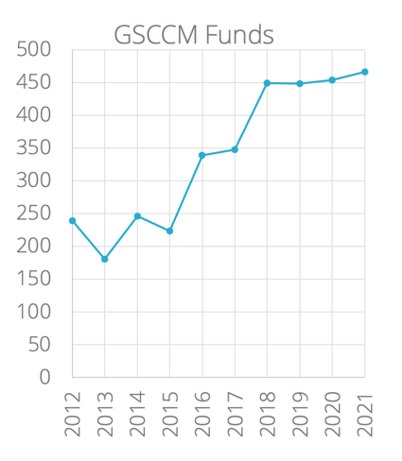

***3b. Membership Report (Lane)***

GSCCM membership has continued to grow from a low point in the mid 300s, to a current membership of 469.

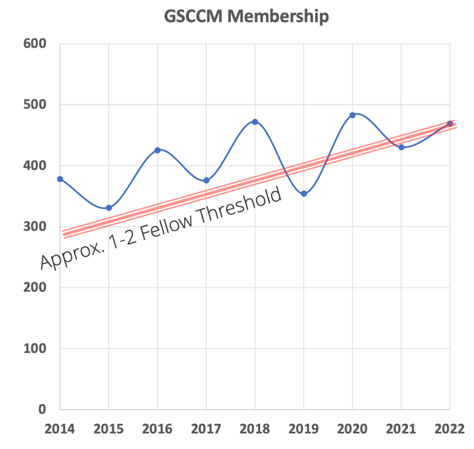 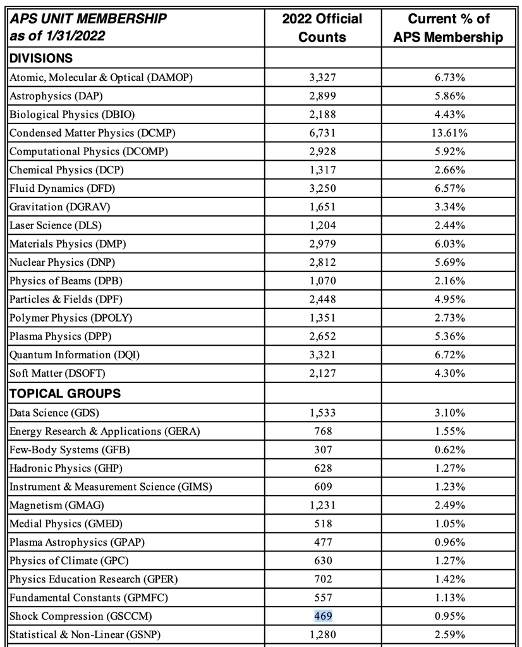

***4. Summary of SCCM-2022 conference (Jordan/Gleason)***

The 2022 conference (postponed from 2021) navigated rescheduling due to COVID, requirements from APS to find a virtual platform, and a first ever virtual abstract sorting meeting. The conference logistics were led by the APS Meetings team and technical planning led by conference co-chairs. Overall the conference is expected to lose $60,000 to $80,000 due to decreased attendance and new requirements for COVID safety protocols and virtual platform.

***5. Early Career and Student Symposium Summary (Stekovic/Pacheco)***

The early career and student symposium was held Sunday, July 10, 2022. It was an all-day event co-chaired by Lana Stekovic (Northrop Grumman) and Belinda Pacheco Johnson (LANL). The event sponsored student involvement with $18,000 in travel awards. There were 56 total attendees, 15 oral presentations, 7 rapid fire talks, and 9 posters. Awards were given in three categories.

***6. Invitation to SCCM-2023 in Chicago (Peiris)***

Su Peiris announced the 2023 meeting will be held in Chicago, IL at the Sheraton Grand. The dates will be June 18 – 23, 2023. Dayne Fratanduono (LLNL), Suhithi Peiris (Battelle) and Malcolm McMahon (Univ. of Edinburgh) will be co-chairs. There will be 12 topical areas with a focus on growth areas in (1) Emerging high-pressure user facilities and experimental techniques, (2) Static Compression Research, and (3) Data-Driven Modeling and Machine Learning.

***7. Ashcroft Award Review (Lane)***

Matt announced the recently endowed, Neil Ashcroft Early Career Award for Studies of Matter at Extreme High Pressure Conditions. The new award will be presented annually at the APS society level. The award recognizes outstanding theoretical or experimental contributions by an early-career scientist to studies of matter at extreme high pressure conditions. The award is conferred annually and consists of a $5000 stipend, a certificate, and a travel allowance.

Special thanks to the award creation committee: Eva Zurek, Shanti Deemyad, Ivan Oleynik, and Matt Lane.

***8. Program Committee Proposal (Jordan)***

Jennifer Jordan summarized a proposal to create a 6-8 member program committee. The committee would be a way to recruit and train future meeting leaders for both the March Meeting and SCCM conference planning. Continuity is a major motivation.

The first committee would be “ad hoc” per bylaws and would assist in formalizing a standing committee.

***9. Topical Group Expansion Focus Groups and Discussion (Task Force)***

*The following minutes were combined from noted taken by Mitch Wood, Becky Lindsey and Brittany Branch.*

*After a presentation outlining the expansion task force, and the focus groups which have been conducted. The floor was opened for discussion and comment.*

*Brian Barnes: The Program Committee is a great idea. Diversity and inclusion should be at the forefront. i.e., not just DOE, but better representation from DOD & academia to help increase membership in those area.*

*David Damm: Can we tap into the people that are attending this meeting but aren't members? In support of program committee, need to convert attendees into sccm members (~1500 unique attendees over the last few years) // Need to push to retain ‘non-physics’ people in off years, look for a positive not punitive encouragement to do this.*

*Ryan Wixom: Yes to program committee. Ryan is enthused about the change of the early career award, but is there going to be a traditional award for students?*

*Matt Lane: Helping promote continued membership - Pins: I've been a member for n-years, similar to the ACS mugs*

*Becky Lindsey: Likes the pin idea! She spoke with a few people about this and they all were really interested in purchasable "swag," which could be used for fund-raising for future meetings. Quality lanyards, mugs, hats, and hoodies were particularly popular ideas.*

*Dana Dlott: Dana was concerned that there might not be a Proceedings this year. Matt answered with details. APS has excellent car insurance rates - amount saved in insurance payment offsets cost of membership fee for students - a way to encourage more students to join.*

*Q1: boundaries between shock/ramp/laser/static, etc. have blurred?*

*Overwhelming response from raised hands: True*

*>90% of the audience response was in agreement with the statement about blurring the lines of topical areas in recent years*

*Q2: How important is a tie to our past versus we must maintain a tie to our past?*

*Judy Brown from Sandia: Long time in EM, but new to SCCM; MechE Background - historically went to mechanics conferences, but worked on SCCM relevant topics - Didn't get e-mails, heard word of mouth ... maybe we can reach out to candidate members by looking through who is publishing on what and send recruitment e-mails - literally just need to spread the word.*

*Keep some link to history - want them to understand how present links to past .. see evolution ... what you've had and where you're going .. see that evolution from the outside*

*Yasuyuki Hori: All for diversity and openness, but remember that we are part of APS, but not ASME, MRS, "physics is not chemistry nor biology" different from openness and diversity ... historically tried to welcome people static compression from ARAPT for static compression - they stay within that organization... "Is the only goal to increase membership?"*

*He has not seen measurable changes in the topical areas over the years.*

*Ivan Oleynik: Trend of APS is increasing and becoming multidisciplinary ... don't think we need to draw that distinction, but also don't need to forget who we are*

*Matt Lane: How to grow without dilution? We do not want to dilute content, want to grow and properly change*

*Mike Armstrong: SCCM is very specific ... other topical groups are about specific physical systems and regimes ... changing that way may attract more people. “Shock” seems too specific, name change needs to reflect a physics area.*

*Dana Dlott: A lot to offer beyond guns and bombs // Expand to have a focus session on history that addresses the tradition of the group ... part of the Duvall award lectures? Maybe bring in historians - Where's the line? Many of the newer/younger members would be interested in the history of the group and topic in general. Ultrasonic cavitation goes to acoustic society ... why not here? ... Thinks as far as name, "Dynamic behavior of materials" is general enough and covers most of what we do.*

*Joe Olles: There's something to be said for not expanding so large that you have too many people and too many parallel sessions. There's a very strong sense of camaraderie that is not found in other professional communities) ... hard to convey a message in 12 minutes, don't want to get to a point where we have to cut down even further ...*

*Context by John Borg: Want to still be small enough to have that sense of community -- we don't want to grow as big as we can, just a little larger community of people ...*

*Dana Dlott: Maybe set doubling as an upper limit*

*Ryan Wixom: Focus on the extreme conditions bit ... its really high temperatures -- use the program committee to constrain topic areas to help focus what's presented/what the group is about, but more selective with who gets talks, can put unrelated talks in poster session. For names, in favor of ‘ultrafast’, ‘high-temperature’. Can push some extra talks to posters, make poster sessions more robust.*

*Ian Ocampo - his first meeting, graduate student, geologist: Feels more at home here than any of the geo conferences ... lots of geophysicists likely feel the same way .. current geo static compression conference (COMPRESS) is in question going forward, so a community of static and dynamics compression geo physisists looking for a home*

*Matt Lane: follow up, how do we do this in a manner that we're not just stealing from others*

*Expanding SCCM topical group should stay within condensed matter and not cross into plasma physics. Maybe ask a few people to create symposia to pull in people from other communities*

*Include special symposium to encourage new membership.*

*Focus group in extremes*

*Christine Wu: Comes here to hear different work on related methods/applications/problems ... going to a place where she could talk about different aspects of the same problem, i.e., the physics versus chemistry versus mechanics of shock compressed matter. She wants this conference to be where you hear new ideas // wants static compression community present in this conference/community. Enjoys the multi-disciplinary nature of this topical group.*

*-- thinking about the future: What kind of students do we want to attract that will move the society forward ... everyone's interest evolves over time, could be a lot of cross-talk between communities.*

*Stan (?) – Background in statics // students are trained in ‘feeder’ areas that roll into the large facilities/programs nationwide/globally. Need to address what kinds of students are going to carry this topical group forward in years to come.*

*Brian Barnes.: comments on broadening to extremes, including extremes in the name: Q to Ivan on discussion group on materials under extremes... thoughts on the other extremes communities in APS? Focus at March meeting on matter in extreme conditions, this is more general than “shocks” (Question to Ivan Oleynik how to bring those people to sccm)*

*Ivan response: APS suggested SCCM be the home of the extreme conditions categories.*

*Oleynik - Focus topic groups organized by divisions (DCOMP, DMP, etc) need to lean on these organizers to advertise? // Individuals are the connection point to these divisions, need something more formal. // Need to bring in the statics community.*

*Mark (?): For names… Likes the words extreme, likes broadening, but doesn't like "materials" likes matter more than materials .. "a rock is not a material" (lol) ... broadens us much better*

*Naresh Thadani – Disciplines evolve, need to acknowledge that, has personally seen this shift (gave example of how more materials science considerations like microstructure are picked up by everyone). best part of this group is that we all work together, even with very different backgrounds ... evolution of topic is important ... 2 decades ago, no one was discussing microstructure, now everyone is ... now mechanics are relevant ... now we call care about strength ... evolutionary and self-organized ... not forced extensions to different areas .. people just came because they were either learning from shock people and shock people learning about whether microstructure matters*

*Brittany Branch: Knows this society is attached to the national labs… Outreach is a major issue ... at academia, most faculty not familiar with topical groups .. needs to reach out to students at universities to raise awareness ... some type of committee with fellows/senior members to do outreach because as you progress through career, have established those contacts "currently, people don't become part of our society unless they're tied to the DOE/DOD mission" .. need outreach beyond DOE/DOD. Group is cross disciplinary and that’s visible with evolution of program topics. Need further outreach and recruitment to other communities i.e. static, acoustic, geophysics, etc.*

*Ryan Wixom: Other groups do outreach for their topical group at the march meetings , table outside their sessions, posters, etc ... we're not doing that ... advertise that way and tell them about the march meeting - Need more representation at the march meeting*

*Ivan Oleynik: difficult to recruit students into this field because it doesn't look sexy, but there's so much interesting science going on, but not apparent from the name ... "shock doesn't sound very exciting" (Note from Becky: I agree. I think as a group we would benefit from having some promotional materials (slides/posters/etc) that we can use to advertise at booths or in presentations we give that overview some of the "sexier" applications our group focuses on, e.g., explosives, planetary science, etc. Maybe we could start by collecting cover art/"artists interpretation-like" figures from members of our group?)*

*On the list of candidate name ideas:*

*AWE member: Doesn't do shock or extreme but feels like he fits in ... if we refocus and rename to shock and extreme (and mean it) then I'll stop coming because I'm not welcome here .. so is the name change actually narrowing the outlook? ‘extreme’ is everywhere now, consider using that in the name to pull more people in. Pointed out that there is a large international contingent, and to be aware that the US (national lab) focus may hurt in recruiting new members.*

*UK Professor: Word extreme is being widely used ... e.g., synchrotrons ... extreme is being applied in our field ... word students will recognize from mass media they've heard of and sounds exciting ... also, this is a very DOE/DOD lab-centric communities ... need to be an international community ... need to bring in people from UK and CEA ... don't' just consider the best for the US, consider the effect you'll have outside these shores*

*Consider the international community, not just DOE and DOD.*

*John Eggert: Started as a static person, favorite meetings have been SCCM+AIRAPT. 1st time joint AIRAPT/SCCM meeting ... his favorite meetings, and the broadest ... shock in the name hurts inclusiveness (statics don't show up) ... name should get rid of dynamic and shock ... and extreme eliminated .... want to be inclusive, I think we are inclusive, but need to be more-so -- plenty of people in APS (static) don't have a home. Don’t dilute or grow too much. March meeting too big, but is a good opportunity to recruit speakers but don’t want meeting to become this big*

*Yasuyuki Hori: Question: Any subgroups within APS that changed name? Yes, but we are the largest who've ever done this ... only allowed if changing scope and need name to change afterward ... i.e., can't just change name for the sake of it*

*Name should be more specific and concentrate on regimes and physics phenomena.*

*Have focus sessions that addresses history but expands towards multidisciplinary.*

*Comments on naming:*

*Proposed Name: Dynamic Behavior of Materials*

*Use EXTREME to attract younger generations, used widely and resonates with students*

*Keep MATTER not Materials in name*

*Name change might narrow membership*

*Membership be part of registration.*

***Appendix A: Meeting attendees. (81 total attendees)***

|  |  |  |
| --- | --- | --- |
| Minta | Akin | LLNL |
| Michael | Armstrong | LLNL |
| Tom | Arsenlis | LLNL |
| Brian | Barnes | ARL |
| Nathan | Barton | LLNL |
| Iskander | Batyrev | ARL |
| Matt | Beason | LANL |
| Jack | Borg | Marquette University |
| John | Borg | Marquette University |
| Neil | Bourne | Univ of Manchester |
| Brittany | Branch | SNL |
| Judith | Brown | SNL |
| Justin | Brown | SNL |
| Katie | Brown | NSWC IHD |
| Tod | Caldwell | NNSA |
| Peter | Celliers | LLNL |
| Peter | Chung | Univ of Maryland |
| Federica | Coppari | LLNL |
| Scott | Crockett | LANL |
| Allen | Dalton | NNSA |
| David | Damm | SNL |
| Dana | Dattelbaum | LANL |
| Dana | Dlott | Univ. of Illinios |
| Avinash | Dongare | Univ of Connecticut |
| Leora | Dresselhaus-Marais | Stanford |
| Jon | Eggert | LLNL |
| Tim | Germann | LANL |
| Arianna | Gleason | SLAC |
| George T. (Rusty) | Gray | LANL |
| Brenden | Hamilton | LANL |
| James | Hawreliak | WSU |
| Nathaniel | Helminiak | US Military Acad. (West Point) |
| Bryan | Henson | LANL |
| Yasuyuki | Horie | UDRI |
| Trevor | Hutchinson | LLNL |
| Zsolt | Jenei | LLNL |
| Jennifer | Jordan | LANL |
| Robert | Knepper | SNL |
| Rick | Kraus | LLNL |
| Andy | Krygier | LLNL |
| Matt | Lane | SNL |
| Becky | Lindsey | LLNL |
| Jonathan | Lino | LLNL |
| Rafee | Mahbub | Marquette University |
| Anirban | Mandal | LANL |
| Christopher | Meredith | ARL |
| Marc | Meyers | UC San Diego |
| Kien | Nguyen-Cong | Univ of South Florida |
| Ian | Ocampo | Princeton Univ |
| Ivan | Oleynik | Univ of South Florida |
| Joe | Olles | Navy |
| Kathy | Opachich | LLNL |
| Suhithi | Peiris | Battelle |
| Yuan | Ping | LLNL |
| Vikas | Prakash | Washington State Univ |
| Mike | Prime | LANL |
| Pritha | Renganathan | Washington State Univ |
| Ryan | Rettinger | LANL |
| Rob | Rudd | LLNL |
| William | Schill | LLNL |
| Chris | Seagle | SNL |
| Tommy | Sewell | Mizzou |
| Laura | Smilowitz | LANL |
| Camelia | Stan | LLNL |
| Blake | Sturtevant | LANL |
| Naresh | Thadhani | Georgia Tech. |
| Scott | Turnage | ARL |
| Kevin | Vandersall | LLNL |
| Tracy | Vogler | SNL |
| Justin | Wark | University of Oxford |
| Emily | Weerakkody | LLNL |
| Trevor | Willey | LLNL |
| Cyril | Williams | ARL |
| David | Williamson | University of Cambridge |
| Jonathan | Willman | USF |
| Ryan | Wixom | SNL |
| Mitch | Wood | SNL |
| Christine | Wu | LLNL |
| Choong-Shih | Yoo | Washington State Univ |
| Min | Zhou | Georgia Tech. |
| Tony | Zocher | LANL |

***Appendix B: Meeting slides (12 slides)***