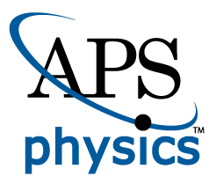
EMBARGOED FOR RELEASE
Until 7 a.m. EDT, Monday, November 8, 2021
MEDIA CONTACTS
Saralyn Stewart
(512) 694-2320
stewart@physics.utexas.edu

Harnessing Hot Helium Ash to Drive Rotation in Fusion Reactors
New model explains how and when waves can exploit the energy of hot fusion ash to power plasma rotation.
PITTSBURGH—In controlled nuclear fusion, heavy isotopes of hydrogen fuse into helium, releasing a huge amount of energy in the process. A large portion of the energy released by a laboratory fusion reaction goes into hot helium ash (an impurity in the plasma that bears no resemblance to ash from a fire). This ash is around 30 billion degrees Celsius, compared to 200 million degrees for the bulk plasma. For context, the temperature at the core of the sun is 15 million C. The ash energy may be captured by a plasma wave, via wave-particle interaction known as alpha channeling. The energy in the wave can then be absorbed by fuel ions, powering the fusion reaction.

The wave-particle interaction that gives rise to alpha channeling occurs when the helium ash velocity matches the velocity of the wave, a condition known as Landau resonance after its discoverer, 20th century Soviet physicist Lev Landau. This resonance allows energy and momentum to exchange efficiently between the wave and particle, in much the same way a surfer gains energy from an ocean wave when traveling at the same speed as the wave.

The result is that, twice per orbit in a magnetic field in doughnut-shaped tokamak fusion facilities, the particle receives a “kick” from the wave. Over many interactions, these kicks lead to random walk diffusion, as can be seen in Figure 1a. For a well-chosen wave, this diffusion draws ash out of the plasma while cooling it, transferring energy into the wave.

Before now, physicists did not know whether the extraction of helium ash by alpha channeling also extracts a net charge from the plasma. Such extraction drives rotation in the plasma. Rotation, in turn, can stabilize instabilities in plasma, and shear in the rotation can suppress plasma turbulence.

This reduction in instabilities and turbulence makes it possible to maintain the plasma’s high temperature with less power and reduced operating costs. Thus, extracting charge and driving rotation via alpha channeling could dramatically help to improve the performance of tokamaks.

Alternatively, if net charge is not extracted through alpha channeling, fuel ions must be pulled into the hot plasma center to balance the charge lost by the helium ash. That is also an advantageous effect. The question is: which advantageous effect occurs, charge extraction or plasma fueling?

To answer this question, we note that extraction of the charge depends on how all the plasma particles respond to the chosen wave. Treating all the components of the plasma requires a self-consistent alpha channeling model that has been missing until now.

Our model shows that there is a critical difference between plane waves that grow in time, versus steady-state waves that grow in space. A time-growing wave creates conditions that cancel all the charge extraction from the ash, by causing a slight drift in the relatively cold bulk ions (Figure 1b). As a consequence, no rotation is driven. In contrast, steady-state waves injected by an antenna at the plasma edge allow for extraction of charge and rotation drive.

More complex waves exhibit a mix of these behaviors, in a readily predictable way. Thus, this model self-consistently establishes the conditions under which alpha channeling extracts charge and drives rotation, bringing us closer to finer-tuned plasma control.
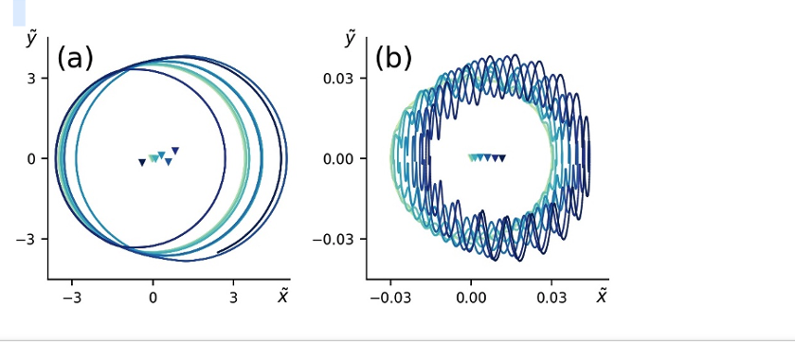
Figure 1: Trajectories of (a) hot ash and (b) colder fuel ions as they interact with a growing, high-frequency wave in a magnetized plasma. The ash diffuses stochastically due to resonant interactions with the wave. Absent any response in the fuel ions, this diffusion will create an electric field, leading to plasma rotation. However, the ion drift from left to right in (b) demonstrates new understanding of how the fuel ions respond to the wave, which can sometimes negate the rotation drive effect.
This work was supported by grants NNSA DE-NA0003871, NNSA DE-SC0021248, DE-SC0016072, and DE-FG02-97ER25308.

Contact:
Ian Ochs, Princeton University, iochs@princeton.edu

Abstract
ZI01.00001 Current Drive and Alpha-Channeling-Driven Rotation
Session ZI01: MFEVI: Waves, Energetic Particles, and Runaway Electrons
9:30 AM–12:30 PM, Friday, November 12, 2021
Room: Ballroom B

