EMBARGOED FOR RELEASE
Until 7 a.m. PDT, Monday, Oct 17, 2022
MEDIA CONTACTS
Saralyn Stewart
(512) 694-2320
stewart@physics.utexas.edu

Unveiling the Origin of Magnetic Batteries in Space
Calculations of magnetic relaxation processes reveal the origin of various current sheet types in space.
SPOKANE, Wash.—Many well-known explosive events in space, such as solar flares in the sun’s atmosphere or gamma ray bursts from distant galaxies, involve magnetic fields. A prerequisite for these events is the existence of magnetic batteries that store magnetic energy and convert it into heat energy, much like how batteries in our mobile phones store chemical energy and convert it into electrical energy. Plasma structures called “current sheets” act as these magnetic batteries and are ubiquitous in planetary magnetospheres (Figure 1), the solar wind and corona, and even in man-made magnetic fusion devices. They are also closely related to important plasma phenomena such as magnetic reconnection and turbulence that often entail explosive releases of magnetic energy, where current sheets serve as energy conversion sites.

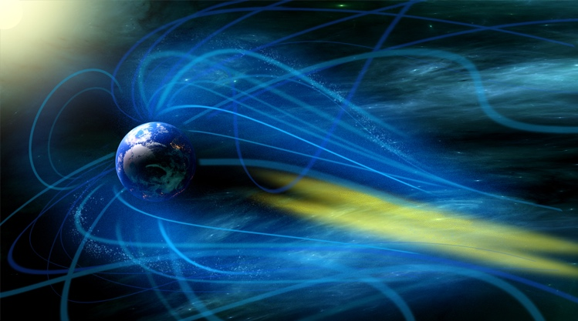
Current sheets represent a balance between magnetic and thermal forces, and they can be divided into different types depending on how each force contributes to the balance. For example, the balance may be achieved by thermal forces at the sheet core and magnetic forces at the outskirts, or even by purely magnetic forces everywhere. Current sheets are readily observed by satellites, but understanding how the different types of current sheets form has been elusive.
Figure 1: Artist’s depiction of current sheets (yellow) formed in the Earth’s magnetotail (Image Credit: Sung Jin Park).

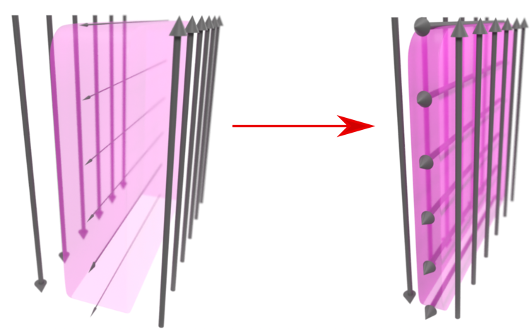
An international collaboration of scientists at Pohang Accelerator Laboratory (PAL), Pohang University of Science and Technology (POSTECH) in South Korea, and at NASA Goddard Space Flight Center (GSFC) in the U.S. has uncovered the origin of various current sheet types. The scientists first used a theoretical technique they previously developed (published in Nature Communications; doi:10.1038/s41467-021-24006-x) to predict plasma dynamics in a “relaxing” current sheet (Figure 2). Relaxation refers to the process by which an initial imbalance of magnetic and thermal forces comprising a current sheet naturally achieves balance, much like how partially filled gas in a container eventually relaxes to fill up the container. The scientists theoretically predicted that the different current sheet types originate from the infinite number of ways the initial imbalance may exist at the outset.
Figure 2: Schematic depiction of the current sheet relaxation process. The arrows are the magnetic field lines and the purple color is the plasma thermal pressure.

Next, by conducting particle simulations at the KAIROS supercomputer cluster at the Korea Institute of Fusion Energy and comparing the results to the theoretical predictions, the scientists numerically confirmed that the predicted dynamics indeed take place during current sheet relaxation. Finally, the simulation results were also compared to observations by NASA’s Magnetospheric Multiscale (MMS) spacecraft, further supporting the proposed origin of the magnetic batteries.

“Our work not only has crucial implications on its own, but also has immense potential as it can be extended to other commonly-existing plasma structures,” said Dr. Young Dae Yoon at PAL, who led the study. “Using similar techniques, we are now trying to reveal the origin of a closely-related system called ‘magnetic flux ropes,’ which are the underlying structures of, for example, astrophysical jets, solar coronal loops, and some magnetic fusion concepts.”

This material is based upon work supported by the National Research Foundation (NRF) of Korea under grant Nos. NRF-2019M1A7A1A03088456 and NRF-2019R1A2C1004862, the Ministry of Science and ICT under grant No. 2021-SRETC-P01-2, the NASA Magnetospheric Multi-Scale Mission in association with NASA contract NNG04EB99C, the PIURI Fellowship of POSTECH, and the POSCO Science Fellowship of POSCO TJ Park Foundation. The simulations were conducted on the KAIROS computing cluster at the Korea Institute of Fusion Energy.

Contact:
Young Dae Yoon, Pohang Accelerator Laboratory, yyoon11@postech.ac.kr

Abstract
JO07.00003 Current sheet equilibrium selection via relaxation and dynamo processes
Session JO07: Reconnection
2:00 PM–5:00 PM, Tuesday, October 18, 2022
Room: 401 ABC

