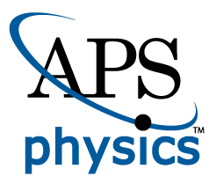**EMBARGOED FOR RELEASE**

Until 7 a.m. PDT, Monday, October 17, 2022

**MEDIA CONTACTS**Saralyn Stewart  
(512) 694-2320

stewart@physics.utexas.edu

**Shifting Momentum: Lab Confirms Key Theory of How Planets and Stars Form**

PPPL uses novel device to demonstrate a long-standing theory.

SPOKANE, Wash.—The Princeton Plasma Physics Laboratory (PPPL) has produced the first laboratory realization of the long-standing but never-before confirmed theory explaining the puzzling formation of planets, stars and even supermassive black holes from swirling surrounding matter. This breakthrough confirmation caps more than 20 years of experiments at PPPL, the U.S. Department of Energy (DOE) laboratory devoted to the study of plasma science and fusion energy.

The puzzle arises because matter orbiting around a central object does not simply fall into it, due to the conservation of angular momentum that keeps planets and the rings of Saturn from tumbling out of their orbits. That is because the outward centrifugal force balances the inward pull of gravity on the orbiting matter. However, the clouds of dust and plasma called accretion disks that swirl around and collapse into celestial bodies do so in defiance of the conservation of angular momentum (Figure 1).

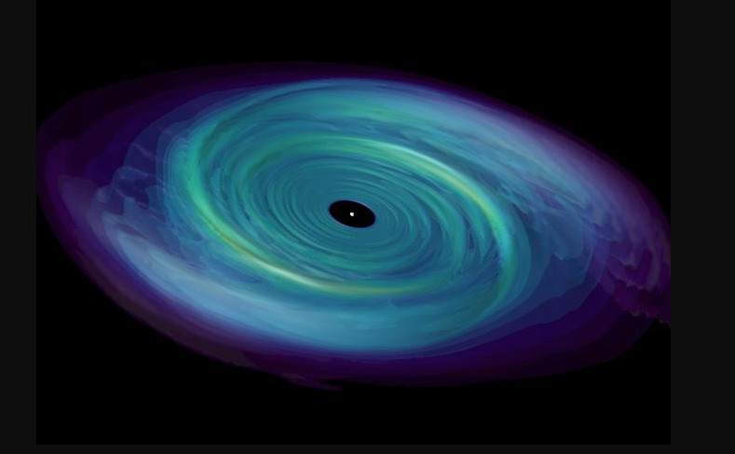The solution to this puzzle, a theory known as the Standard Magnetorotational Instability (SMRI), was first proposed in 1991 by University of Virginia theorists Steven Balbus and John Hawley. They built on the fact that in a fluid that conducts electricity, whether the fluid be plasma or liquid metal, magnetic fields behave like springs connecting different sections of the fluid. This allows ubiquitous Alfvén waves, named after Nobel Prize winner Hannes Alfvén, to create a turbulent back-and-forth force between the inertia of the swirling fluid and the springiness of the magnetic field, thereby transferring angular momentum between different sections of the disk.

*Figure 1: Simulated accretion disk swirling around a celestial body. (Simulation by Michael Owen and John Blondin, North Carolina State University.)*

This turbulent instability shifts the plasma toward a more stable configuration, the SMRI theory says. The shift pushes the orbit-conserving angular momentum outward toward the rim of the disk, freeing inner sections to collapse over millions to billions of years into the encircled celestial bodies, creating the planets and stars. While this process has been verified numerically, it had not been demonstrated experimentally or observationally.

“This has remained theoretical until now,” said physicist Yin Wang, lead author of two recent papers, [one](https://journals.aps.org/prl/abstract/10.1103/PhysRevLett.129.115001) in September in *Physical Review Letters* and a *Nature Communications* [paper](https://www.nature.com/articles/s41467-022-32278-0) published in August that details the combined experimental, numerical, and theoretical confirmation. Recent results produced on the novel MRI device developed at the laboratory,“have successfully detected the signature of SMRI,” Wang said.

The unique device, initially conceived by physicists Hantao Ji of PPPL and Jeremy Goodman of Princeton, both coauthors of these papers, consists of two concentric cylinders that spin at different speeds, creating a flow that mimics a swirling accretion disk (Figure 2). The experiment spun galistan, a liquid metal alloy enclosed in a magnetic field. The caps that seal the top and bottom of the cylinders rotate at an intermediate speed, contributing to the experimental effect.

*Figure 2: Laboratory SMRI experiment showing transparent outer cylinder and darkened inner cylinder. (Photo courtesy of Eric Edlund and Elle Starkman.)*

Physicists now plan new experimental and numerical studies to further characterize the reported SMRI. One study will test the crucial outward shift of angular momentum by measuring the velocity of the swirling liquid metal together with the dimensions of the magnetic field and the correlations between them.

“These studies will advance the emerging field of interdisciplinary laboratory astrophysics,” Wang said. “They illustrate how astrophysics can be done in laboratories to help solve problems that space telescopes and satellite missions can’t handle on their own, a major achievement for laboratory research.”

This work has been supported by the DOE, NASA and the National Science Foundation over the years.

**Contact:**

Yin Wang, Princeton Plasma Physics Laboratory, [ywang3@pppl.gov](mailto:ywang3@pppl.gov)

**Abstract**

[JI01.00001](https://meetings.aps.org/Meeting/DPP22/Session/JI01.1) [Experimental observation of the standard magnetorotational instability in a modified Taylor-Couette cell](https://meetings.aps.org/Meeting/DPP22/Session/JI01.1)

**Session** [JI01: Astrophysical/Space Plasmas 1](https://meetings.aps.org/Meeting/DPP22/Session/JI01)

2:00 PM–5:00 PM, Tuesday, October 18, 2022

Room: Ballroom 100 A