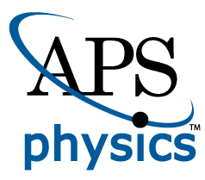
EMBARGOED FOR RELEASE
Until 7 a.m. PDT, Monday, October 17, 2022
MEDIA CONTACTS
Saralyn Stewart
(512) 694-2320
stewart@physics.utexas.edu

Pressure Drop: New Insights into Timing of Magnetic Explosions in Space
Scientists develop the first model that can predict the magnetic reconnection rate in space.

SPOKANE, Wash.—In just minutes, a solar flare on the sun can release enough energy to power civilization on Earth for 20,000 years. Similar, but less energetic explosions also occur in the giant magnetic bubble surrounding Earth called the magnetosphere. These explosions, caused by a process called magnetic reconnection, drive space weather that can harm satellites and space missions.

Magnetic reconnection happens in plasma when magnetic fields pointing in opposite directions are brought together in a region that is narrow enough to allow magnetic field lines to break and rejoin. The associated magnetic tension converts the magnetic energy into high-speed jets of plasma away from the reconnection site. The rate at which this magnetic energy is converted into flowing plasma has been measured by computer simulations and satellite observations, including by NASA’s Magnetospheric Multiscale Mission (MMS). A theoretical model that could predict these values, however, did not exist – until now.

Scientists at Dartmouth College and the theory team of MMS have derived the first mathematical solution for the magnetic reconnection rate in space. The results were recently published in Communications Physics.

The key breakthrough of this theory is incorporating the impact of pressure. A commonly observed phenomenon in plasma called the “Hall effect” occurs when the plasma flows at right angles to a magnetic field, causing positive and negative charges in the plasma to separate (Figure 1). When the Hall effect dominates near a magnetic reconnection site, it reduces the pressure and causes the site to implode, more rapidly transferring the magnetic energy into jets. By including this pressure depletion due to the Hall effect in the theory, a larger reconnection rate is predicted and can be compared to observations made by MMS.

“We found from MMS measurements where reconnection rate varies up to twice around a normalized value of 10 percent. Now with this new theory, involving the pressure depletion resulting from the Hall effect, we can both understand and predict the reconnection rate,” said Jim Burch, the Principal-Investigator of NASA’s MMS mission and the Senior Vice-President of the Space Sector at Southwest Research Institute. “This new tool should improve our future ability to predict strong space weather events.”

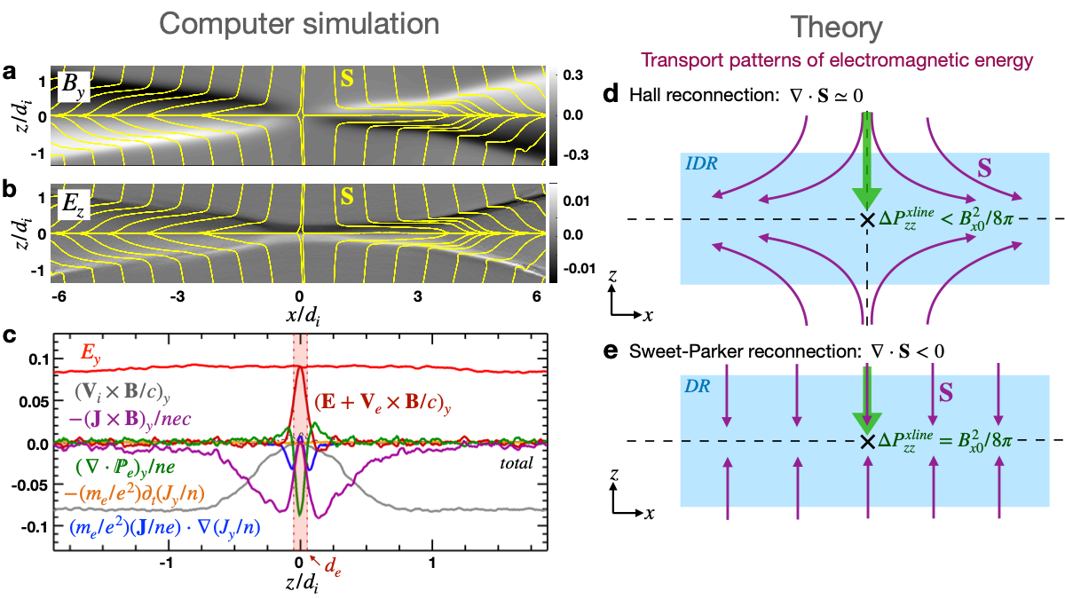
The rate of magnetic reconnection is important because it controls how quickly energy is released in solar flares and harmful geomagnetic substorms. Knowing this rate helps scientists understand planetary magnetospheres, magnetically confined fusion devices and astrophysical plasmas.
Figure 1: The simulated electromagnetic fields (panels a and b) around the reconnection site are associated with the Hall effect, that shows up as the purple curve (panel c) along the cut of Ohm’s law analysis across x/di=0. These Hall electromagnetic fields cause a pressure vacuum right at the reconnection site (labeled “x” in panel d), causing the implosion, facilitating fast magnetic reconnection. In contrast, a case without the Hall effect does not need to develop the pressure vacuum (panel e).

This theory may also explain the fast reconnection in plasmas around black holes and neutron stars. In these astrophysical plasmas, the Hall effect can be weak or completely absent. Nevertheless, computer simulations predict a similarly fast reconnection rate, suggesting that an alternative mechanism must cause the pressure depletion at the reconnection site. The research team at Dartmouth College is using the new mathematical model to unravel the details. Their results are under review in Physical Review Letters.
This research is supported by NSF grant PHY-1902867 through the NSF/DOE Partnership in Basic Plasma Science and Engineering, NASA’s MMS mission 80NSSC18K0289, 80NSSC21K2048, and NSF Career Award 2142430.

Contact
Y. -H. Liu, Dartmouth College, Yi-Hsin.Liu@Dartmouth.edu

Abstract
TI01.00003 First-Principles Theory of the Rate of Magnetic Reconnection
Session TI01: Reconnection and Space Plasmas
9:30APM–12:30 PM, Thursday, October 20, 2022
Room: Ballroom 100A

