EMBARGOED FOR RELEASE
Until 7 a.m. PDT, Monday, October 17, 2022
MEDIA CONTACTS
Saralyn Stewart
(512) 694-2320
stewart@physics.utexas.edu

Taking A New Angle to Boost Plasma Performance in Advanced Tokamaks
In Advanced Tokamak plasmas, off-axis particle beam injection improves confinement.
SPOKANE, Wash.—Magnetic confinement is one of the leading paths to fusion energy. One variant of this approach uses a device known as a tokamak to confine the super-hot plasmas inside powerful magnetic fields until fusion occurs. The tokamak approach has demonstrated exceptional ability to contain these plasmas, which are created when the fuel gas is heated until atoms separate into charged particles and serve as the fuel for nuclear fusion.
However, sustaining a tokamak plasma for days or weeks remains challenging. The key to such “steady-state” operation is maintaining the part of the magnetic field that is internally generated by the plasma itself. The “Advanced Tokamak” (AT) concept was developed when scientists realized that the right combination of density and temperature can create good plasma confinement, high plasma pressure, and a strong self-generated magnetic field. Because these characteristics affect each other, the AT approach requires precise control of the plasma to avoid instabilities that can allow the plasma to escape confinement.
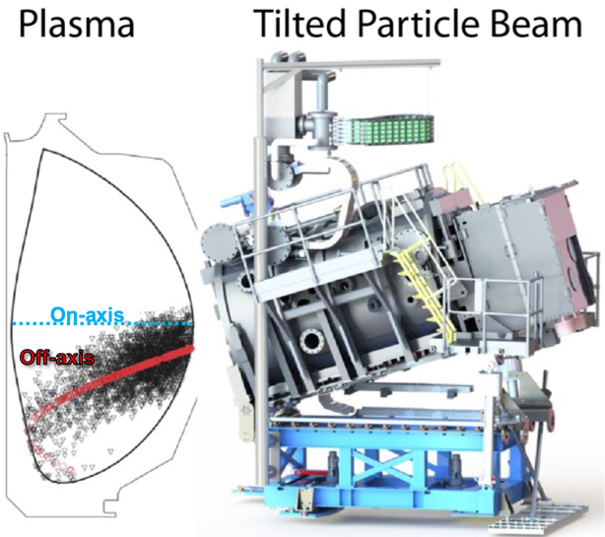
Experiments at the DIII-D National Fusion Facility, an AT reactor prototype, have exploited new capabilities to produce plasma profiles that are more favorable to the AT approach. This was achieved by aiming some of particle beams that heat and fuel the plasma away from the plasma center, using a new vertically tilted beam system, as shown in Figure 1.
Figure 1: When tilted vertically, the particle beams (right of figure) inject downwards, causing the energetic ions to be deposited “off-axis” away from the plasma center (left of figure).
The uncharged particles launched by the beams are ionized as they enter the plasma. Regular beam systems inject fuel particles horizontally, with the resulting beam depositing energy through the center, or “on-axis.” By contrast, the new system at DIII-D deposits these highly energetic ions far away from the plasma center. DIII-D experiments show that this “off-axis” beam injection results in much weaker plasma instabilities compared to “on-axis” beam injection.
Analysis of the neutrons produced by the fusion reactions found better confinement of the energetic ions using off-axis injection. When energetic ions are perfectly confined and do not experience confinement loss from energetic ion instabilities, they are said to be behaving “classically.” Figure 2 compares the experimentally measured neutron rate for both the on-axis and off-axis injection cases to the classically predicted neutron rate. Any discrepancy between the experimental and predicted rates is known as the “fusion neutron deficit.” For on-axis beam injection, the measured neutron rate is 40 percent to 60 percent lower than the classically predicted rate, and thus has a neutron deficit of 40 percent to 60 percent. In contrast, the deficit for off-axis injection is merely 25 percent, and can reach as low as 0 percent, where the energetic ions can be said to be behaving classically.
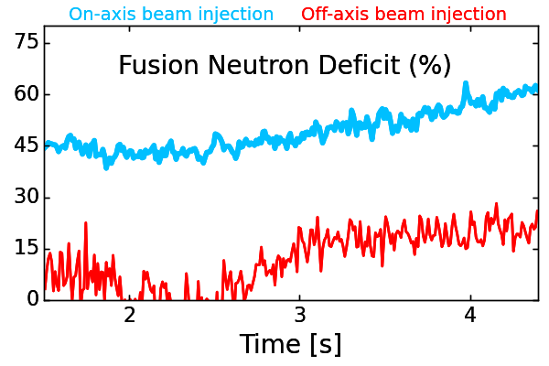
This improved confinement of energetic ions with off-axis injection gives notable improvements in the AT performance. Plasmas with off-axis beam injection show density and current profiles that are desirable for avoiding many types of plasma instabilities. Compared to off-axis plasmas, plasmas with on-axis beam injection show characteristics that are correlated with greater instabilities and poorer confinement. These findings bode well for achieving steady-state profiles in future AT experiments when the off-axis beam injection is combined with increased radiofrequency current drive.
Figure 2: In plasmas with on-axis beam injection, plasma instabilities reduce the fusion neutron rate by 40 percent to 60 percent compared to expectations. By comparison, off-axis beam injection often produces the expected fusion rates, and in worst-case scenarios demonstrate a reduction of 25 percent or less.
This material is based upon work supported by the Department of Energy under Award Number DE-FC02-04ER54698.

Contact:
Dr. Kathreen Thome, General Atomics, thomek@fusion.gat.com

Abstract
BI01.00005 Influence of energetic particle profiles on DIII-D high bootstrap fraction plasmas
Session BI01: Magnetic Confinement Fusion I
9:30 AM–12:30 PM, Monday, October 17, 2022
Room: Ballroom 100 A

