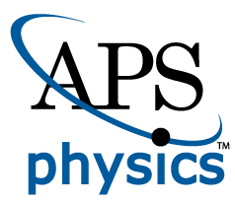
EMBARGOED FOR RELEASE
Until 7 a.m. PDT, Monday, October 17, 2022
MEDIA CONTACTS
Saralyn Stewart
(512) 694-2320
stewart@physics.utexas.edu

Measuring Plasma in 3-D to Better Understand Space Weather

Laboratory makes first 3-D measurements of electrons during magnetic reconnection, revealing clues about heating during extreme space weather.
SPOKANE, Wash.—The space surrounding Earth is filled by an energetic and turbulent fluid called plasma which exhibits a kind of weather driven by solar activity. Many space weather events can drive the charged particles within the plasma to extremely high and potentially dangerous energies and temperatures. Understanding how this environment evolves or predicting its behavior can help mitigate the potentially damaging effects of this space weather on vital satellites or our electric grid infrastructure.

While we have a fleet of satellites and spacecraft around the planet to measure the plasma and to watch for potentially dangerous emissions from the sun, these observations can be limited in their ability to fully characterize the system. Spacecraft embedded within the vast expanse of space can typically only make point measurements of the ever-evolving plasma weather. On the other hand, plasma generated in laboratory conditions on Earth can be more carefully controlled and thoroughly studied over 3-D volumes rather than single points.
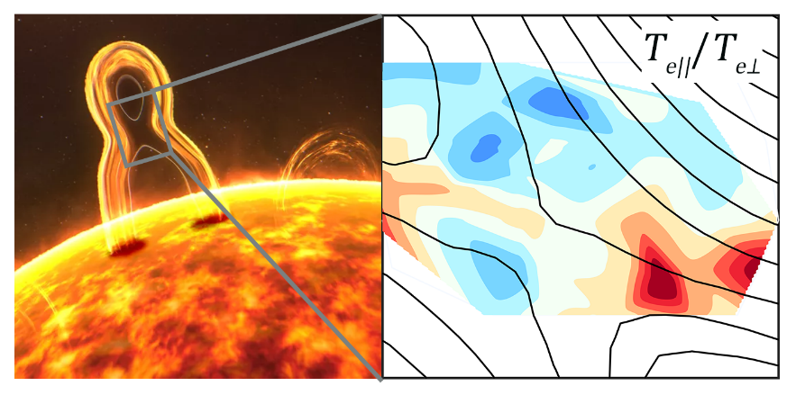
Figure 1: Left: An artist’s impression of one solar flare undergoing the magnetic reconnection process on the sun’s surface, capable of explosively releasing magnetic energy into plasmas, consequently initiating space weather near Earth (Courtesy of NASA). Right: Magnetic reconnection process simulated in laboratory experiments shows the dominating parallel electron temperature.
Researchers at West Virginia University have recently developed a first-of-its-kind advanced laser diagnostic that substantially enhances the ability to measure both 3-D velocity and 3-D position of plasma with high spatial resolution. Plasma generated within the PHAse Space MApping (PHASMA) facility can be set up to reproduce a common phenomenon seen in the plasma environment around Earth called magnetic reconnection (Figure 1). During a magnetic reconnection event, energy contained within magnetic fields can be explosively converted into heat and particle flows.

By measuring the 3-D velocity and positions of electrons emanating from magnetic reconnection within the laboratory plasma, the West Virginia researchers have been able to identify exactly where and in what primary direction electrons gain energy and temperature with respect to the reconnection site – something that is currently not feasible with spacecraft-based measurements.

By connecting these well-diagnosed and well-controlled laboratory experiment results to direct observations of magnetic reconnection in space, as well as computer simulations of theoretical reconnection models, the researchers hope to develop a better understanding of precisely how these electrons get heated and accelerated. These details can better inform the predictive models of space weather activity.

This work was supported by awards NSF AGS 1602769 and PHY 1804428, 1827325 and 1902111, NASA 80NSSC19M0146, and DoE SC0020294. This research uses resources of /NERSC, a DOE Office of Science User Facility supported by the Office of Science under Contract no. DE-AC02-05CH11231.

Contact:
Earl Scime, West Virginia University, earl.scime@mail.wvu.edu
Peiyun Shi, West Virginia University, peiyun.shi@mail.wvu.edu

Abstract
CM09.00007 Anisotropic Electron Heating during Electron-Only Magnetic Reconnection in PHASMA
Session Mini-Conference: Heating and Non-Thermal Particle Acceleration during Magnetic Reconnection in Laboratory, Heliophysical and Astrophysical Plasmas II
2:00 PM – 5:00 PM, Monday, October 17, 2022
Room: 206 AB

