EMBARGOED FOR RELEASE
Until 7 a.m. PDT, Monday, October 17, 2022
MEDIA CONTACTS
Saralyn Stewart
(512) 694-2320
stewart@physics.utexas.edu

Racing to Fusion Energy
Various magnetic configurations, championed by different partnerships, are in the race toward fusion energy commercialization and solutions for fusion pilot plants.
SPOKANE, Wash.—As the development of fusion energy around the world is intensifying, many groups are exploring and commissioning various innovative magnetic configurations. Controlled fusion, which offers a carbon-free, dispatchable energy source, can contribute to a future decarbonized electrical generation infrastructure. From the mainstream tokamak configuration to more-compact systems such as the spherical tokamak and magnetic-mirror trap, various privately and publicly funded institutions are focused on two major objectives: 1) operation at high temperatures, hundreds of millions of degrees (10 times hotter than the sun), to fuse isotopes of hydrogen, the lightest atom, and achieve fusion energy; 2) closing the gap for solving the myriad technological challenges required for a viable fusion pilot plant.

To transition to commercial fusion energy to generate net electricity, science and technology must be tested in a realistic fusion power plant environment. These tests, however, do not require a full scale power plant. In the U.S., an upgrade is proposed for the DIII-D facility, a conventional doughnut-shaped tokamak, to close gaps on reactor physics and serve as a test bed for a fusion pilot plant. Increased radiofrequency heating will provide the flexibility to vary the plasma’s internal current distribution to pioneer pulsed and steady state configurations to meet reactor goals. When combined with a proposed volume, field and current rise, it also transforms access to reactor-relevant low rotation, thermalized, opaque regimes. New flexible “divertor” structures that direct the plasma heat into cold, dense, radiative dissipation zones at the plasma’s edge, will then explore what physical and magnetic geometries best contain these dissipation zones, and their compatibility with the fusion core. As Professor Dr. Hartmut Zohm, a Director at Germany’s Max Planck Institute who chaired a review of this proposal, noted, “These are ambitious plans. The proposed upgrades will provide an effective route to resolving crucial questions towards an attractive Fusion Power Plant based on the tokamak principle.”

In the U.K., Tokamak Energy’s ST40 spherical tokamak (compacting the fuel into a high magnetic field region), has recently achieved a primary objective of reaching a thermal plasma temperature of 100 million degrees. Tokamak Energy’s ST40 is a high field spherical tokamak with a major radius of 40 centimeters. The device utilizes a 4-meter-tall, stainless-steel vessel with copper toroidal field coils which are designed to produce magnetic fields up to 3 T. ST40 achieved its first initial objective of 100 million degree plasma ion temperature in a high-field, low-aspect-ratio tokamak. Achieving an impressive value of result of 6x10¹⁸ keV.s.m⁻³ for the important triple-product metric of density times temperature times confinement time at 100 million degrees is a new record for such a compact tokamak with plasma volume less than 1 cubic meter. This takes the spherical tokamak closer to energy-breakeven conditions (i.e., fusion energy gain exceeding 100 percent). Tokamak Energy is now focused on the design work for its next device, the ST-HTS, which will be the world’s first spherical tokamak to demonstrate the full potential of higher (than liquid helium) temperature superconducting (HTS) magnets.

Other devices, of alternative simpler magnetic designs, are also working toward major fusion energy objectives. The Centrifugal Mirror Fusion Experiment (CMFX) at the University of Maryland will be the first superconducting centrifugal magnetic mirror to ever be experimentally tested. The magnetic mirror is the simplest form of steady magnetic confinement, and centrifugal rotation at supersonic speeds makes it a promising fusion reactor candidate for its stability, engineering simplicity, and expected affordability with respect to other fusion concepts. A magnetic mirror is made in a cylindrical machine with a minimum of two coils that trap the plasma between them. Simple mirrors, however, are known to be unstable under thermonuclear conditions. Imposed supersonic rotation stabilizes them and helps heat the plasma all the way to fusion temperatures. The primary goal in CMFX is to achieve high temperatures, with better density control and longer steady discharges than in the previous generation. CMFX is an intermediate but important step in the development of a centrifugal mirror reactor, and success in this program will enable a fast path toward the goal of commercial fusion reactors.

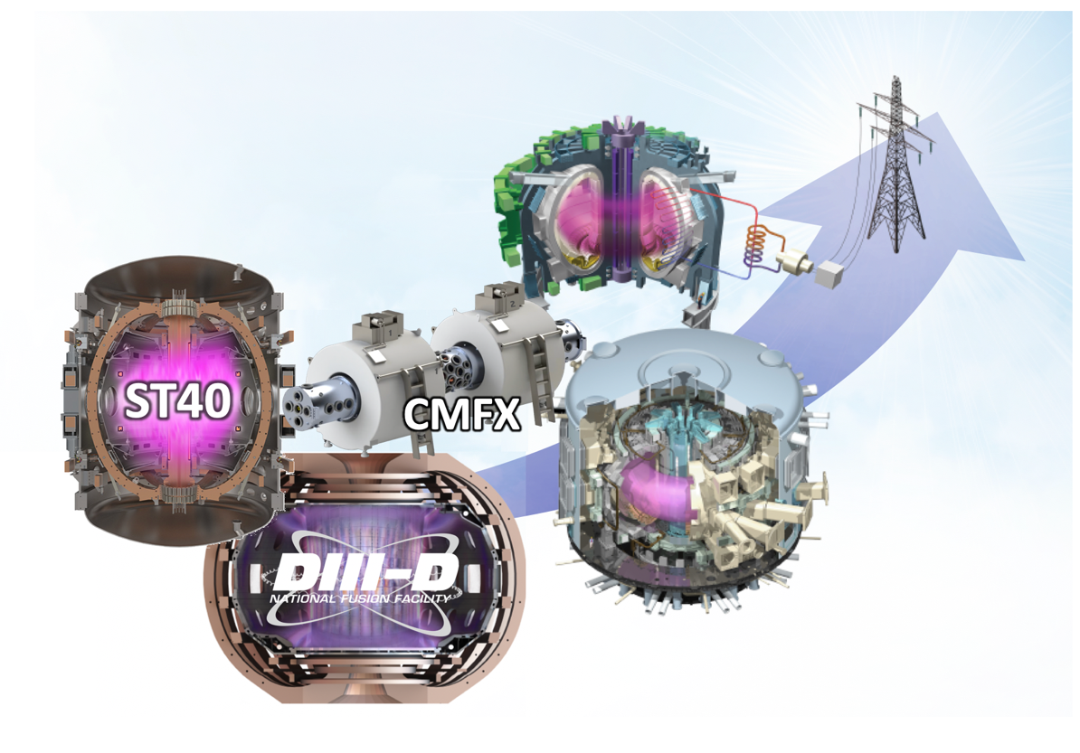
Together, these developments show exciting potential to rapidly resolve critical science and technology challenges for fusion energy, and they provide evidence for the design credibility of a viable fusion pilot plant.
Figure 1: Championed by different partnerships, the race toward net electricity generation from fusion energy includes a portfolio of magnetic configurations, from the mainstream tokamak to compact systems (with a small sample of such devices shown), as well as credible designs for viable pilot plants.
Contact:
Richard Buttery, General Atomics, buttery@fusion.gat.com
Mark Koepke, Tokamak Energy, Mark.Koepke@tokamakenergy.com
Carlos Romero Talamas, University of Maryland Baltimore County, romero@umbc.edu

Abstracts

Richard Buttery
PM10.00006 A Performance Upgrade to Resolve the Physics of the ITEP Gap with DIII-D
Session PM10: Mini-Conference: The Integrated Tokamak Exhaust and Performance Gap I
2:00 PM–4:59 PM, Wednesday, October 19, 2022
Room: 206 CD
GP11.00002 DIII-D: Closing the Gaps to Future Fusion Reactors
Session GP11: Poster Session III: MFE: DIII-D, Low Temperature Plasma, FUND: Dusty Plasmas; Plasma Sources
9:30 AM–12:30 PM, Tuesday, October 18, 2022
Room: Exhibit Hall A and Online

Mark Koepke
PM09.00010 Tokamak Energy is expanding, with INFUSE projects and increased collaboration with U.S. scientists
Session PM09: Mini-Conference: Public-Private Partnerships for Fusion Energy IV
11:30 AM–11:45 AM, Monday, October 17, 2022
Room: 206 CD

Carlos Romero Talamas
JM09.00005 The Roadmap to Fusion Energy for the Centrifugal Mirror
Session JM09: Mini-Conference: Public-Private Partnerships for Fusion Energy II
2:00 AM–5:00 PM, Tuesday, October 18, 2022
Room: 206 AB
TP11.00065 Overview of the Centrifugal Mirror Fusion Experiment (CMFX)
Session TP11: Poster Session VII: MFE: FRC, RFPs etc. ICF: Fast Ignition; Diagnostics; Computational; Laser Plasma Interactions. FUND: Computation
9:30 AM–12:30 PM, Thursday, October 20, 2022
Room: Exhibit Hall A and Online

