EMBARGOED FOR RELEASE
Until 7 a.m. PDT, Monday, October 17, 2022
MEDIA CONTACTS
Saralyn Stewart
(512) 694-2320
stewart@physics.utexas.edu

A New Way to Detect Space Debris
Satellite measurements of plasma waves could detect space debris, helping space agencies protect spacecraft from damage.
SPOKANE, Wash.— Researchers have demonstrated a potential new way to locate pieces of space debris that threaten spacecraft and satellites in orbit.

Space debris, or space junk, consists of leftovers from human-made objects – such as discarded launch vehicles or parts of a spacecraft – typically trapped in orbit around the Earth. Currently, NASA tracks over 27,000 such objects in low Earth orbit. The European Space Agency (ESA) estimates that the total mass of all space debris in Earth’s orbit is close to 22 million pounds (10 million kilograms). The number of debris that are too small to be tracked, yet large enough to cause severe damage upon impact, is in the millions. Since both space debris and active spacecraft travel at tremendous speeds of about 15,700 miles per hour (25,265 kilometers per hour), an impact of even a tiny piece of orbital debris with a spacecraft could create significant issues.

Researchers traditionally detect space debris with satellite and ground sensors that use optics and ranging radars. These methods, however, cannot detect many smaller debris. For the first time, scientists from the University of Alaska and the University of Calgary have demonstrated a novel technique for locating space debris by measuring the electric fields that surround them while in motion. This new technique, called Space Object Identification by In Situ Measurements of Orbit-Driven Waves, or SOIMOW, relies on waves created as charged space debris move through plasma.

The Earth is surrounded by the ionosphere – a plasma layer which consists of charged particles such as ions and electrons. All satellites move through this plasma at speeds faster than the speed of sound. Both spacecraft and space debris become electrically charged as they are bombarded by solar light particles and electrons from the plasma environment. Moving charged objects can stimulate a wide range of plasma waves as they travel through the ionosphere and across the Earth's magnetic field lines.

The Radio Receiver Instrument (RRI) on the Canadian SWARM-E satellite has been attempting to detect plasma waves around orbital debris using in situ measurements, or direct measurements made at the point of interest. The RRI observations seem to show magneto-hydrodynamic (MHD) waves and electrostatic waves that can be detected as far as 56 miles (90 km) away from the space object producing them. MHD waves are produced by “striking” magnetic field lines, much like plucking a guitar string. Electrostatic waves are disturbances in the plasma that are caused by oscillating charged particles.

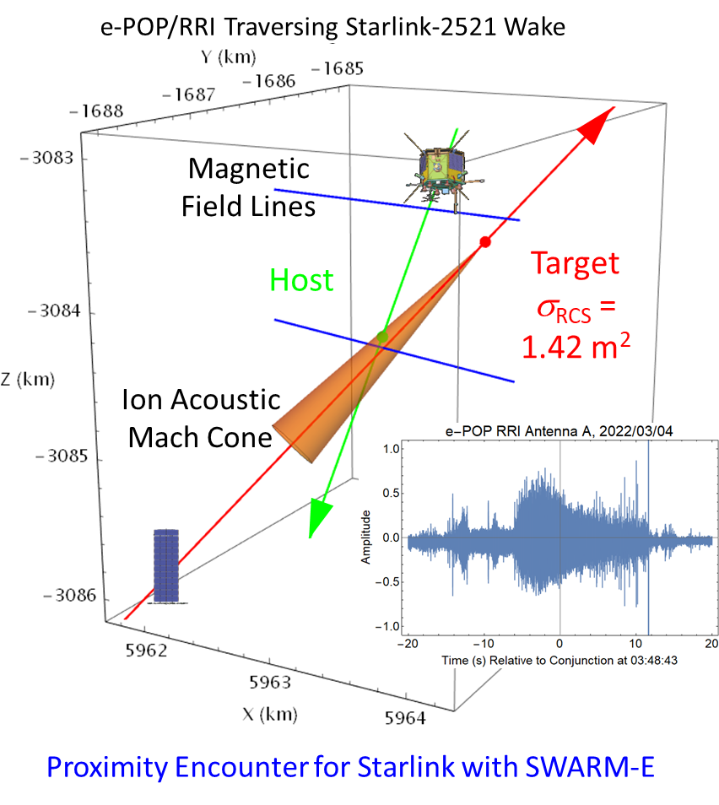
In Figure 1, trajectories of the Starlink 2521 (red, bottom-left) encounter with RRI sensor (green, top- center) showing an electric field “Flash” (inset) 20 dB above the background noise level. The peak of this enhanced signal happens at the point of closest approach between the RRI detector and Starlink 2521. The cloud of enhanced plasma-wave noise lasting 18 seconds is interpreted as spacecraft-driven turbulence, or a mixture of different kinds of plasma waves.
Figure 1

The challenge is to make these newly discovered waves travel much farther so they can be detected from a distant satellite or even from Earth, and to accurately determine the location of their sources. The SOIMOW team has proposed to convert the non-propagating electrostatic waves into electromagnetic waves, which can travel all the way to a radio receiver on a host satellite or to a ground receiver. The angular spread and time of arrival recorded from multiple receivers could then be processed to yield an image of the space debris traveling across the radio sky. The SOIMOW team is conducting experiments to determine if stimulated scatter from ground-based transmitters can be employed to observe the trajectories of satellites and space debris.

Contact:
Paul A Bernhardt, Geophysical Institute, University of Alaska, pabernhardt@alaska.edu

Abstract
YI02.00004 Space Object Identification by Measurements of Orbit-Driven Waves (SOIMOW)
Session YI02: Magnetic Confinement Fusion/Postdeadline
9:30 AM – 12:30 PM, Friday October 21, 2022
Room: Ballroom 100 B

