EMBARGOED FOR RELEASE
Until 7 a.m. PDT, Monday, October 17, 2022
MEDIA CONTACTS
Saralyn Stewart
(512) 694-2320
stewart@physics.utexas.edu

Mitigating Catheter-Associated Urinary Tract Infections Using Cold Plasma Technology
Plasma technology could be a useful tool for eliminating microbes in catheter tubes.
SPOKANE, Wash.—Cold atmospheric plasmas (CAP), partially ionized gases that can be generated at atmospheric pressures, can eliminate dangerous cultures of Escherichia coli (E. coli) and other bacteria. Now, researchers have shown that they can destroy these cultures inside long catheter tubes and protect patients from infections.

Antibiotic-resistant urinary tract infections (UTIs) are on the rise and becoming increasingly hard to treat with oral antibiotics. A catheter-associated (CA) UTI is the most common type of healthcare-associated infection and accounts for over 30 percent of acute care hospital infections with high mortality (13,000 deaths per year in the U.S.). In total, over $340 million spent in healthcare is attributable to the annual incidence of CAUTIs in the U.S. alone. Multiple diseased outpatient populations (e.g., spinal cord injury, diabetes, multiple sclerosis) further require intermittent or indwelling catheterization that creates a significant cost burden on patients as well as results in high CAUTI cases.

To help prevent CAUTIs, researchers are investigating the use of CAP technology for real-world applications. When generated in an ambient air environment, CAPs generate a cocktail of electrons, ions, excited atoms, reactive species (such as hydrogen peroxide, nitrates, nitrites, ozone, etc.), ultraviolet light, and heat. The relatively low degree of ionization (less than 0.001) enables them to operate at room temperature.

CAPs can eliminate cultures of E. coli and diverse other bacteria because they produce reactive oxygen and nitrogen species, which in synergy with other plasma components (UV, heat, electrons, ions) modify the bacteria’s membranes at low pH. Although several promising results on the use of CAPs to eliminate bacterial species have been obtained, attempts to study the effect of CAPs against biofilms of uropathogenic E. coli inside catheter tubes are lacking. This may be due to the challenges associated with optimizing the formation of plasma and growing bacteria within long and narrow catheter tubes.

Being able to create longer plasma plumes, with sufficient concentrations of reactive species, could enable sterilizing CAUTI inside catheter tubing. Bhagirath Ghimire of the Propulsion Research Center at the University of Alabama in Huntsville and co-authors have investigated this by generating a relatively longer plasma plume length, and with higher concentration of the hydrogen peroxide required for sterilizing CAUTI pathogens.

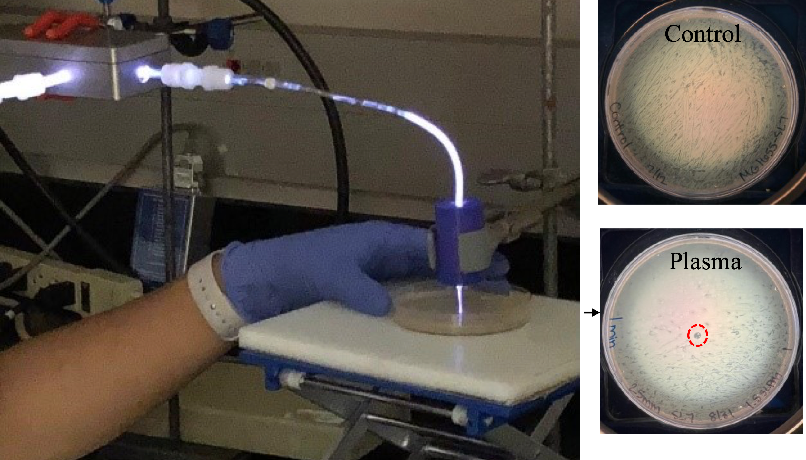
The scientists utilized an atmospheric pressure plasma jet with an unshielded high voltage electrode to increase the length of the plasma plume inside the catheter tube. In contrast to the plasma jet with a shielded high voltage electrode, it produced more than two times longer length of the plasma plume. The unshielded configuration also produced more than twice the concentration of hydrogen peroxide than the shielded jet. A clear zone of inhibition was obtained on a petri dish containing E. coli culture (Figure 1) at the end of ~ 20 cm long catheter tubing. These experimental results suggest that CAP technology could become an ideal technique to sterilize CAUTIs within catheter tubing and lead to significant health benefits for patients (Figure 2).
Figure 1: Experimental approach adopted to eliminate microbes inside catheter tubes. The antimicrobial effect against E. coli measured through zone of inhibition is shown on the right. The clear zone of inhibition (circled in red) shows that plasma could be effective killing microbes inside long (18 centimeter) catheter tubes. Credit: Bhagirath Ghimire and Elaine Briggs, University of Alabama in Huntsville

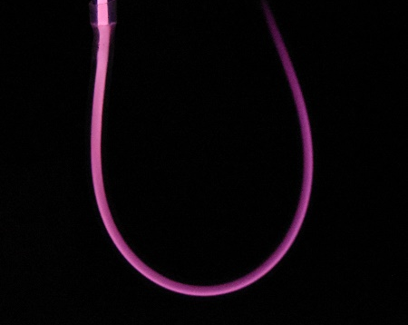
Figure 2: Propagation of plasma inside catheter tubes. Credit: Bhagirath Ghimire
Acknowledgements: Kunning G. Xu, Tatyana Sysoeva, Elaine Briggs, John Mayo

Contact:
Bhagirath Ghimire, University of Alabama in Huntsville, bhagirath.ghimire@uah.edu

Abstract
UO08.00006 Atmospheric pressure plasma jets operated by shielded and unshielded high voltage electrodes: Physicochemical characteristics and application to bacterial killing
Session UO08: Plasma-Surface Interactions, Interfacial Plasmas, Emerging Applications
2:00 PM–4:36 PM, Thursday, October 20, 2022
Room: 402 ABC

