Physicist Career Profiles
Mark Alpert - Magazine Editor
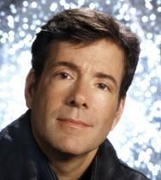
A lifelong science geek, Mark Alpert majored in astrophysics at Princeton University and wrote his undergraduate thesis on the application of the theory of relativity to Flatland, a hypothetical universe with only two spatial dimensions. (The resulting paper was published in the journal General Relativity and Gravitation and has been cited in more than 100 scholarly articles.) After Princeton, Alpert entered the creative writing program at Columbia University, where he earned an M.F.A. in poetry in 1984. He started his journalism career as a small-town reporter for the Claremont (N.H.) Eagle Times, then moved on to the Montgomery (Ala.) Advertiser. Having lots of family time, Alpert is very close to his wife and two non-robotic teenagers. He's a proud member of Scientific American's softball team, the Big Bangers.
markalpert.com/author.php
Summer Ash - Director of Outreach
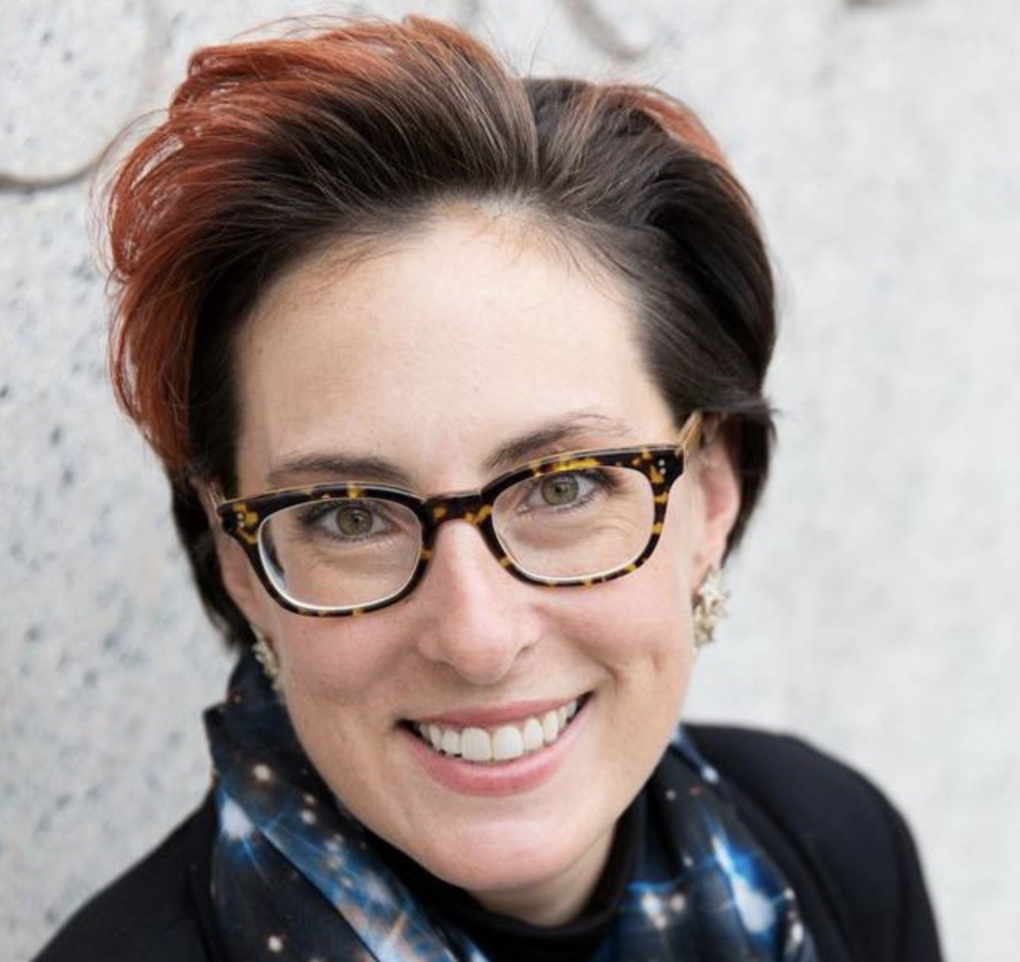
Summer Ash is the Director of Outreach for Columbia University’s Department of Astronomy where she has been based since 2008. She spent her first three and a half years teaching as a Science Fellow on Frontiers of Science in Columbia’s Core Curriculum before transitioning to public outreach for the last five. As a self-professed space cadet, Summer grew up dragging friends and family out at all hours of the day or night to look up at the sky. She earned a bachelor’s degree in mechanical engineering from Stanford University and a master’s in space studies from the International Space University and worked as an aerospace engineer on the X-34 Program at Orbital Sciences Corporation (now Orbital ATK) before making the jump from low-earth orbit to intergalactic scales. Summer did five years of graduate research at the University of Cambridge on the evolution of radio galaxies and the effect of active galactic nuclei (a.k.a. AGN or supermassive black holes) on galaxies and galaxy clusters. Consequently, she will work AGN into everyday conversation whenever possible. Having been both a rocket scientist and a radio astronomer, she’s now harnessing her powers for science communication and to advocate for equity and inclusion across all STEM fields.
summerash.com

Jessica Barrios - Structural Engineer
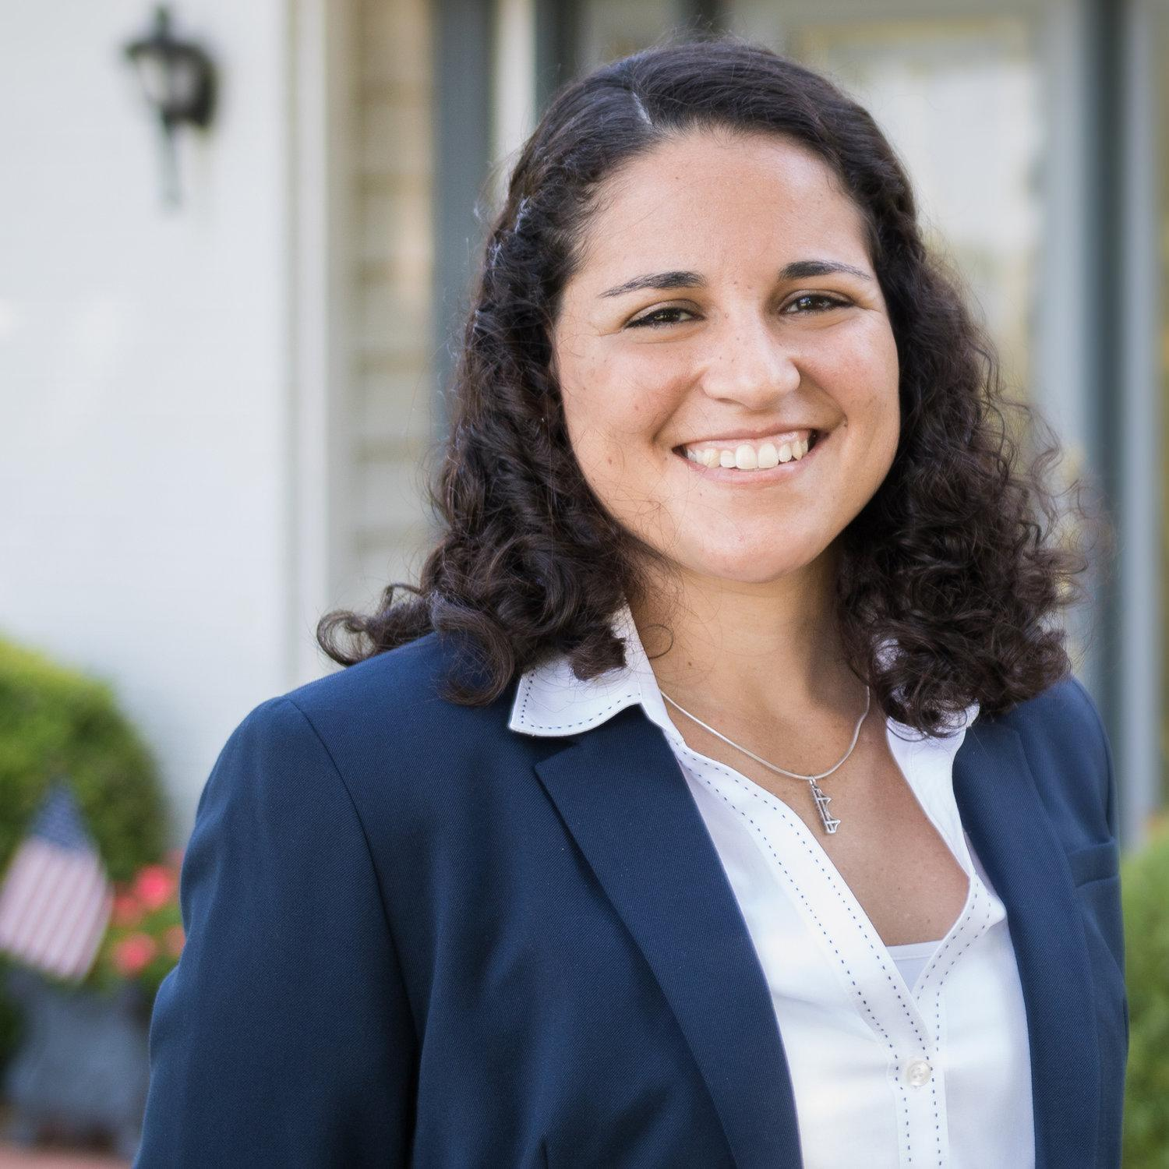
Jessica Barrios was inspired to pursue engineering by her father, who is a professional petroleum engineer. “For as long as I can remember, I’ve enjoyed science, problem solving and building structures out of any material available,” she says. Authentic and hardworking, Jessica enjoys tackling the different challenges unique to each project, “challenges that keep you on your toes no matter how much experience you have.” She also likes seeing each project go “from drawings on paper to a tangible structure everyone can see, and seeing it safely used for its purpose.” She was attracted to CE Solutions in 2016 because the growing company allows her to grow, too, within its distinctive culture. Jessica is a self-proclaimed “sports junkie,” whether it’s practicing, watching or simply talking about athletics. She also likes to watch movies, cook, and spend time with family.
cesolutionsinc.com/jessica-barrios-1
Christina Barrow - Medical Physicist
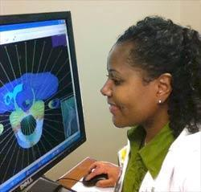
Christina Barrow was interested in math and science from an early age, entering her first science fair as a second grader. “I was always tinkering around the house as a child, trying to figure out how and why things worked the way they did,” she says. After finishing her undergraduate degree, Christina worked in server development at Dell Computer Corporation for three years and then went on to accept a position in the biomedical engineering field. At this point in her career, Christina realized that she wanted to use her science background to make a contribution to the medical field and work in patient care. She pursued graduate school in Medical Physics, a field that combined her love for modern medicine, math, and physics.
aps.org/careers/physicists/profiles/barrow.cfm

Deborah Berebichez - Financial Risk Analyst
Growing up in Mexico City, Mexico, Debbie Berebichez was filled with a natural curiosity about the world and dreamed of being an astronaut. Unfortunately, she grew up in a conservative community that strongly discouraged girls from pursuing careers in science. So, Debbie let go of dreams of science and focused on more socially acceptable pursuits, such as theatre and writing. Debbie continued to work hard in school and received a scholarship to study philosophy in the US at Brandeis University. Part of her coursework included an intro-level astronomy course, which she immediately fell in love with. She successfully caught up with the needed physics coursework and was able to finish her physics degree before her scholarship ended.
After becoming the first Mexican woman to graduate from Stanford University with a physics Ph.D., and completing two postdoctoral research positions, Debbie decided that she wanted a life outside of academia and research. She took her smarts to Wall Street and became a quantitative risk analyst. Now, as Vice President of Risk Analytics at Morgan Stanley, Debbie uses math models and quantitative analysis, like in statistics, to determine and manage the financial risk of investments. She trains her clients to use these math models, customizing solutions for their needs, creating mathematical models that will assess the risk of investments worth millions.
aps.org/careers/physicists/profiles/berebichez.cfm
Alison Binkowski - Health Policy Analyst
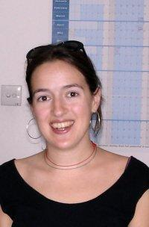
Alison Binkowski has had what many people would consider a "non-traditional" physics career. Her passion always drew her toward international health care issues, and some of her personal experiences helped form her concern. "I thought I wanted to work in... international health, " she says, "but after a summer in Senegal and Mali with the UN where I ended up being hospitalized in Mali for a week, making use of my talents/abilities I became more cognizant of the advantages of working on domestic health issues." Alison believes that her background in physics and computer science has served her well throughout her work. "Many fields – including international development and health policy – need more people with strong analytic backgrounds." For this reason, her training was considered an asset by her academic institutions. "My analytic training was noted as a primary reason why I was offered a partial academic scholarship in graduate school, and what helped me stand out from other candidates to get my current job at the [Government Accountability Office]." Alison says that she was drawn to physics because she "was always interested in how the world worked: from why objects fall to what was at the ‘edge’ of the universe. I also found the fact that phenomena could be captured and explained by mathematical formulas elegant, appealing, and even a bit spiritual."
careersinphysics.org/physicists/Detail.cfm?id=2855
Dianna Cowern - YouTuber
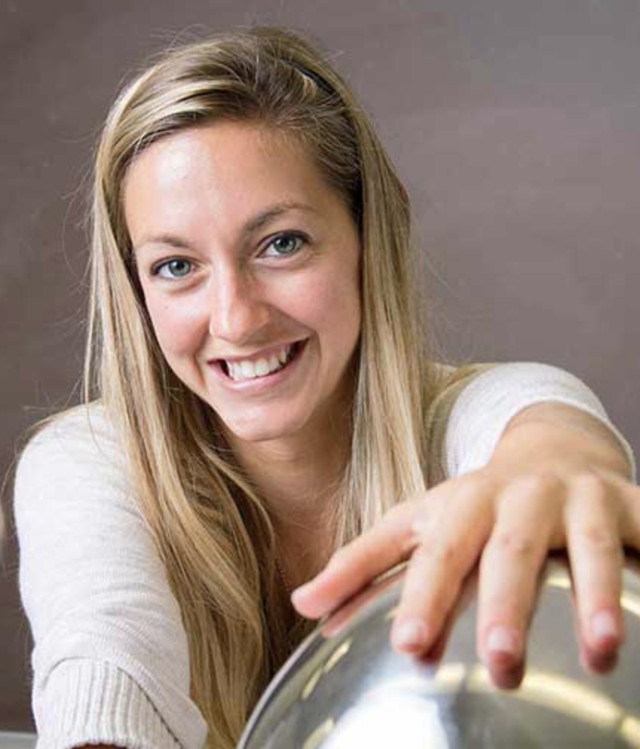
Dianna Cowern is the creator of the award-winning YouTube channel Physics Girl, an educational series with PBS Digital Studios. She has reached over one million subscribers with 130+ videos on topics like, “How to create a vortex in your pool,” and “Why is the universe flat?” Through Physics Girl, public talks, and private workshops for teachers across the nation, Dianna explains exciting science topics, inspires kids—especially young girls—to pursue an interest in science, and rallies the general public to think critically through the wonder of science. Surprise cameos from Bill Nye, skateboard legend Rodney Mullen, and Anne Wojcicki (23andMe) have helped the channel receive over 78 million views. Before starting Physics Girl, this Hawaii-raised MIT physics alumna completed a post-baccalaureate fellowship in astrophysics at Harvard, then worked as a software engineer at General Electric, and as UCSD’s physics outreach coordinator. Physics Girl has been featured on the Huffington Post, Slate Magazine, Scientific American blogs, and Popular Science.
sciencemag.org/news/2017/03/meet-physics-girl-youtuber-who-makes-living-explaining-science
Kelle Cruz - Astrophysicist
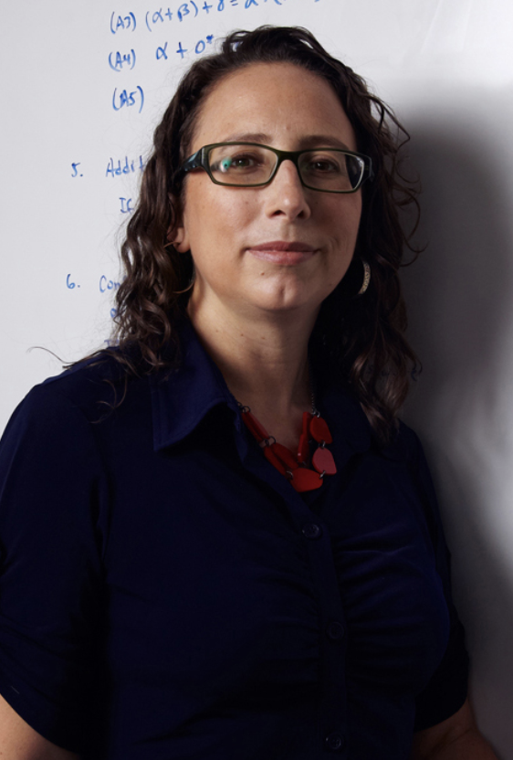
Kelle Cruz studies a kind of celestial body called brown dwarfs to better understand planets outside our solar system. She is an assistant professor at Hunter College in New York, where she continues her work on brown dwarfs. Kelle loves the independence that her degree in physics has given her. She gets to pick her activities based on personal choice and interests. She enjoys the freedom of essentially being her own boss and having a lot of free rein in her work. “I decided early on that I never wanted to make money by making other people money and my physics degree has enabled me to accomplish that goal,” she says. She is currently serving on the Board of the American Astronomical Society. Prior to being elected to the Board, she served as the Chair of the Committee on Employment from 2010-2017. She is the founder and Editor-in-Chief of the AstroBetter blog and wiki and is on the Coordination Committee of the Astropy Project where she promotes information-sharing practices among astronomers. She also started ScienceBetter Consulting, a small business dedicated to serving the needs of the scientific community.
aps.org/careers/physicists/profiles/cruz.cfm
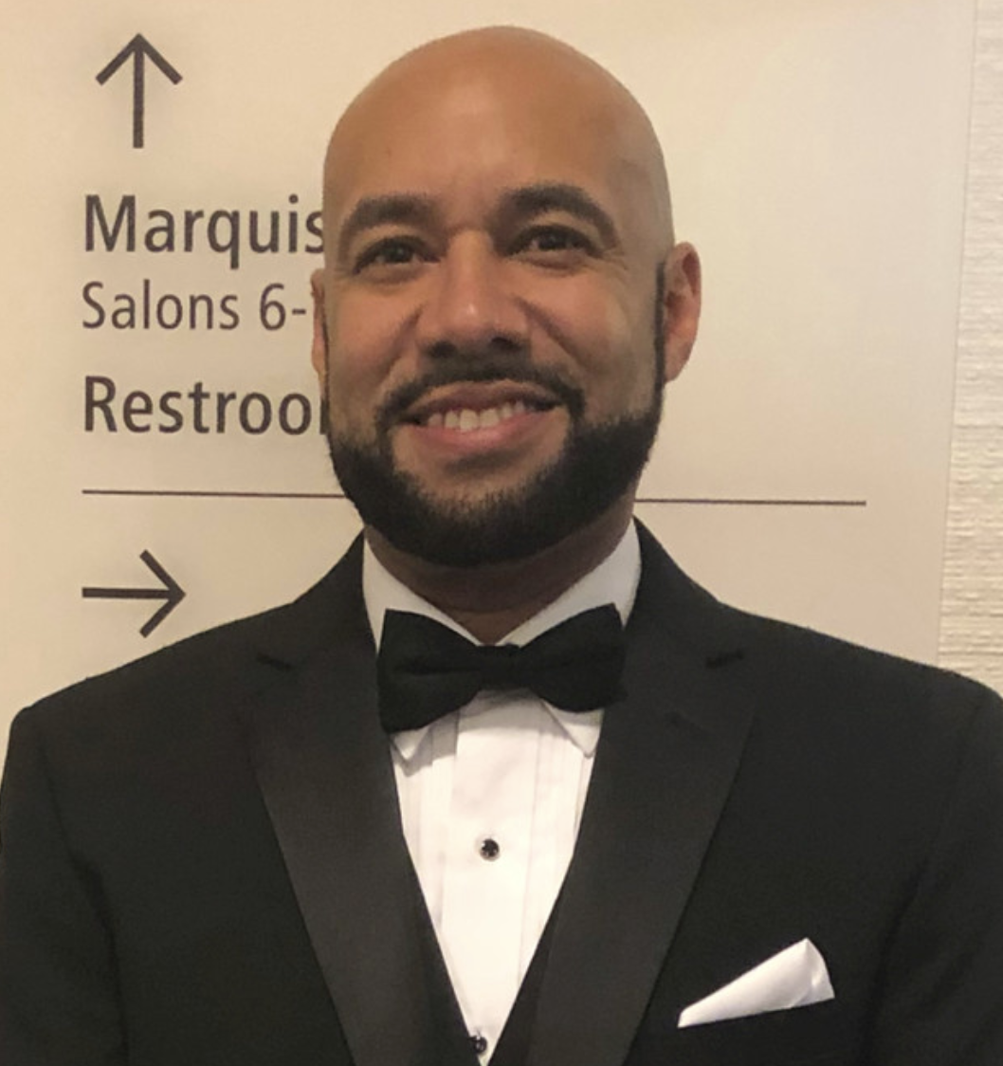
Paul Davis - Applications Engineer
Paul Davis earned his BS in Physics at Howard University. He is employed through Corning, Inc and works on a team of engineers who support a major customer that uses Corning optical fiber to manufacture fiber optic cable. This industrial job allows him to contribute to the development of important products for the company and their clients. Paul’s advice for students looking to follow on a similar path is to build a network with other students and professionals as “this can open doors.” He also encourages asking lots of questions of this network and the world to stay curious and constantly learning. Paul also suggests that aspiring engineers join technical organizations and to make sure you “don't stay in a job that isn't meeting your needs.”
spsnational.org/career-resources/physicist-profiles/paul-davis

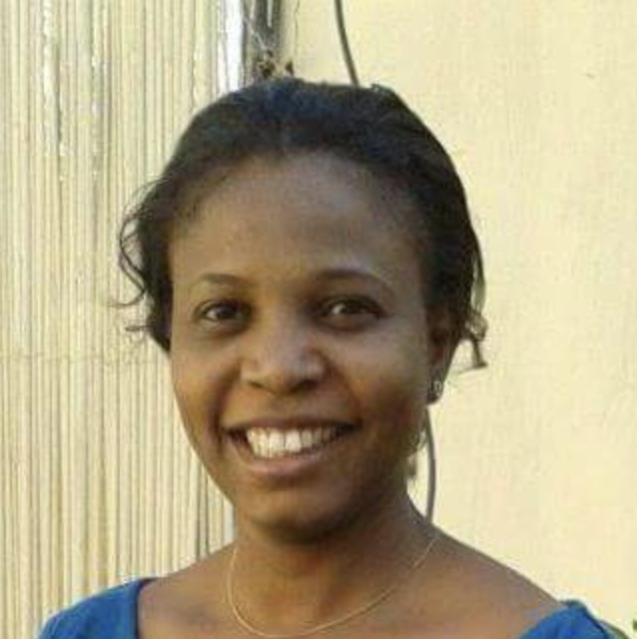
Nashwa Eassa - Nanoparticle Physicist
Nashwa Eassa has a Master of Science in Material Physics and Nanotechnology and is pursuing a Postdoctoral fellowship in nano-photonics. She founded Sudanese Women in Science, an organization dedicated to “increasing effectiveness and participation of Sudanese women in science and technology at all levels and to enforce the role of women in development.” In Sudan, more women pursue sciences in higher education institutions than men, however, there are very few women scientists involved in leadership.
Nashwa won the Elsevier Foundation Award for Early Career Women Scientists in the Developing World in 2015 for her research in nanoparticle physics. She is also an assistant professor of physics at Al Neelain University - Khartoum and is currently collaborating on a project that aims at sanitizing water through solar radiation.
https://cpb-us-e1.wpmucdn.com/blogs.uoregon.edu/dist/9/13268/files/2016/07/Eassa-bio-19ox3va.pdf
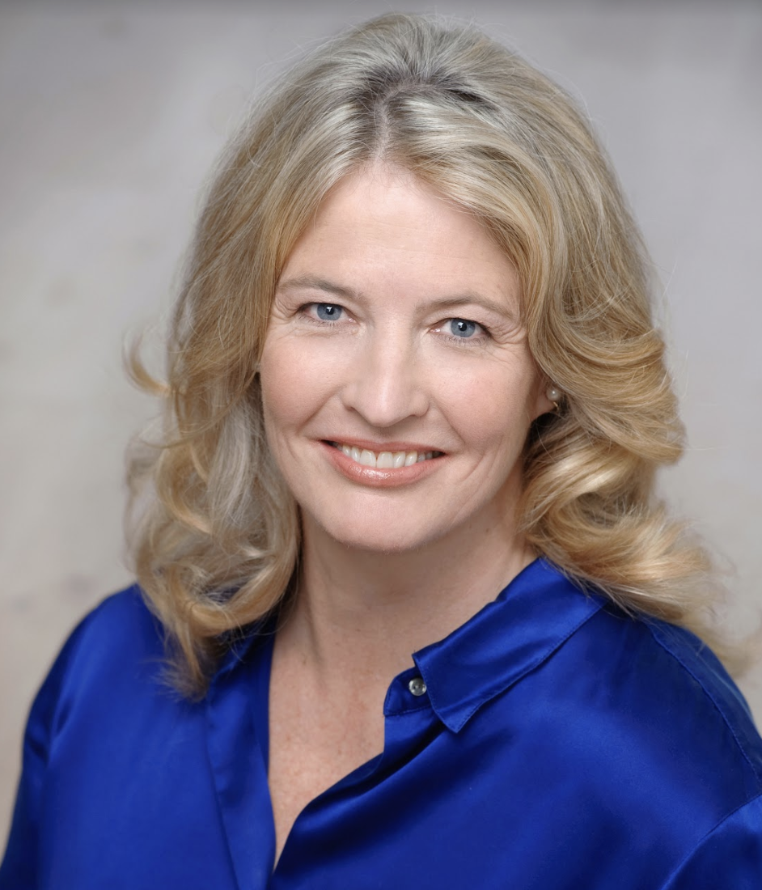
Katherine Freese - Physics Professor
Katherine Freese is the George E. Uhlenbeck Professor of Physics at the University of Michigan. She has contributed to early research on dark matter and dark energy and was one of the first to propose ways to discover dark matter. Her idea of indirect detection in the Earth is being pursued by the IceCube Neutrino Observatory experiment, and the "wind" of dark matter particles felt as the Earth orbits the Milky Way (work with David Spergel) is being searched for in worldwide experiments. Recently she proposed a new theoretical type of star, called a dark star, powered by dark matter annihilation rather than fusion. Freese has also worked on the beginnings of the universe, including the search for a successful inflationary theory to kick off the Big Bang, and she has studied the ultimate fate of the universe, including the fate of life in the universe. Her hope for the future of humanity is based on the fact that “humans are very smart. We can think not only of solutions to problems but also are capable of remarkable insights and inventions. The same drive that pushes us to explore our Earth, to head into space, and to think about the Cosmos, has given us the brainpower to survive and I hope it always will." She wrote a book called “The Cosmic Cocktail: Three Parts Dark Matter” and has made appearances on TV, including BBC and Discovery Channel.
en.wikipedia.org/wiki/Katherine_Freese

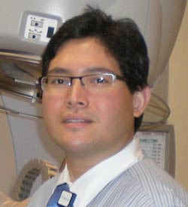
Albin Gonzalez - Medical Physicist
One of the problems Albin Gonzalez solves nearly every day is how to position patients during radiation treatments for the most efficient and least painful access. He also routinely solves difficulties with the technology itself. Albin checks treatment plans and monitors the machines to make sure they're working properly and that their output is within an acceptable range. Together with doctors, dosimetrists, radiation therapists and nurses, Albin treats around 40 patients per day with extremely high doses of radiation. Physics allows Albin to work in a fast-paced environment that's constantly adapting to the latest technology. Right now, his department is lucky enough to use "a fantastic treatment planning system that is the latest in the market," he says. It makes treatment plans much more efficient, which is good news for cancer patients!
aps.org/careers/physicists/profiles/agonzalez.cfm

Gabriela Gonzalez - Astrophysicist
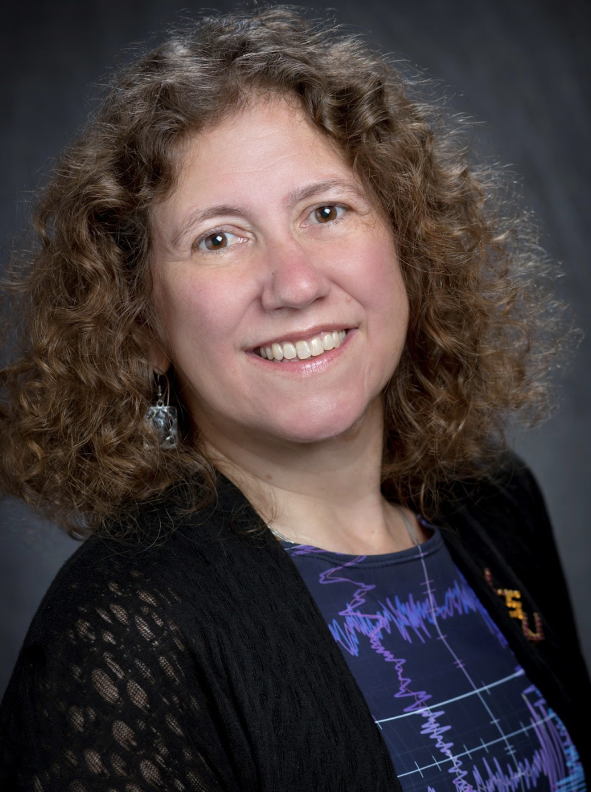
When asked about her love for physics, Gabriela Gonzalez said, "I was amazed at how we could ‘explain’ the world with physics and we could predict what objects would do. When I found out this also applied to stars and the universe, and that there were unknown phenomena waiting to be discovered, I decided I couldn’t do anything else!" She is currently a professor in the physics and astronomy department at Louisiana State University (LSU). In addition to teaching, she works with the nearby Laser Interferometer Gravitational-Wave Observatory (LIGO) in Livingston, Louisiana.

aps.org/careers/physicists/profiles/ggonzalez.cfm

Evelynn Hammonds - History of Science Professor
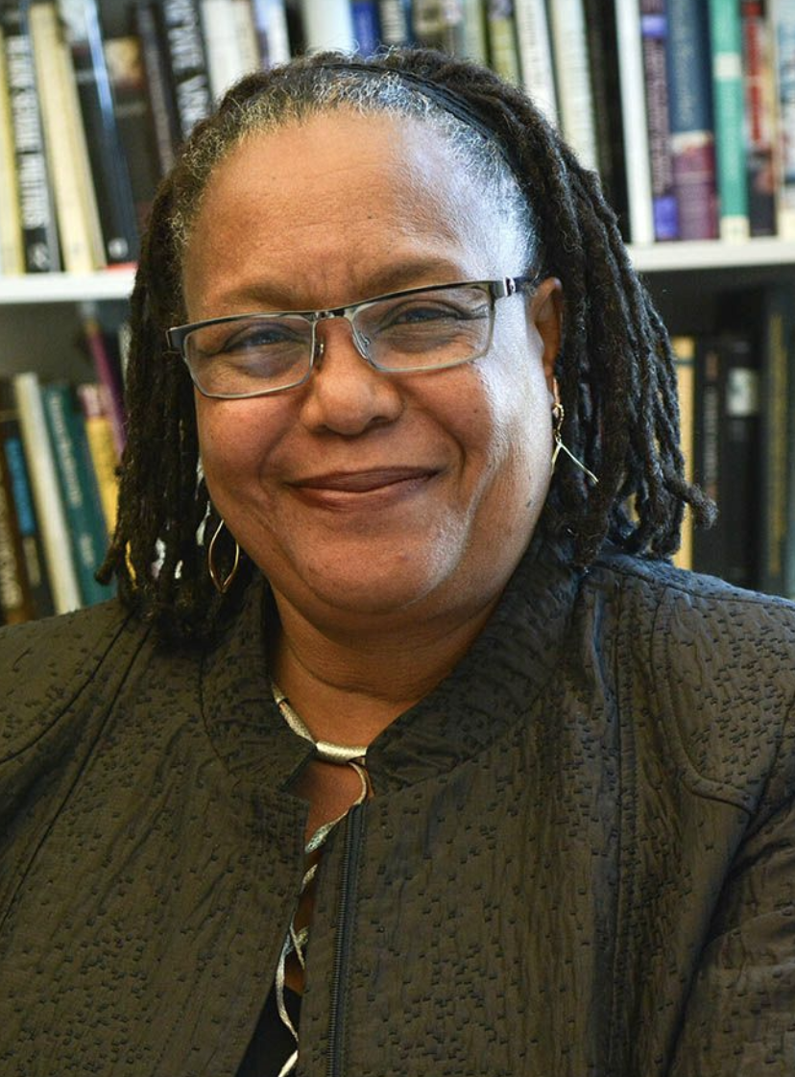
Professor Hammonds is the Barbara Gutmann Rosenkrantz Professor of the History of Science and Professor of African and African American Studies and current chair of the Department of the History of Science at Harvard University. From 2008–2013 she served as Dean of Harvard College. Professor Hammonds’ areas of research include the histories of science, medicine and public health in the United States; race and gender in science studies; feminist theory and African American history. She has published articles on the history of disease, race and science, African American feminism, African-American women and the epidemic of HIV/AIDS and analyses of gender and race in science and medicine. Her current work focuses on the intersection of scientific, medical and socio-political concepts of race in the United States. Professor Hammonds earned a Ph.D. in the history of science from Harvard University, a S.M. in physics from the Massachusetts Institute of Technology (MIT), a B.E.E. in electrical engineering from the Georgia Institute of Technology, and a B.S. in physics from Spelman College. In 2010 she was appointed to President Barack Obama’s Board of Advisors on Historically Black Colleges and Universities and in 2014 to the President’s Advisory Committee on Excellence in Higher Education for African Americans. She is currently director of the Project on Race & Gender in Science & Medicine at the Hutchins Center for African and African American Research at Harvard.
aps.org/careers/physicists/profiles/hammonds.cfm

Laura Kasian - Production Technician/Software Engineer
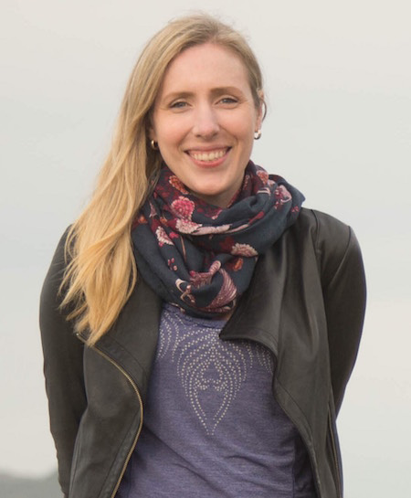
Music is blaring in a downtown nightclub closed for a private party. Screens mounted around the venue run a movie trailer and a credits list, attracting small crowds that drift up to point out names. Beside the dance floor is a photo booth and a table loaded with props. It’s the wrap party for Hotel Transylvania 2, an unexpected place to find someone with a Ph.D. in astronomy. Laura Kasian is a physicist who puts her analytical skills to use in visual effects at Sony Pictures Imageworks in Vancouver, Canada. Working on everything from the gritty Suicide Squad to the animated movie Spider-Man: Into the Spider-Verse, Kasian operates behind the scenes to smooth out the many technical elements that go into creating the movies we love. Kasian’s unusual career path demonstrates that physics is about learning skills instead of facts. She completed her bachelor’s in physics at the University of Winnipeg, then pursued a graduate degree in astronomy at the University of British Columbia. She overlapped the last year of her doctorate with her first year of law school, earning her Ph.D. in 2012 and her law degree in 2013.
physicstoday.scitation.org/do/10.1063/PT.5.9093/full/

Ginger Kerrick - NASA Flight Director
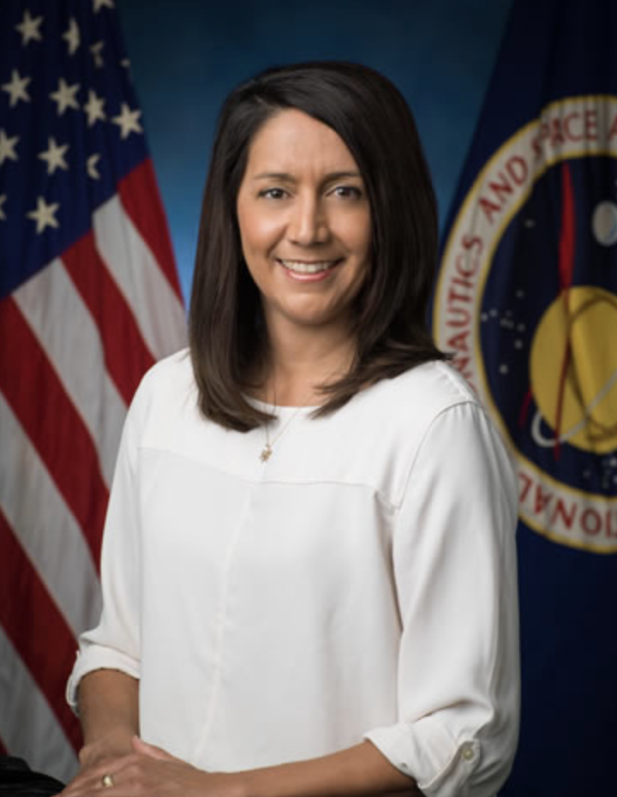
Ginger Kerrick uses physics every day to quickly change plans to account for weather changes and ensure that the astronauts can safely return home. Her job as a flight director can even be seen as more important than that of an astronaut because of the amount of time and skill that she has to use to think of every single scenario that could occur while the astronauts are in space. Even though Ginger could not become an astronaut, she became one of the key people who plans everything for the astronauts and gives them the instructions on how to complete their tasks. More importantly, her experience and willingness to learn new skills gave her the opportunity to work in space exploration as a NASA flight director. The setbacks that Ginger has experienced have never stopped her from pursuing a career in space exploration.

aps.org/careers/physicists/profiles/kerrick.cfm

Yung Tae Kim - Skateboarding Physicist & Educator
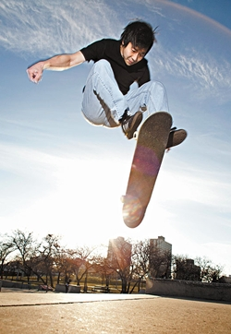
Yung Tae Kim grew up in Atlanta, Georgia, with an early love for skateboarding. Tae describes his dive into physics as a stroke of luck citing a high school math teacher who “even worked with me outside of class so I could study more advanced math…he was a real mentor,” Tae says. In college, Tae stumbled upon a physics class that changed the course of his academic studies, and led him to major in physics. “This [physics] class was special - it was an honors section that only 8 students bothered to sign up for,” Tae says.

After graduating and teaching as a visiting physics professor at several universities in the Chicago area, Tae took his talents and physics know-how to the video game industry, becoming a consultant and controls engineer for two games in the popular Tony Hawk skateboarding game series. Tae provided game developers with the physics behind skating tricks, allowing them to more accurately simulate them in the game. As an engineer, he revamped the game’s new interactive skateboard controller, which players stand on and move to produce on-screen tricks. In his next career move, Tae created an educational web series called “The Physics of Skateboarding with Dr. Tae” targeting skaters to get them to think scientifically about the sport. He also serves on the advisory board for the Puget Sound Community School in Seattle, Washington.
aps.org/careers/physicists/profiles/kim.cfm
Liz Kruesi - Freelance Science Writer
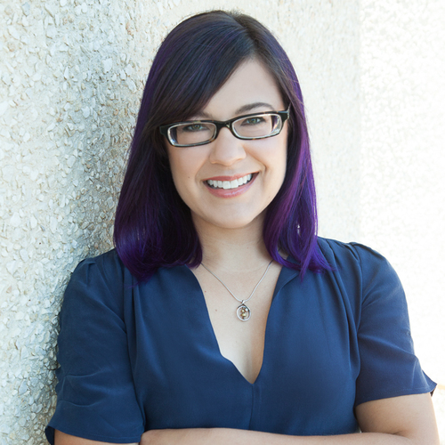
Liz Kruesi studied physics and astrophysics in college and graduate school, and soon found herself leaving behind mathematical equations to focus instead on the words and stories describing astronomical concepts. As a science journalist, she has been able to explore everything from dark matter and black holes to the outer planets and future telescopes. She loves diving into difficult topics — how did the universe evolve, where do the highest-energy particles come from, and what definitive proof do scientists need to declare life on another planet? She has written dozens of feature articles and hundreds of news stories covering all aspects of astronomical science. She translates complex scientific concepts, discoveries, and their stories into language that not only is understandable to anyone, but also captures the topic’s excitement and importance.

lizkruesi.com/about

Nadya Mason – Materials Physics Professor
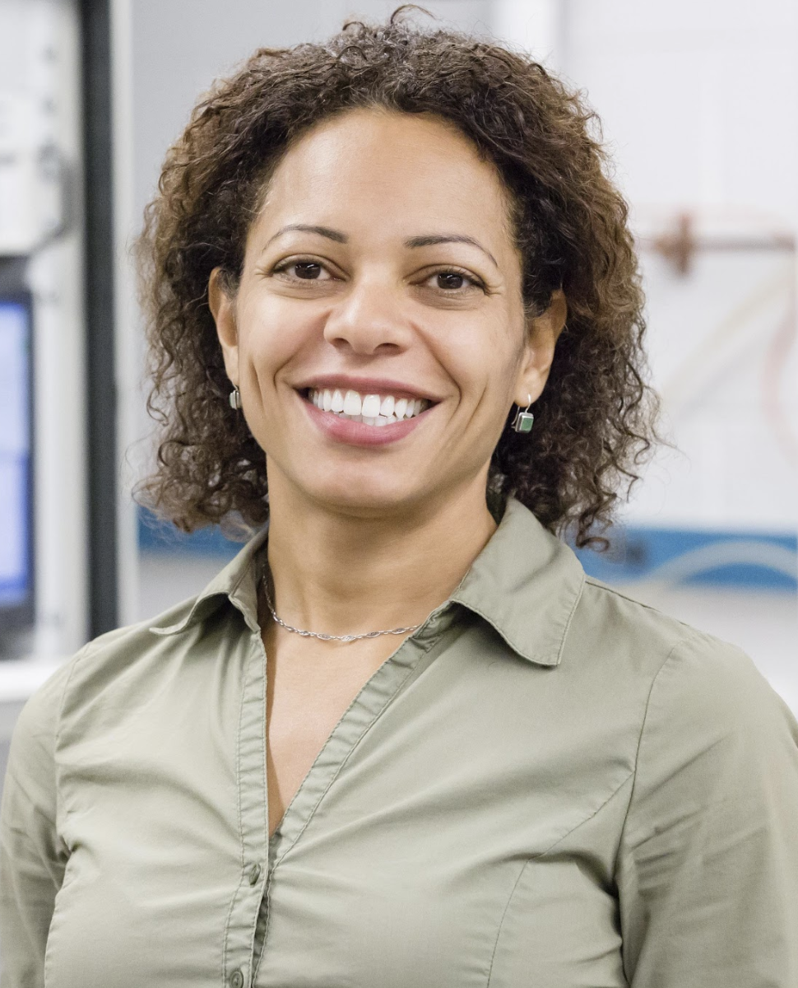
Nadya Mason says that the best thing about having a degree in physics is that she gets to work in a fun and stimulating profession. She also gets to choose her schedule, focus on research and teaching that appeal to her, and travel and meet interesting people from around the world. Nadya’s main strategy for success is to make sure that she enjoys the work that she does. “Most physics-related jobs involve research and problem-solving, so they’re likely to be interesting and even fun,” she says.
Nadya teaches at the University of Illinois at Urbana-Champaign. Her work focuses on the way electrons behave and interact in “low dimensional” materials such as carbon nanotubes and graphene. These materials are made up of extremely thin layers of carbon, sometimes no thicker than a single carbon atom. This means that a stack of 7 million sheets would be only a millimeter thick! When dimensions are so low, electrons interact in ways that create new phenomena, which Nadya aims to explore. “The research that I do explores the fundamental science that may form the basis of the next generation of technology,” she says. For example, carbon nanotubes might play an important role in the next generation of nano-scale computers, leading to super-powerful quantum computers that could be significantly faster than the computers we use today.
aps.org/careers/physicists/profiles/mason.cfm
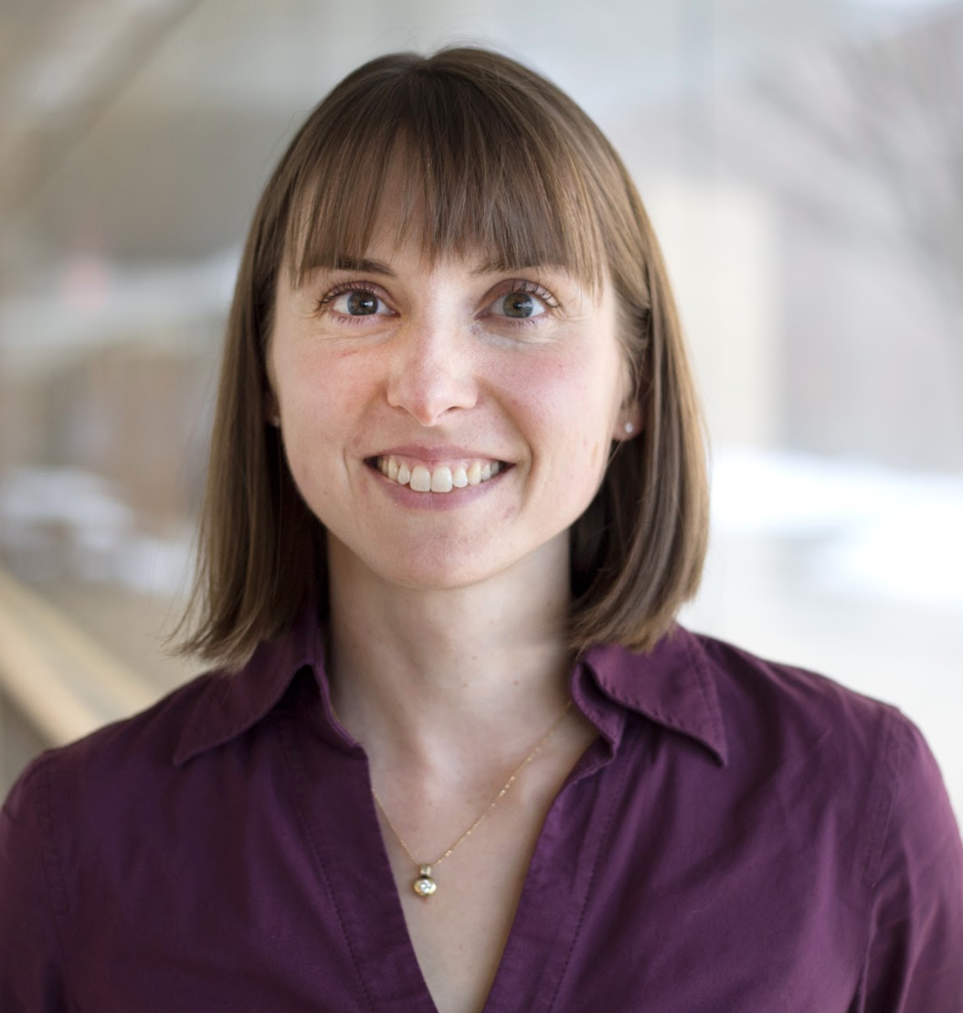
Kate McAlpine - Freelance Writer
“I'm a freelance writer and sometimes rapper, specializing in physics,” says Kate McAlpine. She adds, “as a science communicator, my job is to explain research. Sometimes it’s documenting the progress of a long-term project, like my current work with the ATLAS e-News, for the ATLAS experiment on CERN's Large Hadron Collider (LHC). Sometimes it’s reporting about a recent advance, as in the articles for New Scientist magazine.” On her work surrounding the LHC, Kate often faced challenges around defending the value of scientific research or explaining complex scientific concepts to reassure citizens about the safety of large experiments like the LHC.
Kate received her bachelor's degree from Michigan State University, where she was studying both physics and writing. “I planned the science communicator part while still in college, but I didn’t plan rap as an aspect of my career,” says Kate. Having an exciting job is definitely one of the goals she had in mind. Kate is planning on finishing a nuclear physics rap soon, and is also working on a rap about black holes.

cnet.com/news/when-rap-physics-and-fame-collide/

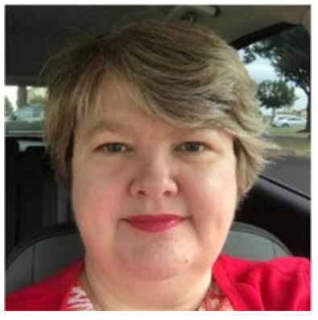
Amanda Joy McDonald – Actuary
Amanda Joy McDonald earned a BS in physics from Southern Nazarene University (SNU, in Bethany, OK) in 1989, where she published a paper in the Journal of Undergraduate Research in Physics. She was elected into Sigma Pi Sigma in the SNU chapter when it was chartered in 1994. Joy began her career as an actuary before graduation by taking the first actuarial exam in November 1988. Then life intervened. Needing lots of family time, she took several years off from Fellowship studies to raise children while still working as an actuary for American Fidelity. In 2006, realizing she was approaching the twentieth anniversary of starting the Fellows program, Joy set a goal to achieve the FSA before that anniversary. That goal was realized a few months early when Joy completed the final requirement in July 2008. Joy concentrated her actuarial studies in Group and Health Insurance.
Joy has remained a highly visible “hidden physicist” throughout her actuarial career. She presents talks to university math clubs and chapters of the Society of Physics Students, describing how a background in physics prepares one well for actuarial studies.
careersinphysics.org/physicists/Detail.cfm?id=2845

Mary Lee McJimsey - High School Physics Teacher
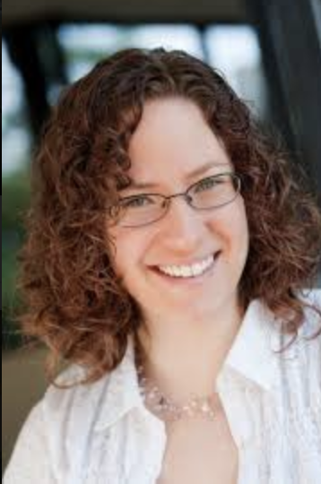
Mary Lee McJimsey decided to become a teacher while she was an undergraduate physics major at Cal Poly in San Luis Obispo. She was doing physics research at the time and remembers, “everyday I came in and did exactly the same thing.” Mary Lee found herself inspired to pursue a career in teaching – a goal which could provide variety and excitement in her career. This proved to be true. Responding to a question of why she loves teaching, Mary Lee says, “I understand how much this job is doing to change my community. I can help a student choose to go to college, and maybe even become one of the next engineers or physicists who's going to change the world. Also, every single day is different…I see many teachers, every day, who come to me to have me help them solve a problem. I plan, but I never know what to expect.”

Mary Lee is now the proud mom to two boys, and recently spent a year as elementary science specialist, teaching science to students from grades K–3. She most recently worked as a physics teacher at a small school focused entirely on problem-based learning (PBL). She is temporarily out of the classroom caring for her newest family member but hopes to return to high school teaching soon.

knowlesteachers.org/bios/mary-lee-mcjimsey
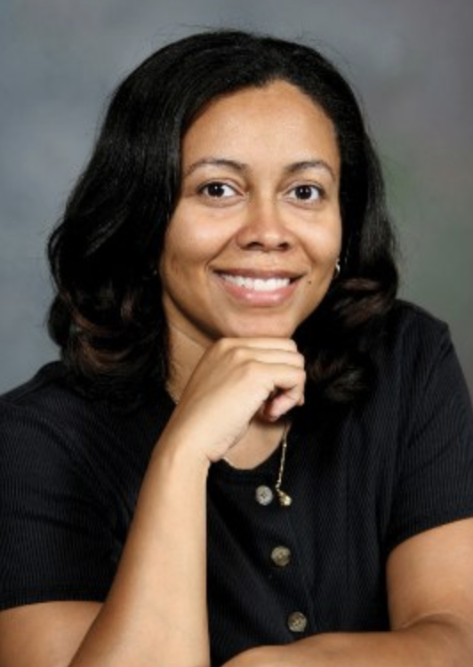
Marta Dark McNeese - Laser Science Professor
Marta Dark McNeese teaches undergraduate students of all levels and backgrounds, from humanities students to physics majors, at Spelman College. “I enjoy interacting with my students most, but I also love having to continually learn new things,” she says. Marta gets ample opportunities to learn new things while she works on her latest research projects. The focus of her research has shifted from knee cartilage to light-emitting materials. Marta’s main project deals with synthesizing molecules that can give off light when they’re hit with light or when voltage is applied. She’s interested in these so-called “electroluminescence properties” and improving them. Marta's lab is experimenting with adding metals to the molecule of interest, in hopes that this will improve the electroluminescence of the molecule. Her work has applications in light-emitting devices, diodes for displays, and even flexible light-emitting materials.

aps.org/careers/physicists/profiles/mcneese.cfm

Deborah Moore - Environmental Consultant
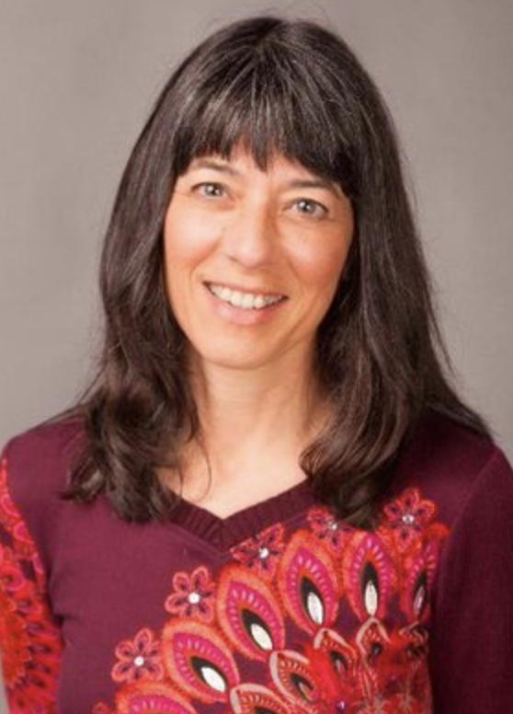
Deborah Moore is an award-winning scientist, advocate, changemaker, mother, and nature lover. While she may not be a household name to you, her work has touched millions of lives and thousands of square miles of nature around the world. She has led winning campaigns across a wide range of issues, from river restoration efforts, green and healthy school programs to advancing the human rights of indigenous peoples. Throughout her varied career, Deborah has held roles as a research scientist, environmental advocate, non-profit director, educator, foundation consultant, and coalition builder, from small start-ups to large global initiatives. She says proudly: “I am an award-winning changemaker, advocate, scientist, and social entrepreneur for the environment and human rights. I produce tangible results with lasting value by bringing together people with diverse perspectives to forge broadly supported solutions. My passions are climate change, water, and children - all are fundamental to a healthy future!”

compadre.org/careers/physicists/Detail.cfm?id=2313

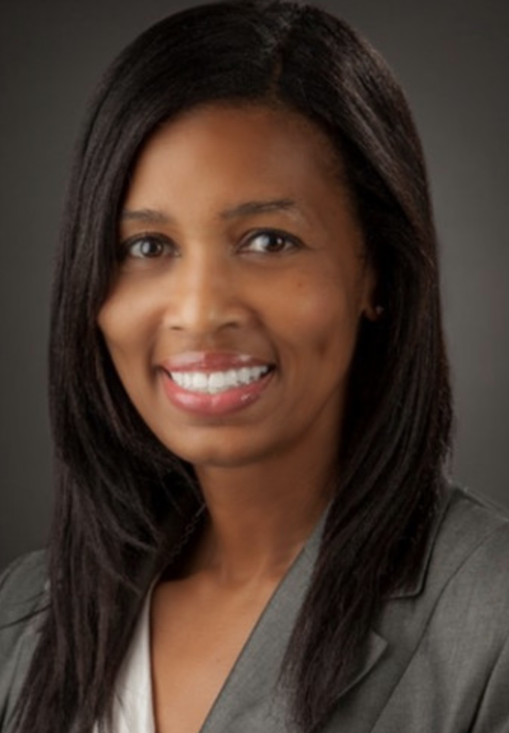
Carlane Pittman - Director for Outreach
Carlane Pittman is responsible for student concerns and student advising at the College of William and Mary. She also coordinates and maintains the outreach efforts of the physics department to recruit and advise students. She enjoys seeing students benefit from my educational programs, and promoting science at the same time. Carlane's main focus for the past 21 years while at the College of William and Mary has been in the area of college student development including classroom and out of classroom experiences. She received her B.S. in physics from Spelman College and then her M.A. in education from Hampton University.

spsnational.org/career-resources/physicist-profiles/carlane-pittman

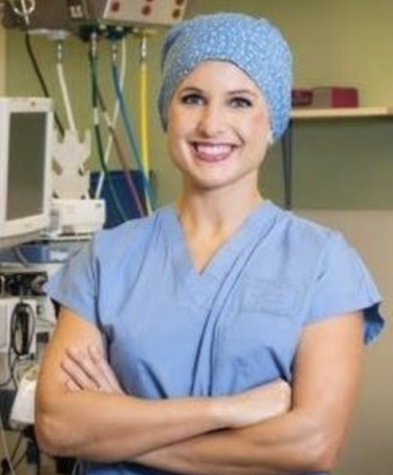
Allison Porter - Biophysics Technician
Allison Porter had always been interested in the sciences and showed special interest in becoming a doctor, partially due to her aunt's fight with ovarian cancer. In high school, her physics class introduced her to astrophysics with a lesson that allowed students to create a simulated solar system by determining objects masses and velocities. When going through her undergraduate years, she wanted to choose a major that gave some breadth to her education, and her good experience in high school steered her towards astrophysics. “I think a lot of [my interest] is from a philosophical standpoint, studying things that are much larger than we can really comprehend.” After graduating from Harvard, Allison entered the Miss America pageant, representing her state of Washington. She chose the pageant due to its goal to develop well-rounded women, and currently employs her role as Miss Washington to raise awareness of cancer prevention, treatment, and funding. She is currently in the M.D. program at the University of Washington. Aside from her work, Allison Porter is helping people by being involved in a wide range of community support activities. She has spent time in Mexico doing disease education, Calcutta working at a disabled children's orphanage, and Ecuador as a part of a mobile surgery unit.
physicscentral.com/explore/people/porter.cfm

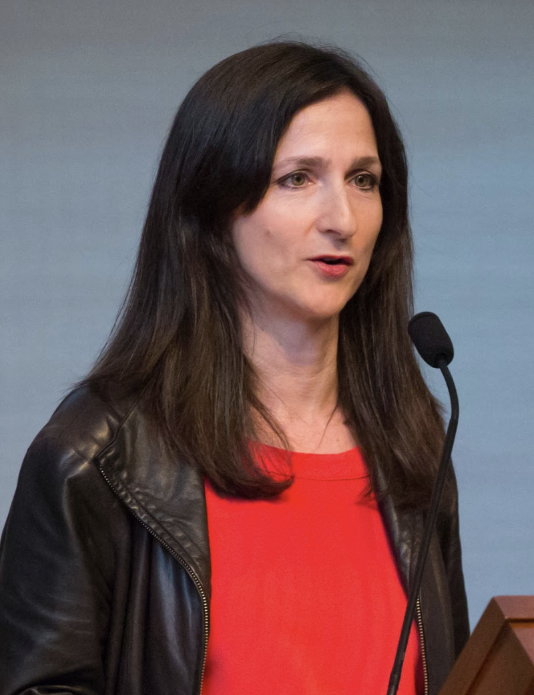
Sara Seager - Astronomer and Planetary Scientist
Sara Seager is a Canadian-American astronomer and planetary scientist. She is a professor at MIT and is known for her work on exoplanets and their atmospheres. She has pioneered many research areas of characterizing exoplanets with concepts and methods that now form the foundation of the field of exoplanet atmospheres. Her present research focuses on the search for life by way of exoplanet atmospheric “biosignature” gases has also led to research in the evolution of life through chemical space. Sara is the author of two textbooks on these topics. She has also been recognized for this research by Popular Science, Discover Magazine, Nature, and TIME Magazine. Seager was awarded a MacArthur Fellowship in 2013 citing her theoretical work on detecting chemical signatures on exoplanet atmospheres and developing low-cost space observatories to observe planetary transits.

en.wikipedia.org/wiki/Sara_Seager
Maggie Seeds - Associate Consultant
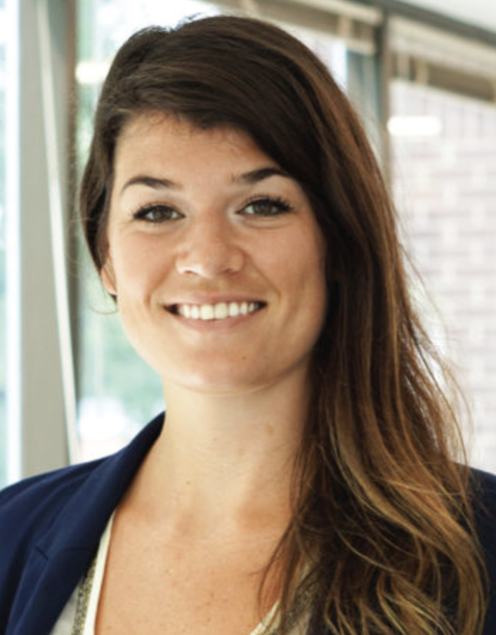
Maggie Seeds was always a stargazer and wanted to pursue that passion in her undergraduate education. Maggie attended Appalachian State University where astronomy was a concentration available to physics majors. She felt that physics was a natural path of study for her, and found that she enjoyed the mathematical side of physics, working through difficult challenges and finally arriving at the answer to complicated problems. Today, Maggie is a consultant at Clarkston Consulting (N.C.), a management and technology consulting firm which focuses on consumer products and the life sciences industries. As a consultant, Maggie plays many different roles depending on a client’s needs. She says these range “from technical to strategic, across supply chain and business process areas.” The terms “supply chain” and “business process” refer to how raw materials make their way into a finished, marketable product.

Maggie says that one of the reasons she chose this career path was because she enjoyed having to be flexible and having to examine a problem from many different angles. She knew that she wanted to utilize the critical thinking skills she'd learned studying physics, but she also wanted to travel and take on a variety of complex problems. She says that consulting filled all of these needs, since every client is different and has a new, interesting problem.

aps.org/careers/physicists/profiles/seeds.cfm
Kate Shaw - Experimental Particle Physicist
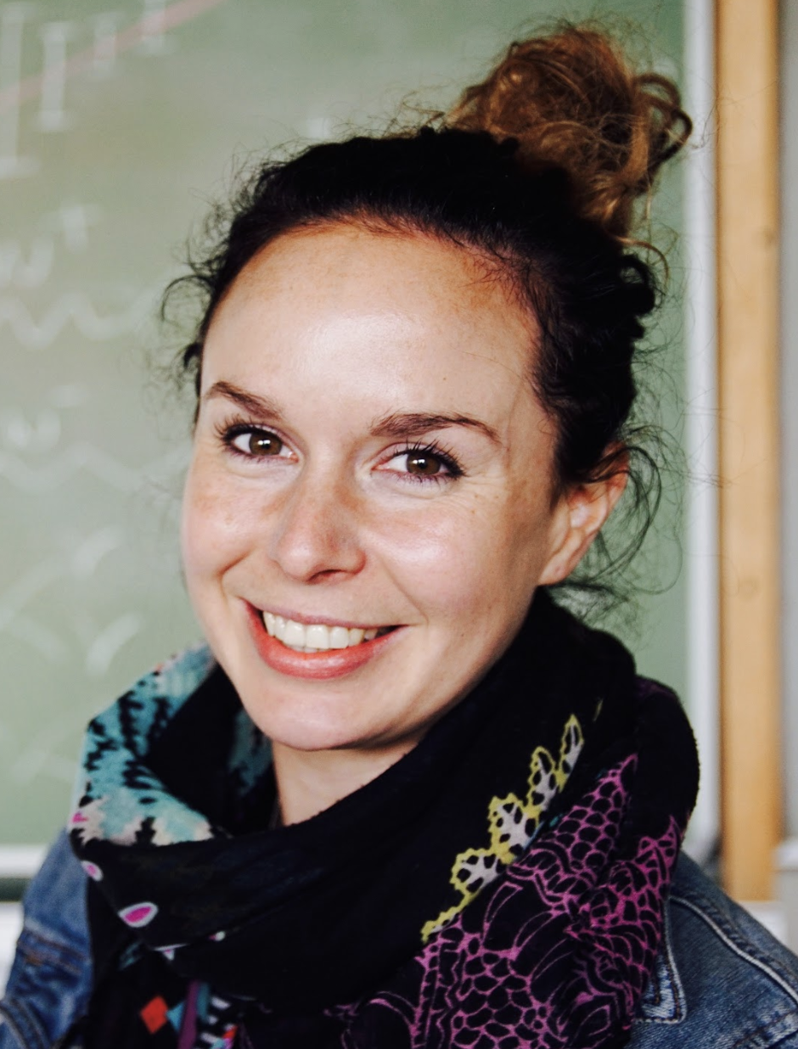
Kate Shaw is an experimental particle physicist working on the ATLAS Experiment at the Large Hadron Collider (LHC). She is a lecturer at the University of Sussex (UK) and a staff scientist at the Abdus Salam International Centre for Theoretical Physics (ICTP) in Trieste, Italy. She has worked on the ATLAS Experiment since 2006 when she was doing her Ph.D. at the University of Sheffield. Her work includes research into the Top Quark, which is the heaviest known fundamental particle, and research on the Higgs Boson, the recently discovered particle that allows fundamental particles to acquire their different masses. Kate also worked on luminosity calibration and determination, and commissioning of the Semiconductor Tracker (SCT), part of the inner detector of ATLAS. Kate works intensively in physics outreach and public engagement. She was the ATLAS outreach coordinator for 5 years, and in 2015 won the EPS outreach prize. She is passionate to reach those who might have less access to science or are a minority in the field. In 2012, Kate founded the ICTP Physics Without Frontiers program which works to support and promote physics worldwide by empowering scientists to run educational training programs.
kate-shaw.co.uk

David Sullivan - Engineer
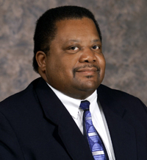
David Sullivan is an engineer at Raytheon, but involved in many ways. First of all, he is a principal system producibility engineer within the company. He also is very involved with recruiting university students for Raytheon, as well as working with middle and high schoolers, encouraging in them an interest in math and science. In addition to his various positions within Raytheon, David is an active member of the community. He is a member of the Decision Making Committee for the Townview Science and Engineering Magnet High School. David is an active member of his church, Friendship West Baptist, where he has been involved with the men's ministry and college groups. He has also been a coach for little league football. David’s position requires his expertise in education, research, management, and government. His job utilizes his skills in complex problem solving, synthesizing information, knowledge of physics principles, communication, and teamwork.

careersinphysics.org/physicists/Detail.cfm?id=2332

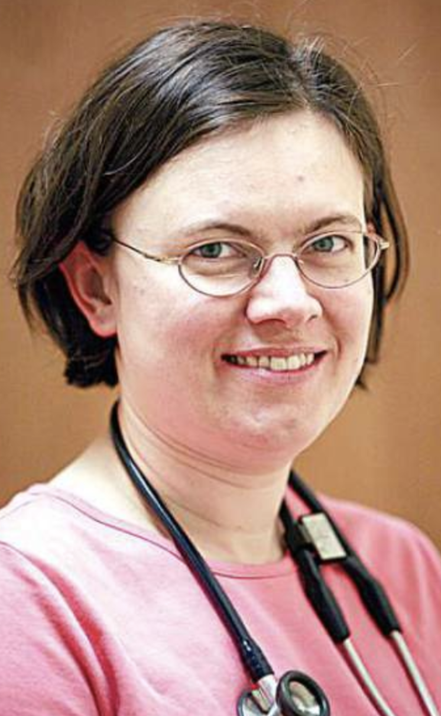
Urszula Tajchman - Pediatric Cardiologist
In her job, Urszula Tajchman treats children with heart disease, as well as conducts research in molecular biology. Urszula received her medical training at the Johns Hopkins University. She then did her residency in pediatrics at the University of Colorado, and a fellowship in pediatric cardiology at the University of Iowa. She worked as a pediatric cardiologist at the University of South Dakota before becoming the first pediatric cardiologist in Central Oregon in 2002. Urszula is board certified in pediatrics and pediatric cardiology. She says that the best things about her job are caring for patients, teaching children and parents about their health, and studying therapies for disease.

careersinphysics.org/physicists/Detail.cfm?id=2321

Aaron Weiss - Prototype Engineer
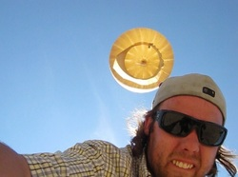
Studying physics fueled Aaron Weiss’ curiosity. “When I started to grasp how complex and diverse our world can be, things started clicking, and my curiosity shot through the roof,” he says. Aaron was always interested in nearly every scientific field, so he kept his options open after graduation. He soon found his way to a small hardware company and describes the experience thus: “It was a scrappy group of engineers cooking circuit boards on hot plates in a tiny room with no ventilation. Bingo… [they were] pioneering open source hardware and I fell in love with building electronics and haven’t stopped since.”

Now, Aaron works at a research and development facility founded by Google and contributes to many exciting new technologies including space-based projects and self-driving cars. Aaron is part of the machine learning team in the robotics division. Aaron has also founded his own company, a design outfit called Bitsmashed. With Bitsmashed, Aaron has created a variety of power sensing and GPS tracking systems such as Hawkpack – a solar powered cellular enabled backpack worn by large birds of prey that can track their motion. Aaron is constantly applying his physics knowledge to work on exciting projects.

aps.org/careers/physicists/profiles/weiss.cfm

Alice White - Materials Scientist
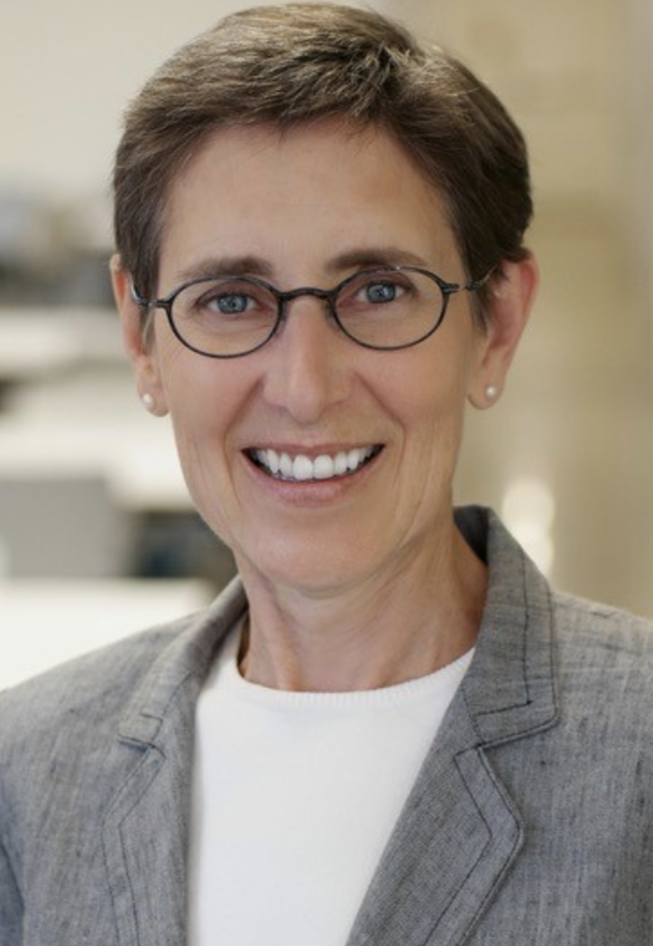
Alice first got into science in high school and went on to study chemistry at Middlebury College, a small liberal arts school in Vermont. Alice loved Middlebury’s close-knit and supportive science department and one semester took an organic chemistry and physics course at the same time. She found she didn’t like the messiness of her chemistry lab, but loved all the math used in physics. The experience led her to change her major and complete her degree in physics.
Alice is now a research scientist and works at the Boston University Department of Mechanical Engineering as Chair. Her technical background focuses on experimental solid-state physics and fabrication of optical components. She’s received many awards and fellowships for her work, which has led to over 125 publications and 7 patents. She had a lot of support from her family and has had good mentors in her career. She strives to give back through mentorship, and outreach such as talks and physics demonstrations at local elementary schools. She says, “I really benefited...and it's something that I'm happy to give back.”

aps.org/careers/physicists/profiles/white.cfm
Feel free to add additional career profiles!

