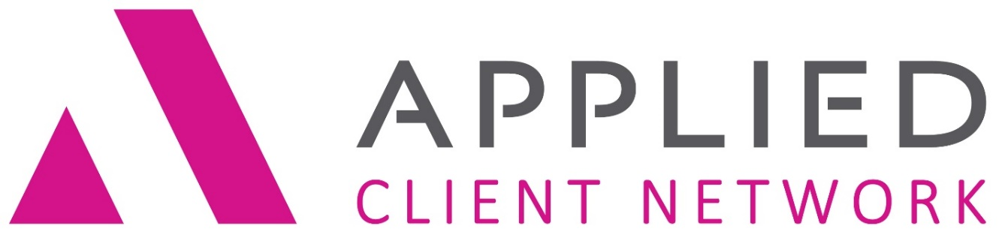
North Dakota Chapter

Training and Business Meeting- November 7th, 2018
AGENDA
8:00 – 8:30 Registration (coffee, juice, and rolls)
8:30 – 10:00 Presentation: So, Your Agency Needs a Proposal
10:00 – 10:15 Break
10:15 – 11:45 Presentation: Microsoft® Word® - Intermediate Formatting
11:45 – 12:00 Business Meeting
12:00 – 1:00 Lunch (Included)
1:00 – 2:30 Presentation: Microsoft® Word® - Inserting Signatures
2:15 – 2:30 Break
2:30 – 4:00 Presentation Standard vs Paragraph vs Master Templates

Bu

This session will cover:
So, Your Agency Needs a Proposal: This session will explore how to create an organization proposal using the methods of importing custom items, copying existing templates, and creating a template from scratch. We will walk through customization steps of creating unique styles, managing those styles, and applying them to other templates. The session will also touch on the management of the proposal templates and cover documents through the use of Proposals Groups.

Microsoft® Word® – Intermediate Formatting: This intermediate Microsoft® Word® skills session will review tools for document template improvement. Use of tables, borders and shading, section and page breaks, and page headers and footers will be included. Bring Your Own Laptop (though not required) for this hands-on session. The session will be taught using Microsoft® Office® 2010/2013 and skills apply to Applied TAM, Applied Vision, and Applied Epic users.

Microsoft® Word® - Inserting Signatures: This class is for both Applied TAM and Applied Epic users. Applied TAM users will learn how to access information, such as the producer's email address and CSR's phone number into letters despite the fact that the information is not stored in the database in a way that is accessible to the Microsoft® Word®/Applied TAM interface. Applied Epic users will learn how to identify which name should be pulled out of the servicing role field for the various staff members assigned to the account. Both Applied TAM and Applied Epic users will learn how to insert the correct signature image into the letter.

Standard vs Paragraph vs Master Templates: What is the difference between a standard template, a paragraph template and a master template? How do you decide which type of template to create and use? How do you convert existing standard templates into paragraph or master templates? Are there limitations to be aware of when creating paragraph and master templates? These are the questions we will answer in this session.

PRESENTER: Jennifer Godwin Highly skilled and enthusiastic professional with over thirty years of experience in the insurance industry with an extensive background in agency operations management including:
- Business Process Analysis and Design
- Business Process problem solving and software troubleshooting
- Agency Performance Reporting and Statistics (Best Practices & Agency Standards Compliance)
- Software skills training including TAM, Epic, MSOffice Products
- Project evaluation, planning and implementation skills
- 25 years of experience with Applied Systems, including TAM and Epic platforms, both as an insurance agency account manager, agency trainer and Applied consultant.

HOTEL ACCOMODATIONS can be made at:
Holiday Inn  3803 13th Ave South  Fargo, ND 58103  701-282-2700 | Group Name: Applied Client Network  Group Rate of $994 plus tax  Reservation Link: Reservations
►►►►►►►►►►►►►►►►►►►►►►►►►►►►►►►►►►►►►►►►►►►►►►►►►►►►►►
Cost: $35 each attending member; $100 each attending non-member

Please register online on the Applied Client Network website: Registration
Please direct any questions you have to Dani Kelly at Heritage Insurance Services
Email: dkelly@heritageinsservices.com
You are receiving this email because of your relationship with Applied Client Network North Dakota. You may have your name
removed from our list if you no longer wish to receive our emails.

