Providing Trauma Informed Care:
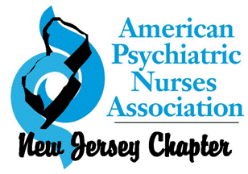
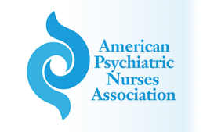
SAVE THE DATE!
Resources for Nurses and APN’s

FALL CONFERENCE

Saturday, September 9

The Renaissance Hotel 515 US-1 Iselin, NJ 08830

APNA and APNA NJ Chapter are co-providing this conference.
The American Psychiatric Nurses Association is accredited as a provider of continuing nursing education by the American Nurses Credentialing Center’s Commission on Accreditation.
Registration brochure coming soon!
Please contact Valeria Dworkowitz, NJ Chapter President with any questions : vdworkowitz @gmail.com

