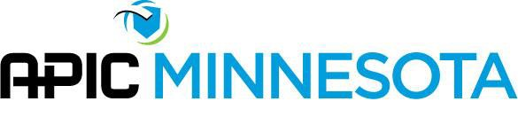

Policy/Procedure
Policy # 6

Subject: Advertising Policy

Effective Date: 2000

Reviewed by: News and Views Editor
Approved by: APIC MN Board of Directors
Revision Dates: 3/2021
POLICY
Advertisements for the newsletter and APIC MN related activities will follow the structure delineated below.

PURPOSE
To establish guidelines for advertising with APIC MN.

PROCEDURE:
- Requests for advertising shall be made to the Communications Director, as appropriate. All advertisements will be subject to the appropriate editor’s discretion and approval. The Board of Directors will be consulted as necessary.
- The Communcations Director shall ensure all criteria in this policy are met, request an invoice to be processed by the Treasurer, and communicate with the Administrative Assistant as needed.
- Criteria for activities other than the Newsletter shall be determined on a case by case basis by the Board of Directors. (e.g., advertisements on conference flyers, sponsorship programs, etc.)
- Payments for advertisements other than job posting shall be paid in advance.
- Vendor Application (see Appendix A) must be completed by vendor and reviewed by appropriate editor prior to advertisement approval.
- See Price List (Appendix B) for advertisement costs. See APIC MN Sponsorship Program for Sponsorship Program cost information.
- Advertisements will include this disclaimer language: “APIC MN does not endorse, nor promote any specific vendor, product, or service.”

REFERENCES: None

ATTACHMENTS & RELATED FORMS: Appendix A (Vendor Application), Appendix B (Price List), Appendix C (Process Details for Vendor Advertising).

